**MINISTRY OF EDUCATION AND TRAINING**

**FPT UNIVERSITY**

Capstone Project Document

**Just Walk Out Library**

|  |  |
| --- | --- |
| **Group 1** | |
| **Group members** | Võ Hồng Hà – SE61394  Nguyễn Tuấn Anh – SE61476  Đặng Nhật Thiên – SE61357 |
| **Supervisor** | Kiều Trọng Khánh |
| **Ext. Supervisor** | N/A |
| **Capstone Project code** | JWL |

- Ho Chi Minh city, April 3rd 2017 -

*This page is intentionally left blank*

Table of Contents

[1. List of Tables 6](#_Toc480027553)

[2. List of Figures 8](#_Toc480027554)

[Definitions, Acronyms, and Abbreviations 10](#_Toc480027555)

[A. Introduction 11](#_Toc480027556)

[1. Project Information 11](#_Toc480027557)

[2. Introduction 11](#_Toc480027558)

[3. Current Situation 11](#_Toc480027559)

[3.1 Ho Chi Minh City University of Social Sciences and Humanities library 11](#_Toc480027560)

[3.2 FPT University library 11](#_Toc480027561)

[4. Problem Definition 12](#_Toc480027562)

[5. Proposed Solution 12](#_Toc480027563)

[5.1 Technologies 13](#_Toc480027564)

[5.2 Feature Functions 14](#_Toc480027565)

[5.3 Advantages and Disadvantages 15](#_Toc480027566)

[6. Functional Requirements 15](#_Toc480027567)

[7. Role and Responsibility 16](#_Toc480027568)

[B. Software Project Management Plan 17](#_Toc480027569)

[1. Problem Definition 17](#_Toc480027570)

[1.1. Name of this Capstone Project 17](#_Toc480027571)

[1.2. Problem Abstract 17](#_Toc480027572)

[1.3. Project Overview 17](#_Toc480027573)

[2. Project organization 26](#_Toc480027574)

[2.1. Software Process Model 26](#_Toc480027577)

[2.2. Roles and responsibilities 27](#_Toc480027578)

[2.3. Tools and Techniques 28](#_Toc480027579)

[3. Project Management Plan 28](#_Toc480027580)

[3.1. Software development life cycle 28](#_Toc480027582)

[3.2. Phase Detail 30](#_Toc480027583)

[3.3. All Meeting Minutes 32](#_Toc480027584)

[4. Coding Convention 34](#_Toc480027585)

[C. Software Requirement Specification 36](#_Toc480027586)

[1. User Requirement Specification 36](#_Toc480027587)

[1.1 Unauthorized User Requirement 36](#_Toc480027588)

[1.2 Authorized User Requirement 36](#_Toc480027589)

[1.3 Borrower Requirement 36](#_Toc480027590)

[1.4 Librarian Requirement 36](#_Toc480027591)

[1.5 Admin Requirement 37](#_Toc480027592)

[1.6 Automatic Handler Requirement 37](#_Toc480027593)

[1.7 Emulator Requirement 37](#_Toc480027594)

[2. System Requirement Specification 38](#_Toc480027595)

[2.1 External Interface Requirement 38](#_Toc480027596)

[2.2 System Overview Use Case 39](#_Toc480027597)

[2.3 List of Use Case 39](#_Toc480027598)

[3. Software System Attribute 98](#_Toc480027599)

[3.1 Usability 98](#_Toc480027601)

[3.2 Reliability 98](#_Toc480027602)

[3.3 Availability 98](#_Toc480027603)

[3.4 Security 98](#_Toc480027604)

[3.5 Maintenanability 98](#_Toc480027605)

[3.6 Portability 98](#_Toc480027606)

[3.7 Performance 98](#_Toc480027607)

[3.8 Conceptual Diagram 98](#_Toc480027608)

[D. Software Design Description 100](#_Toc480027609)

[1. Design Overview 100](#_Toc480027610)

[2. System Architectural Design 101](#_Toc480027611)

[2.1 Web Application Architecture Description 101](#_Toc480027612)

[2.2 Web Service Application Architecture Description 103](#_Toc480027613)

[2.3 Mobile Application Description 104](#_Toc480027614)

[3. Component Diagram 105](#_Toc480027615)

[4. Detailed Description 106](#_Toc480027616)

[4.1 Class Diagram 106](#_Toc480027617)

[4.2 Class Diagram Explanation 108](#_Toc480027618)

[4.3 Interaction Diagram 113](#_Toc480027619)

[5. Interface 119](#_Toc480027620)

[5.1 Component interface 119](#_Toc480027621)

[5.2 User Interface Design 124](#_Toc480027622)

[6. Database Design 151](#_Toc480027623)

[6.1 Entity Relationship Diagram (ERD) 151](#_Toc480027624)

[6.2 Data Dictionary 152](#_Toc480027625)

[7. Algorithms 154](#_Toc480027626)

[7.1 Check in Algorithms 154](#_Toc480027627)

[7.2 Timsort Algorithms 157](#_Toc480027628)

[7.3 Color Distance Algorithms 157](#_Toc480027629)

[7.4 Detect Best Color Algorithms 157](#_Toc480027630)

[7.5 Search with Picture Algorithms 160](#_Toc480027631)

[7.6 Suggest T-Shirt Size Algorithms 163](#_Toc480027632)

[7.7 Suggest Shirt Size Algorithms 163](#_Toc480027633)

[D. Report No. 5 System Implementation & Test 165](#_Toc480027634)

[1. Introduction 165](#_Toc480027635)

[1.1 Overview 165](#_Toc480027636)

[1.2 Test Approach 165](#_Toc480027637)

[2. Database Relationship Diagram 165](#_Toc480027638)

[2.1 Physical Diagram 166](#_Toc480027639)

[2.2 Data Dictionary 167](#_Toc480027640)

[2 Implementation 171](#_Toc480027641)

[3.1 Backend Architecture Implementation 171](#_Toc480027642)

[3.2 Mobile Application Architecture Implementation 171](#_Toc480027643)

[3.3 Web Architecture Implementation 172](#_Toc480027644)

[3 Test Plans 174](#_Toc480027645)

[4.1 Features to be tested 174](#_Toc480027646)

[4.2 Features not to be tested 174](#_Toc480027647)

[3.2 System Testing Test Case 174](#_Toc480027648)

[5.1 Communication Diagram 174](#_Toc480027649)

[5.2. System Test Cases 176](#_Toc480027656)

[E. Software User’s Manual 183](#_Toc480027657)

[1. Installation Guide 183](#_Toc480027658)

[1.1. Setting up environment at server side 183](#_Toc480027659)

[1.2. Deployment at server side 183](#_Toc480027660)

[1.3. Deployment at Client Side 187](#_Toc480027661)

[2. User Guide 187](#_Toc480027662)

[2.1. Web application 187](#_Toc480027663)

[2.2. Mobile application 210](#_Toc480027664)

[2.3. Emulator application 219](#_Toc480027665)

[I. Appendix 224](#_Toc480027666)

## List of Tables

[Table 1 : Roles and Responsibilities 15](#_Toc480027387)

[Table 2 : Hardware requirement for Server 19](#_Toc480027388)

[Table 3: Hardware requirement for Web 19](#_Toc480027389)

[Table 4 : Hardware requirement for Mobile 20](#_Toc480027390)

[Table 5: Hardware requirement for Arduino Emulator 20](#_Toc480027391)

[Table 6: Hardware requirement for RFID reader 21](#_Toc480027392)

[Table 7: Hardware requirement for RFID converter 22](#_Toc480027393)

[Table 8 : Hardware requirement for tag/card 23](#_Toc480027394)

[Table 9: iBeacon 24](#_Toc480027395)

[Table 10 : Software requirements 25](#_Toc480027396)

[Table 11 : Roles and responsibilities 26](#_Toc480027397)

[Table 12: Tools and Techniques 27](#_Toc480027398)

[Table 13: Software Development Life Cycle Detail 28](#_Toc480027399)

[Table 14: Phase 1 - Infrastructure 29](#_Toc480027400)

[Table 15: Phase 2 - System & Web Application 30](#_Toc480027401)

[Table 16: Phase 3: Web service 30](#_Toc480027402)

[Table 17: Phase 4 - Mobile Application 31](#_Toc480027403)

[Table 18: <Unauthorized User> Login 40](#_Toc480027404)

[Table 19: <Authorized User> Get Profile Detail 43](#_Toc480027405)

[Table 20: <Authorized User> Logout 44](#_Toc480027406)

[Table 21: <Authorized User> Edit Profile 47](#_Toc480027407)

[Table 22: Get Account Detail 53](#_Toc480027408)

[Table 23:<Admin> Update Account 57](#_Toc480027409)

[Table 24: <Admin> Delete Account 59](#_Toc480027410)

[Table 25: <Librarian> Search Book 61](#_Toc480027411)

[Table 26: <Librarian> Add Book 65](#_Toc480027412)

[Table 27: <Librarian> Get Book Detail 66](#_Toc480027413)

[Table 28: <Librarian> Update Book 70](#_Toc480027414)

[Table 29: <Librarian> Remove Book 71](#_Toc480027415)

[Table 30: <Librarian> Add Borrower 74](#_Toc480027416)

[Table 31: <Librarian> Search Borrower 76](#_Toc480027417)

[Table 32: <Librarian> Get borrower detail. 77](#_Toc480027418)

[Table 33: <Librarian> Update Borrower 80](#_Toc480027419)

[Table 34: Borrower> Search Book 82](#_Toc480027420)

[Table 35: <Borrower> Add book to wish list 83](#_Toc480027421)

[Table 36: <Borrower> Get Borrowed Books 85](#_Toc480027422)

[Table 37: <Borrower>Renew Book 86](#_Toc480027423)

[Table 38: <Automatic Handler> Check in Borrower 89](#_Toc480027424)

[Table 39: <Automatic Handler> Notify return date 90](#_Toc480027425)

[Table 40: <Automatic Handler> Notify Borrowing Books 92](#_Toc480027426)

[Table 41: <Automatic Handler> Notify Available Books 93](#_Toc480027427)

[Table 42: <Automatic Handler> Check out Borrower 95](#_Toc480027428)

[Table 43: <Automatic Handler> Check out Borrow Books 97](#_Toc480027429)

[Table 44: Conceptual Diagram Data Dictionary 98](#_Toc480027430)

[Table 45: Component Dictionary 105](#_Toc480027431)

[Table 46: Class Diagram Dictionary 107](#_Toc480027432)

[Table 47: Profile class attributes explanation 107](#_Toc480027433)

[Table 48: Profile class methods explanation 108](#_Toc480027434)

[Table 49: Account class attributes explanation 108](#_Toc480027435)

[Table 50: Account method methods explanation 108](#_Toc480027436)

[Table 51: UserRole class attributes explanation 108](#_Toc480027437)

[Table 52: UserRole class methods explanation 109](#_Toc480027438)

[Table 53: Book class attributes explanation 109](#_Toc480027439)

[Table 54: Book class methods explanation 109](#_Toc480027440)

[Table 55: Wishbook class attributes explanation 109](#_Toc480027441)

[Table 56: Wishbook class methods description 110](#_Toc480027442)

[Table 57: BorrowedBookCopy class attributes explanation 110](#_Toc480027443)

[Table 58: BorrowedBookCopy class methods explanation 110](#_Toc480027444)

[Table 59: BookCopy class attributes explanation 111](#_Toc480027445)

[Table 60: BookCopy class methods explanation 111](#_Toc480027446)

[Table 61: Author class attributes explanation 111](#_Toc480027447)

[Table 62: Author class methods explanation 111](#_Toc480027448)

[Table 63: Category class attributes explanation 111](#_Toc480027449)

[Table 64: Category class methods explanation 111](#_Toc480027450)

[Table 65: BookType class attributes explanation 112](#_Toc480027451)

[Table 66: BookType class methods explanation 112](#_Toc480027452)

[Table 67: BookPosition class attributes explanation 112](#_Toc480027453)

[Table 68: BookPosition class methods explanation 112](#_Toc480027454)

[Table 69: <Unauthorized User> Login 113](#_Toc480027455)

[Table 70: <Borrower> Check in with NFC 114](#_Toc480027456)

[Table 71: <Borrower> Check in with QR Code 115](#_Toc480027457)

[Table 72: Book Borrow API 119](#_Toc480027458)

[Table 73: Book Return API 120](#_Toc480027459)

[Table 74: Book API 121](#_Toc480027460)

[Table 75: History API 121](#_Toc480027461)

[Table 76: User API 123](#_Toc480027462)

[Table 77: WishBook API 123](#_Toc480027463)

[Table 78: Web application UI - <Admin> Manage Accounts Fields 142](#_Toc480027464)

[Table 79: Web application UI - <Admin> Manage Accounts Buttons/links 143](#_Toc480027465)

[Table 80: Web application UI - <Admin> Create New Account Fields 144](#_Toc480027466)

[Table 81: Web application UI - <Admin> Create New Account Buttons/links 145](#_Toc480027467)

[Table 82: Web application UI - <Admin> Get Account Detail Fields 145](#_Toc480027468)

[Table 83: Web application UI - <Admin> Get Account Detail Buttons/links 146](#_Toc480027469)

[Table 84: Web application UI - <Librarian> Get Account Detail Fields 147](#_Toc480027470)

[Table 85: Web application UI - <Librarian> Get Account Detail table 147](#_Toc480027471)

[Table 86: Web application UI - <Librarian> Borrow Book Copies Buttons/links 148](#_Toc480027472)

[Table 87: Web application UI - <Librarian> Return Book Copies table 149](#_Toc480027473)

[Table 88: Web application UI - <Librarian> Return Book Copies Buttons/links 149](#_Toc480027474)

[Table 89: RFID Reader GUI Buttons/links 150](#_Toc480027475)

[Table 90: Data Dictionary 152](#_Toc480027476)

## List of Figures

[Figure 1: Borrower goes to borrow book 13](#_Toc480027477)

[Figure 2: Borrower borrows book with Librarian 13](#_Toc480027478)

[Figure 3: RFID Module Reader 22](#_Toc480027479)

[Figure 4: UART Converter 23](#_Toc480027480)

[Figure 5: RFID tag/card 24](#_Toc480027481)

[Figure 6: Estimote Beacon 25](#_Toc480027482)

[Figure 7 : Scrum model 26](#_Toc480027483)

[Figure 8 <Use Case> System overview 39](#_Toc480027484)

[Figure 9: <Unauthorized User> Overview Use Case 39](#_Toc480027485)

[Figure 10: <Unauthorized User> Login 40](#_Toc480027486)

[Figure 11: <Authorized User> Overview Use Case 42](#_Toc480027487)

[Figure 12: <Authorized User> Get Profile Detail 42](#_Toc480027488)

[Figure 13: <Authorized User> Logout 44](#_Toc480027489)

[Figure 14: <Authorized User> Edit Profile 45](#_Toc480027490)

[Figure 15: <Admin> Overview Use Case 49](#_Toc480027491)

[Figure 16: <Admin> Create Account 49](#_Toc480027492)

[Figure 17: <Admin> Get Account Detail 53](#_Toc480027493)

[Figure 18: <Admin>Update Account 55](#_Toc480027494)

[Figure 19: <Admin> Delete Account 58](#_Toc480027495)

[Figure 20: <Librarian> Overview Use Case 61](#_Toc480027496)

[Figure 21: <Librarian> Search Book 61](#_Toc480027497)

[Figure 22: <Librarian> Add Book 63](#_Toc480027498)

[Figure 23: <Librarian> Get Book Detail 66](#_Toc480027499)

[Figure 24: <Librarian> Update Book 67](#_Toc480027500)

[Figure 25: <Librarian> Remove Book 71](#_Toc480027501)

[Figure 26: <Librarian> Add Borrower 73](#_Toc480027502)

[Figure 27: <Librarian> Search Borrower 75](#_Toc480027503)

[Figure 28: <Librarian> Get borrower detail. 77](#_Toc480027504)

[Figure 29: <Librarian> Update Borrower 78](#_Toc480027505)

[Figure 30: <Borrower> Overview Use Case 81](#_Toc480027506)

[Figure 31: <Borrower> Search Book 82](#_Toc480027507)

[Figure 32: <Borrower> Add book to wish list 83](#_Toc480027508)

[Figure 33: <Borrower> Get Borrowed Books 85](#_Toc480027509)

[Figure 34: <Borrower> Renew Book 86](#_Toc480027510)

[Figure 35: <Automatic Handler> Overview Use Case 88](#_Toc480027511)

[Figure 36: <Automatic Handler> Check in Borrower 88](#_Toc480027512)

[Figure 37: <Automatic Handler> Notify return date 90](#_Toc480027513)

[Figure 38: <Automatic Handler> Notify Borrowing Books 92](#_Toc480027514)

[Figure 39: <Automatic Handler> Notify Available Books 93](#_Toc480027515)

[Figure 40: <Automatic Handler> Check out Borrower 94](#_Toc480027516)

[Figure 41: <Automatic Handler> Check out Borrow Books 96](#_Toc480027517)

[Figure 42: Conceptual Diagram 99](#_Toc480027518)

[Figure 43: Web Application Architecture 101](#_Toc480027519)

[Figure 44: Web Service Architecture 103](#_Toc480027520)

[Figure 45: Mobile Application Architecture 104](#_Toc480027521)

[Figure 46: Web Service Architecture 105](#_Toc480027522)

[Figure 47: Web Service Architecture 107](#_Toc480027523)

[Figure 48: Activity Diagram - <Unauthorized User> Login 114](#_Toc480027524)

[Figure 49: Activity Diagram - <Borrower> Check in with NFC 115](#_Toc480027525)

[Figure 50: Activity Diagram - <Borrower> Check in with QR Code 116](#_Toc480027526)

[Figure 51: <Librarian> Init borrow book copy 117](#_Toc480027527)

[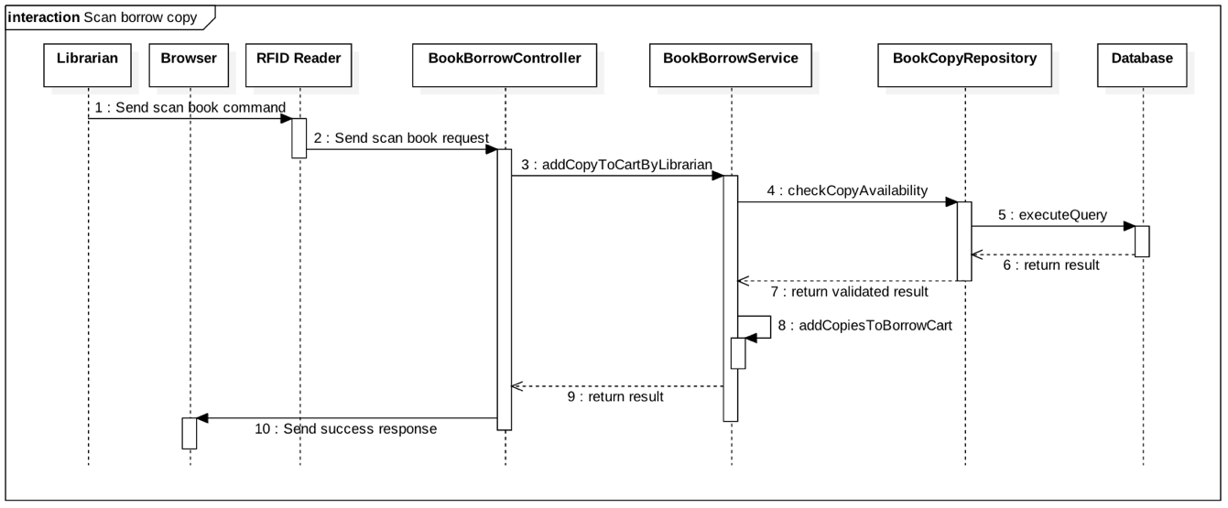Figure 52: <Librarian> Scan borrow copy 117](#_Toc480027528)

[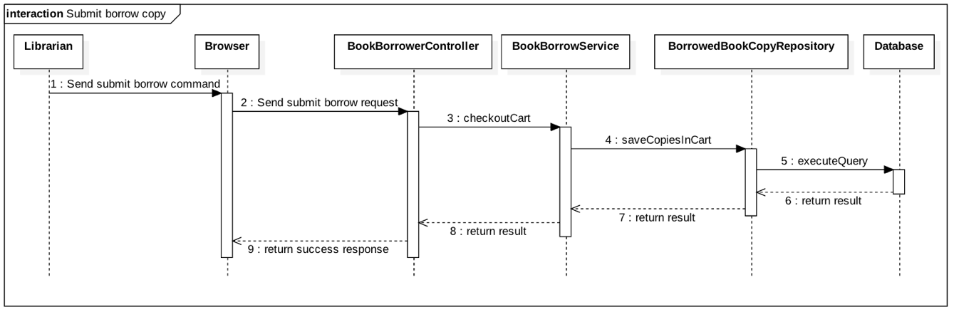Figure 53: <Librarian> Submit borrow copy 118](#_Toc480027529)

[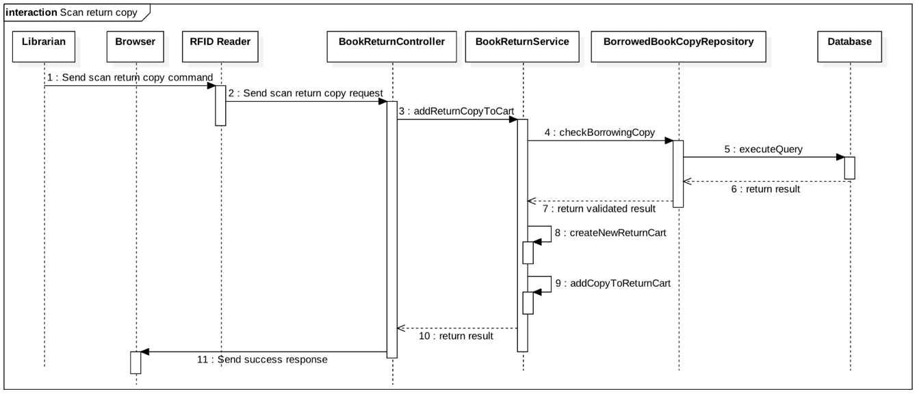Figure 54: <Librarian> Scan return copy 118](#_Toc480027530)

[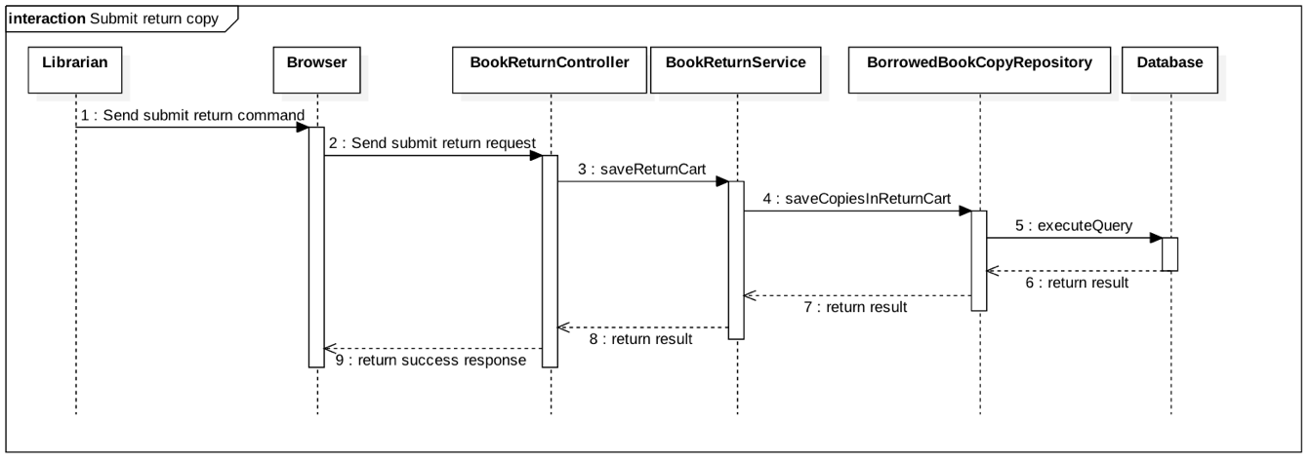Figure 55: <Librarian> Submit return copy 119](#_Toc480027531)

[Figure 56: Mobile application UI - <Unauthorized User> Login 125](#_Toc480027532)

[Figure 57: Mobile application UI - <Authorized User> Home Page 127](#_Toc480027533)

[Figure 58: Mobile application UI - <Authorized User> Taking Picture 129](#_Toc480027534)

[Figure 59: Mobile application UI - <Authorized User> Crop photo 131](#_Toc480027535)

[Figure 60: Mobile application UI - <Authorized User> Choose category 132](#_Toc480027536)

[Figure 61: Mobile application UI - <Authorized User> View search result 134](#_Toc480027537)

[Figure 62: Mobile application UI - <Authorized User> View Product detail 135](#_Toc480027538)

[Figure 63: Mobile application UI - <Authorized User> Choose Product option 137](#_Toc480027539)

[Figure 64: Mobile application UI - <Authorized User> Cart detail 139](#_Toc480027540)

[Figure 65: Mobile application UI - <Authorized User> Check out 141](#_Toc480027541)

[Figure 66: Web application UI - <Admin> Manage Accounts 143](#_Toc480027542)

[Figure 67: Web application UI - <Admin> Create New Account 144](#_Toc480027543)

[Figure 68: Web application UI - <Admin> Get Account Detail 146](#_Toc480027544)

[Figure 69: Web application UI - <Librarian> Get Account Detail 147](#_Toc480027545)

[Figure 70: Web application UI - <Librarian> Borrow Book Copies 149](#_Toc480027546)

[Figure 71: Web application UI - <Librarian> Return Book Copies 150](#_Toc480027547)

[Figure 72: RFID Reader GUI 151](#_Toc480027548)

[Figure 73: Entity Relationship Diagram (ERD) 152](#_Toc480027549)

[Figure 74: Backend Architecture Implementation 171](#_Toc480027550)

# Definitions, Acronyms, and Abbreviations

|  |  |
| --- | --- |
| **Name** | **Definition** |
| JWL | Just Walk Out Library |
| NFC | Near Field Communication |
| RFID | Radio-Frequency IDentification |

# Introduction

## Project Information

* Project name: **Just Walk Out Library**
* Abbreviation: **JWL**
* Product Type: **Web Application & Mobile App**
* Start Date: **January 5th, 2017**
* End Date: **April, 2017**

## Introduction

For a long time, library has been a reliable place for people to study and borrow books. However, almost every library system nowadays still uses a traditional way for their borrowers to obtain books: a borrower has to carry all the books that he/she wants to the librarian, so that the librarian can record which books that the borrower will borrow; after that, the borrower signs in each form to commit that he/she is borrowing those books. Only after these steps, the borrower can take back his/her library card and bring the books home. Because one librarian can only manage one borrower at a time, these traditional steps can be very painful if the library is currently crowded with borrowers.

Therefore, we build a system to help libraries and their borrowers to solve those problems. Applying this system, they will not only save a huge amount of time in book-borrowing process, but they will also have a better way to manage books.

## Current Situation

In order to have a more thorough view on our current situation, we will look into the book-borrowing procedure in the libraries of Ho Chi Minh City University of Social Sciences and Humanities, and FPT University.

### Ho Chi Minh City University of Social Sciences and Humanities library

1. The borrower gives the library’s card/student’s card to the librarian.
2. The borrower receives the locker’s key to put the bag in.
3. The borrower walks into the room.
4. The borrower finds wanted books.
5. The borrower takes wanted books.
6. The borrower fills in the book-borrowing form.
7. The borrower brings the books and the form to the librarian’s desk.
8. The librarian checks the form and records the books.
9. The librarian gives the books to the borrower.
10. The borrower re-checks the books, takes back the bag, returns the locker’s key, and brings the books home.
11. The librarian arranges the book-borrowing forms in a specific order.

Reference: <http://hcmussh.edu.vn/Resources/Docs/SubDomain/lib/TV.QT10.01%20-%20Quy%20trinh%20phuc%20vu%20muon%20tai%20lieu%20ve%20nha.pdf>

### FPT University library

1. The borrower gives the student card to the librarian.
2. The borrower receives the locker key to put the bag in.
3. The borrower walks into the reading room.
4. The borrower finds and takes wanted books.
5. The borrower goes to the librarian to check out.
6. With each book, the student has to fill in a form with the book’s code, and his/her signature.
7. The librarian checks the forms and books.
8. The librarian scans each book’s barcode to record the student’s borrow list. The alarm is turned off for each scanned book.
9. The librarian returns the student’s card to the student.
10. The process finishes. The student can take the books home.

## Problem Definition

Because of current situation, we found that the traditional process has many advantages and disadvantages below:

* Advantages:
* No technical skills needed.
* Disadvantages:
* Borrowing books need to go through complicated steps, thus durring the rush hour, it might take too much time to wait for checking out for both borrowers and librarians.
* The librarian should work very hard when having many borrowers.
* Paper records are hard to manage and easy to be damaged.
* Librarians may forget to remind borrowers about their deadline.
* Borrowers have to memorize the deadline of their borrowing books.
* It is hard for borrowers to know when a wanted book is available.
* All activities that relate to borrowing and returning books are manual.

## Proposed Solution

Our proposed solution is to build a system named Just Walk out Library (JWL), which uses NFC, QR Code, RFID technologies to create a more easily and efficiently book - borrowing process: Borrowers only need to use smartphones to check in the library and borrow books, the system will automatically match and save the right books to the right borrower. Therefore, our solution helps to reduce librarian’s work in book – borrowing process, let them have more time for other tasks. Furthermore, librarians and borrowers can manage the borrowing books better.

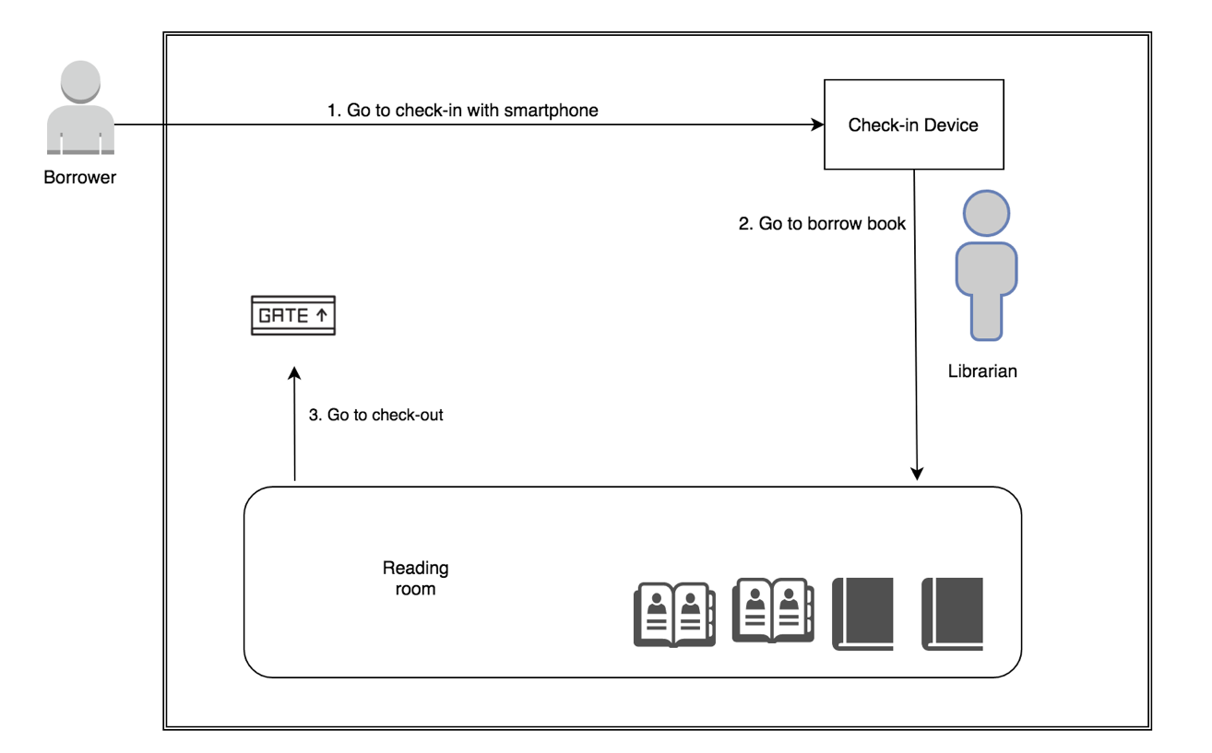

Figure 1: Borrower goes to borrow book

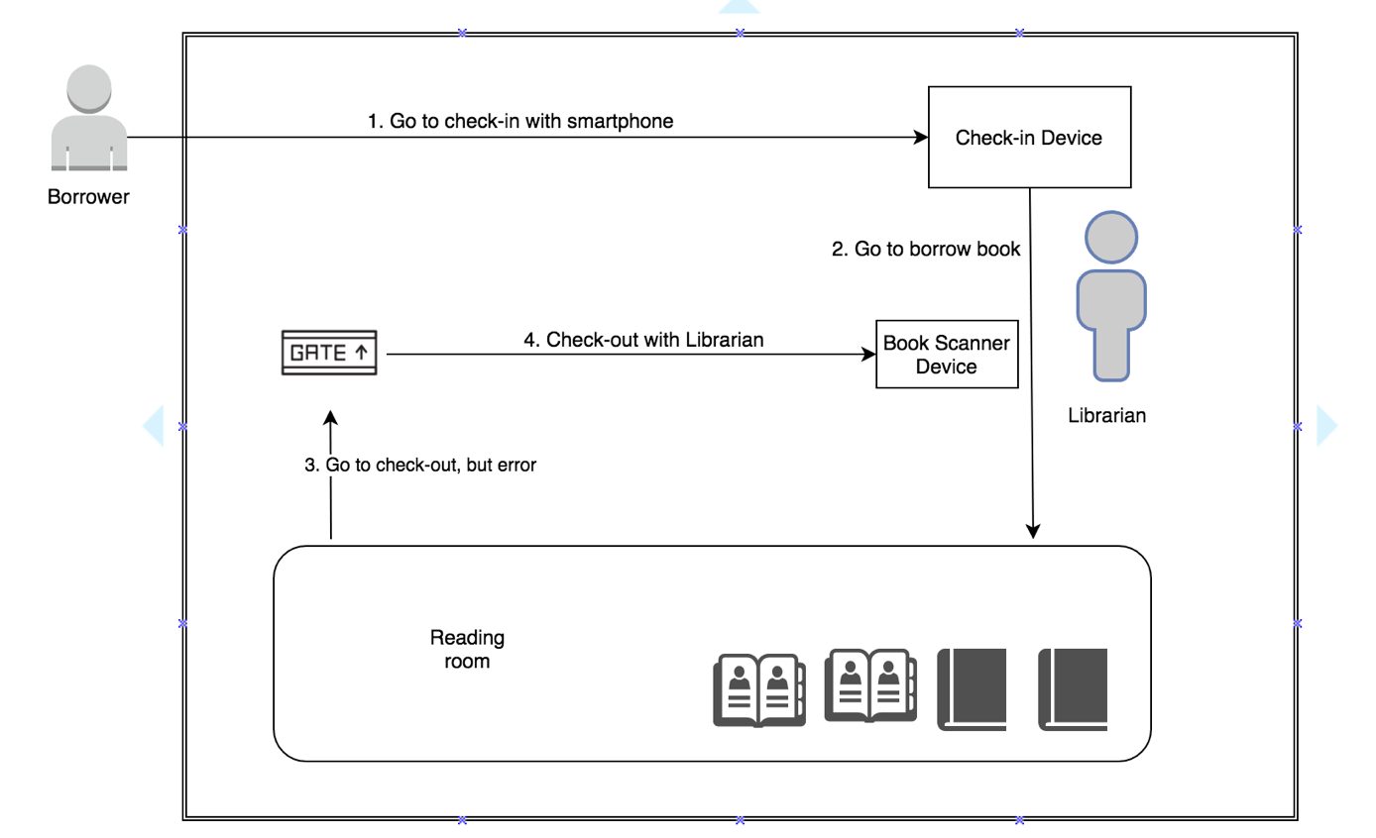

Figure 2: Borrower borrows book with Librarian

### Technologies

* + **NFC (abbreviated from Near Field Communication):** is a form of contactless communication between devices like smartphones or tablets. Contactless communication allows a user to wave the smartphone over an NFC compatible device to send information without needing to touch the devices together or go through multiple steps to set up a connection. NFC utilizes electromagnetic radio fields while technologies such as Bluetooth and Wi-Fi focus on radio transmissions instead. NFC is supported in card or the smartphone (<http://nearfieldcommunication.org/>).
  + **QR code (abbreviated from Quick Response Code):** is the trademark for a type of [matrix barcode](https://en.wikipedia.org/wiki/Matrix_barcode) (or two-dimensional [barcode](https://en.wikipedia.org/wiki/Barcode)) first designed for the [automotive industry in Japan](https://en.wikipedia.org/wiki/Automotive_industry_in_Japan). A barcode is a machine-readable optical label that contains information about the item to which it is attached. A QR code uses four standardized encoding modes (numeric, alphanumeric, byte/binary, and [kanji](https://en.wikipedia.org/wiki/Kanji)) to efficiently store data; extensions may also be used.
  + **RFID (abbreviated from Radio-Frequency Identification):** The acronym refers to small electronic devices that consist of a small chip and an antenna. The chip typically is capable of carrying 2,000 bytes of data or less. The RFID device serves the same purpose as a bar code or a magnetic strip on the back of a credit card or ATM card; it provides a unique identifier for that object. And, just as a bar code or magnetic strip must be scanned to get the information, the RFID device must be scanned to retrieve the identifying information (<http://www.technovelgy.com/ct/technology-article.asp)>.
  + **iBeacon:** They are essentially tiny, low power computers attached to walls or objects in the physical world. Using proximity technologies, they detect human presence and behavior and trigger pre-programmed actions delivering contextual and personalized experiences (<http://estimote.com>).

### Feature Functions

* **Check in:** JWL application supports both NFC and QR Code. To gain permission to the library, a borrower only needs to open the application on his/her phone, and scan it on our check - in device. He/she will be checked in automatically.
* **Borrow books and check out:** the borrower finds all the books he/she needs on the shelves, and carries them out. The RFID Reader Device and the iBeacons at the gate will automatically recognize that borrower and record the list of books he/she borrows.
* **Ring the alarm:** the alarm will go off if someone:
  + - * + Takes the books out without having JWL’s mobile application turned on and a logged in, valid account, or turn off Bluetooth, internet connection.
        + Exceeds the book limit that they can borrow.
        + Does not have enough money to borrow more books.
        + Checks in, or borrows books with invalid account.
* **Search:** a borrower can search for the books they want by title. The search result will show the book (if it is stored in the library) and its availability (if it is still available to be borrowed).
* **Make wish list:** a borrower can mark a book to his/her wish list so as to receive notification when the book is available again.
  + - **Manage borrowing books:** 
      * A librarian can manage borrowing books: get information of the books, their borrowers, and the borrow status (late or not), and confirm returned books from borrowers. A librarian can also help borrowers to borrow books.
      * A borrower can get information of his/her borrowing books, receive notification when a book is near its deadline, and renew a book’s borrow time.
* **Return book:** Librarian return book of borrower by using Book Scanner Device.
* **Renew book:** Extend the deadline of borrowing book’s borrower.

### Advantages and Disadvantages

* + - **Advantages:**
      * Make the book-borrowing process faster and easier.
      * Reduce the management time.
      * Store the borrower’s record at ease and safely.
      * Quickly search for wanted books.
      * Notify borrower when a wanted book is available.
    - **Disadvantages:**
      * + Scanning issues: there maybe cases that make the RFID reader to scan books incorrectly.

## Functional Requirements

* Borrower component:
* Get borrowing/borrowed books.
* Borrow books.
* Get notifications when borrowing books are about to be returned.
* Search books by title.
* Make wish list about an unavailable book, so that borrower can receive notification when the wanted book is back on shelf.
* Renew the borrowing books.
* Librarian component:
* Manage borrowing books: help borrower to borrow or return books.
* Manage borrowers: insert, update, activate, deactivate accounts.
* Tracking books that the borrower are borrowing.
* Search books by title.
* Search borrowers by ID.
* Admin component:
* Admin will have the ability to manage account.
* System component:
* Check-in: the system will check the information of borrower before borrower go to inside library.
* Check-out: the system will check the information of borrower when borrower go to ouside library.
* Scan book: the system will scan the book that has RFID tag/card.
* Notify: the system will notify borrower about the return date, available book, late deadline, recent list book borrowed.

## Role and Responsibility

|  |  |  |  |  |
| --- | --- | --- | --- | --- |
| **No** | **Full Name** | **Role** | **Position** | **Contact** |
| 1 | Kiều Trọng Khánh | Project Librarian | Supervisor | [Khanhkt@fpt.edu.vn](mailto:khanhkt@fpt.edu.vn) |
| 2 | Võ Hồng Hà | Developer | Leader | [Havhse61394@fpt.edu.vn](mailto:Havhse61394@fpt.edu.vn) |
| 3 | Nguyễn Tuấn Anh | Developer | Member | [Anhntse61476@fpt.edu.vn](mailto:Anhntse61476@fpt.edu.vn) |
| 4 | Đặng Nhật Thiên | Developer | Member | [Thiendnse61357@fpt.edu.vn](mailto:Thiendnse61357@fpt.edu.vn) |

Table 1 : Roles and Responsibilities

# Software Project Management Plan

## Problem Definition

### Name of this Capstone Project

* **Official name**: Just Walk Out Library
* **Vietnamese name**: Thư viện mượn sách tự động
* **Abbreviation**: JWL

### Problem Abstract

* We develop JWL system in order to help librarians reduce work overload and give borrowers a much more comfortable experience in acquiring books. The role of this system is to automate the book-borrowing process with the help of RFID, NFC, QR Code, and iBeacon. However, those great technologies could come with below difficulty:
* Those are complicated software and hardware which our team does not have any background knowledge. During the process of doing this research, we spend a good amount of time to study not only the operational principles but also detailed features and requirements. This is our main challenge.

### Project Overview

#### Current Situation

Below are the problems encountered in this project:

* **New technologies:** Our team has no experience in embedded system. Therefore, we need time to do research about each technology, which devices to choose, and how to use them.
* **Traditional habit:** Borrowers have been using traditional way to obtain books for a long time, so libraries should provide proper introduction and assistance for their users to get used to JWL.
* **Devices problem:** RFID/NFC devices may be crashed or damaged after long time using, so backup solution should be prepared and periodically maintenance should be carried out.

#### The Proposed System

* After doing many researches on technology for saving information, we choose RFID, NFC and QR code technologies as these technologies is very capable of resolving the current situations in borrowing book. The basic idea is to use a RFID tag that each tag contains a unique book ID.
* Our system includes four subsystems:
* Mobile application: for borrower, check in emulator.
* Web application: for admin, librarian.
  + API application: to serve API for web application, mobile application and communicate with Emulator application.
  + Emulator application: for check in and scan book.

##### ***Web Application***

For admins:

* + - * Manage accounts (CRUD).

For librarians:

* Manage borrowers (CRUD).
* Deactivate/activate borrowers.

##### ***API Application***

Main functions of backend site include

* Serve formatted data for both web and mobile.
* Communicate with Emulators.
* Communicate with third party service as: Firebase, upload.im.

##### ***Mobile Application***

For borrower:

* Check in user through NFC (or QR Code).
* Get borrower’s information.
* Search books.
* Add books to wish list.
* View list of borrowing books.
* View history about borrowed books.
* View library’s policy.
* Renew books.
* Notify borrow about:
  + Recently borrowed books.
  + Book’s deadline.
  + Available books in borrower’s wish list.

##### ***Emulator Application***

For RFID Reader Gate:

* Reader RFID from scanned books.
* Send data from scanned books to the JWL server.
* Raise alarm when errors occur: robbery, borrowers do not meet requirement to borrow books, or system error.
* Stop alarm manually.

For RFID Reader for Librarian:

* Read RFID from scanned books.
* Send data from scanned books to the JWL server.
* Provide GUI control for librarian to help borrower borrow and return books.

For Check in Device:

* Read NFC/QR Code from mobile application.
* Send read data to JWL server.
* Play sound and show text message result of check in to librarian.

#### Boundaries of the System

* The system should do:
  + Allow borrowers to check in the library by scanning their phone to the Check-in Device of the library.
  + Allow borrowers to check out with their borrowing books by just walking out of the library.
  + Allow borrowers to search wanted books by title.
  + Allow borrowers to add a book to a wish list.
  + Allow librarians to manage borrowers and their borrowing book list.
  + Allow librarians to help borrowers borrow and return books.
  + Allow admins to manage all accounts.
  + Notify borrowers when their borrowing book near to deadline.
  + Notify borrowers when their borrowing book late of deadline.
  + Notify borrowers when their recent borrow books.
  + Allow system to automatic check out borrower with configured time.
* The system should not do:

Our system is not a library management system, therefore, we do not handle any library-related tasks:

* + Do not manage human resource.
  + Do not manage stored books.

#### Future Plans

* With further research and development, the system can apply the following features:
* The system provides more thorough library management.
* The system provides more ways to search books: by category, book type, position, author, and publisher.
* The system separates RFID robbery scanner gate and RFID book scanner gate to provide a more comfortable experience for borrowers.
* The system provides better description when a borrower checks in so that librarian can identify a borrower better.
* Librarian can view the history:
  + When the borrower deposit.
  + When the borrower was penalty.
  + When the borrower renews books.
  + When the borrower returns books.
  + When the borrower borrows books.

#### Development Environment

##### ***Hardware requirements***

* **For server:**

|  |  |  |
| --- | --- | --- |
| Windows | Minimum Requirements | Recommended |
| Internet Connection | Cable, Wi-Fi (4 Mbps) | Cable, Wi-Fi (8 Mbps) |
| Operating System | Window Server 2008 R2 | Window Server 2012 R2 |
| Computer Processor | Intel® Xeon ® 1.4GHz | Intel® Xeon ® Quad Core |
| Computer Memory | 2GB of RAM | 4GB of RAM or more |

Table 2 : Hardware requirement for Server

* **For web application:**

|  |  |  |
| --- | --- | --- |
| Windows | Minimum Requirements | Recommended |
| Internet Connection | Cable, Wi-Fi (4 Mbps) | Cable, Wi-Fi (8 Mbps) |
| Operating System | Window Server 2008 R2 | Window Server 2012 R2 |
| Computer Processor | Intel® Xeon ® 1.4GHz | Intel® Xeon ® Quad Core |
| Computer Memory | 2GB of RAM | 4GB of RAM or more |

Table 3: Hardware requirement for Web

* **For mobile application:**

|  |  |  |
| --- | --- | --- |
| Android | Minimum | Recommended |
| Internet Connection | Wi-Fi or 3G (1 Mbps) | Wi-Fi or 3G (8 Mbps) |
| Operating System | Android 4.4.2 | Android 5.0.0 |
| Mobile Processor | Cortex-A7 Dual-Core 1.3GHz | Cortex-A7 Dual-Core 1.3GHz |
| Mobile Memory | 1GB of RAM | 2GB of RAM or more |
| Mobile Feature | NFC, Bluetooth 4.0, Camera supporting, Google play service version more than 7.0 | NFC, Bluetooth 4.0, Camera supporting, Google play service version more than 7.0 |

Table 4 : Hardware requirement for Mobile

* **For RFID Emulator:**

RFID Emulator consists of 2 part: RFID Reader and Arduino Emulator.

* + Arduino Emulator: we use laptop computer as Arduino Emulator.
  + RFID Reader: RFID module, UART converter, RFID tag/card.

|  |  |
| --- | --- |
| Arduino Emulator | Requirement |
| Communication | Wi-fi, USB, cable |
| Development Language | Python |

Table 5: Hardware requirement for Arduino Emulator

* **Module RFID**

**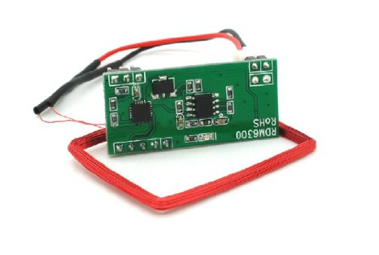**

Figure 3: RFID Module Reader

|  |  |
| --- | --- |
| RFID Module | Information |
| Module | RDM6300 |
| Frequency | 125 kHz |
| Baud Rate | 9600 |
| Interface Type | TTL Level RS232 format |
| Operating Voltage | DC 5V |
| Operating Current | >50mA |
| Reception Range | 20~50mm (depending on the antenna, the card and the surroundings) |

Table 6: Hardware requirement for RFID reader

*Reference:* [*http://www.dientubachviet.vn/498-rfid-rdm6300-125khz-uart-output.html*](http://www.dientubachviet.vn/498-rfid-rdm6300-125khz-uart-output.html)

* **UART converter**

**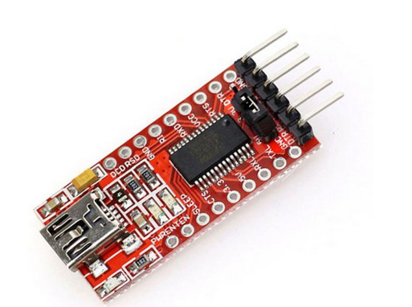**

Figure 4: UART Converter

|  |  |
| --- | --- |
| RFID Converter | Information |
| Main IC | FT232RL from FTDI |
| Baud Rate | Custom |
| Description | Convert from UART TTL to USB |
| Operating Voltage | 5VDC from USB |

Table 7: Hardware requirement for RFID converter

*Reference:* [*http://hshop.vn/products/mach-chuyen-usb-uart-ft232rl*](http://hshop.vn/products/mach-chuyen-usb-uart-ft232rl)

* **RFID tag/card**

**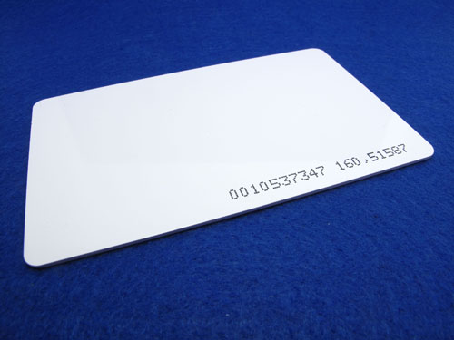**

Figure 5: RFID tag/card

|  |  |
| --- | --- |
| RFID Tag/Card | Information |
| Protocol | EM4100 |
| Operating Frequency | 125 kHz |
| Read Distance | Maximum to 10cm |
| Unique ID | 32 bit |
| Weigth | 8g |

Table 8 : Hardware requirement for tag/card

*Reference:*[*http://hshop.vn/products/the-trang-rfid-125khz*](http://hshop.vn/products/the-trang-rfid-125khz)

* **For Estimote Beacon:**

**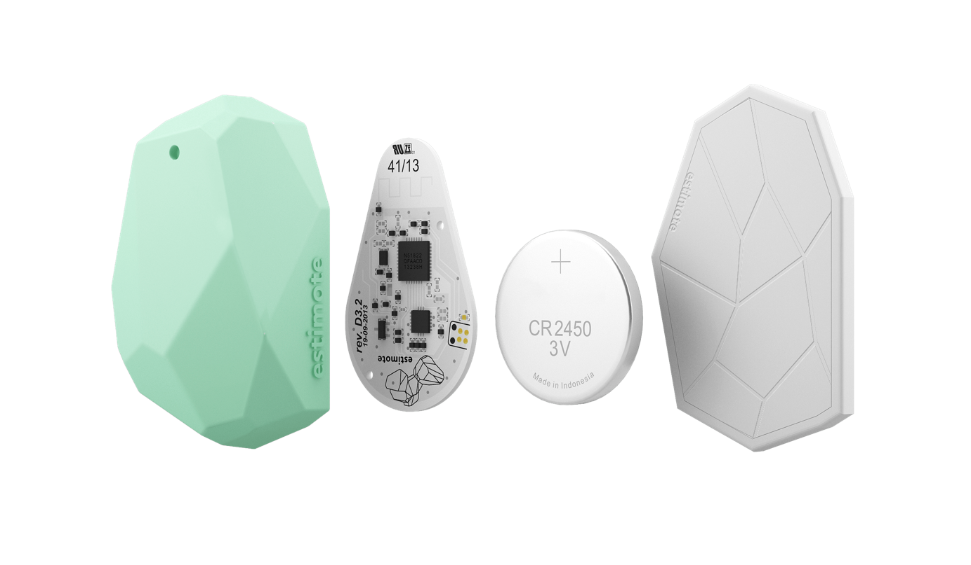**

Figure 6: Estimote Beacon

iBeacon™ is a communication protocol developed by Apple on top of Bluetooth Smart technology. It allows developers to create mobile apps aware of location context provided by beacons. Estimote Beacons are compatible with iBeacon.

|  |  |
| --- | --- |
| iBeacon | Information |
| Name | Estimote Proximity Beacon |
| Protocol | Bluetooth Low Energy |
| Range | Maximum to 70m |
| Lifetime | 2 years |
| Weigth | 31g |

Table 9: iBeacon

*Reference:* [*http://estimote.com/*](http://estimote.com/)

##### ***Software requirements***

|  |  |  |
| --- | --- | --- |
| Software | Name / Version | Description |
| Operating system | Window 7 / MacOS Sierra | Operating system and platform for development. |
| Environment | JDK version 1.8.0 update 101 | Specification for developing web application. |
| IDE | IntelliJ IDE 2016.3.2, Android Studio v2.2.3, Webstorm 2017.1, Sublime 3 | Use to implement website, server, Android mobile app and emulator. |
| Design Model tool | StartUML v2.5.1 | Use to create modal and diagrams. |
| DBMS | PostgreSQL 9.4 | Use to create & manage the database for system. |
| Document storage | Github | Use to store document. |
| Store and manage source code | Github & SourceTree | Use to store all source code. |
| Web browser | Chrome 42 or above | Testing browser. |

Table 10 : Software requirements

## Project organization



### Software Process Model

This project is developed using Scrum Model. This model is appropriate under consideration of 3 following reasons:

* Those technologies used in this project (RFID, NFC, iBeacon, and QR Code) require much attention in studying. This takes time to concentrate on technologies understanding, we plan to apply them gradually to the system.
* Prototypes are delivered frequently for evaluation.
* Team members can involve more in the development process.



Figure 7 : Scrum model

Reference: <http://skytechnovation.com/scrum-development-model/>

### Roles and responsibilities

|  |  |  |  |
| --- | --- | --- | --- |
| No | Full name | Role in Group | Responsibilities |
| 1 | Kiều Trọng Khánh | Product owner, Project Manager | * Specify user requirements * Control the development process   Provide technical and business analysis support |
| 2 | Võ Hồng Hà | Scrum leader, B.A, Developer, Tester | * Manage process * Prepare and combine documents * Design database * Clarify requirements * GUI design * Create test plan * Code * Test |
| 3 | Nguyễn Tuấn Anh | Team member,  B.A, Developer,  Tester | * Design database * Clarify requirements * Prepare documents * GUI design * Create test plan * Code * Test |
| 4 | Đặng Nhật Thiên | Team member,  B.A, Developer,  Tester | * Design database * Clarify requirements * Prepare documents * GUI design * Create test plan * Code * Test |

Table 11 : Roles and responsibilities

### Tools and Techniques

|  |  |  |
| --- | --- | --- |
|  | Tool | Techniques |
| Front-end | Webstorm | * HTML5 * CSS3 * ES6 * NodeJS * ReactJS |
| Back-end | IntelliJ | * RESTFul * JSON * Spring * Java * PostgresSQL |
| Web server | Heroku | N/A |
| Mobile application | Android Studio | * Java 8 * Android SDK |
| Arduino Emulator | Sublime | Python |
| Database management system | PgAdmin | N/A |

Table 12: Tools and Techniques

## Project Management Plan



### Software development life cycle

|  |  |  |  |  |  |
| --- | --- | --- | --- | --- | --- |
| Phase | Description | Deliverables | Resource needed | Dependencies and Constrains | Risks |
| Infrastructure | - Identify and clarify overall requirements.  - Determine the system architecture.  - Build infrastructure for the project. | - Database design.  - System main structure. | 20 man-days |  | - Unclear project scope.  - Lack of member share of understand. |
| System  &  Web admin | - Identify software and hardware requirements.  - Implements all web admin modules.  - Design the web UI  - Build the web admin | - Complete web admin for all roles of the system. | 60 man-days | - Depends on “Infrastructure” | - Unclear project scope.  - Lack of experience. |
| Web services | - Identify requirements for mobile app.  - Build required API for mobile app. | - API for mobile app. | 20 man-days | - Depends on “Web admin & System” | - Lack of experience. |
| Mobile apps | - Design the mobile UI  - Build mobile apps for end users and emulator. | - Complete Android Apps | 20 man-days | - Depends on “Web services” | - Lack of experience.  - Lack of RFID, NFC knowledge |

Table 13: Software Development Life Cycle Detail

### Phase Detail

#### Phase 1: Infrastructure (3/1/2017 – 17/1/2017)

|  |  |  |
| --- | --- | --- |
| Task | Description | Author |
| 1. Assessment | - Determine requirements.  - Create product backlog. | * HaVH * AnhNT * ThienDN |
| 2. Selection | - Determine system architecture: Spring Boot.  - Determine software design pattern: Repository & Service.  - Determine all core functions. | * HaVH * AnhNT * ThienDN |
| 3. Development | - Create the main structure of project. | * HaVH * AnhNT * ThienDN |
| 4. Review | - Review all completed works and presentation.  - Create sprint backlog. | * HaVH * AnhNT * ThienDN |

Table 14: Phase 1 - Infrastructure

#### Phase 2: System & Web app (18/1/2017 – 20/1/2017; 31/1/2017 – 28/2/2017)

|  |  |  |
| --- | --- | --- |
| Task | Description | Author |
| 1. Assessment | - Determine requirements for System and Web app.  - Update product backlog. | * HaVH * AnhNT * ThienDN |
| 2. Selection | - Determine all functions according to requirements of System and Web app. | * HaVH * AnhNT * ThienDN |
| 3. Development | - Design and build prototype for web UI  - Create conceptual diagram  - Design class diagram  - Design database  - Implement the entire web UI: layouts, detail pages, etc.  - Implement all the functions in controllers.  - Build needed utility classes | * HaVH * AnhNT * ThienDN |
| 4. Review | - Review all completed works and presentation.  - Create sprint backlog. | * HaVH * AnhNT * ThienDN |

Table 15: Phase 2 - System & Web Application

#### Phase 3: Web service (11/2/2017 – 15/4/2017)

|  |  |  |
| --- | --- | --- |
| Task | Description | Author |
| 1. Assessment | - Determine requirements for Web service.  - Update product backlog. | * HaVH * AnhNT * ThienDN |
| 2. Selection | - Determine all functions according to requirements of Web service. | * HaVH * AnhNT * ThienDN |
| 3. Development | - Create API for mobile app based on functions on the web app. | * HaVH * AnhNT * ThienDN |
| 4. Review | - Review all completed works and presentation.  - Create sprint backlog. | * HaVH * AnhNT * ThienDN |

Table 16: Phase 3: Web service

#### Phase 4: Mobile app (11/2/2017 – 15/4/2017)

|  |  |  |
| --- | --- | --- |
| Task | Description | Author |
| 1. Assessment | - Determine requirements for System and Mobile app.  - Update product backlog. | * HaVH * AnhNT * ThienDN |
| 2. Selection | - Determine all functions according to requirements of Mobile app. | * HaVH * AnhNT * ThienDN |
| 3. Development | - Implement all the functions based on the designed UI and the provided API. | * HaVH * AnhNT * ThienDN |
| 4. Review | - Review all completed works and presentation.  - Create sprint backlog. | * HaVH * AnhNT * ThienDN |

Table 17: Phase 4 - Mobile Application

### All Meeting Minutes

* All meeting documents could be found [here](https://github.com/kyokid/JWL/tree/master/Documents/Meeting_Minutes).

## 

## Coding Convention

* **Java:** Using for develop android and web service.
  + Naming Convention:
* Use **camel-case** style for variables and functions name (Lowercase for firs letter).
* Use **pascal-case** for classes (Uppercase for first letter).
  + Indentation:
* Use four **spaces** per indentation level.
* User eight **spaces** to continue indent.
* Use **“;”** for separate statements and expressions.
* Classes:
* Classes should be declared using **class** keyword.
* Using **public, private, protected** to declare protection level of instance variable and function.
* Use **this** to refer current class instance.
* **Python:** Using for develop Arduino Emulator
* Naming Convention:
* Use **camel-case** style for variables and functions name (Lowercase for firs letter)
* For function name, class name, use Pascal case. Eg: AddIncome, AddExpense…
* For resource file names are written in lowercase\_underscore. Eg: my\_name
  + Indentation:
* Use four spaces per indentation level.
* Do not use “;” for separate statements and expressions.
* Avoid single-line method.
* Classes:
* Put underscore before name for private instance variables.
* Use **self** to refer current class instance.
* **JavaScript (ES6):** Using for frontend website
* Naming convention:
* Use **camel-case** style for variables and functions name (Lowercase for firs letter)
* Use **camel-case** for classes (Uppercase for first letter)
* Indentation:
* Use two **spaces** per indentation level
* Do not use **“;”** for separate statements and expressions (ES6)
* Avoid **single-line** method
* Classes:
* Classes should be declared using **class** keyword for ES6. Using **function** to declares classes in ES6 is bad
* Use **constructor** function for initialize a class
* Use **export** and **import** to reuse modules
* Use **this** to refer current class instance
* **Reference**:
* [1] Python: <https://www.python.org/dev/peps/pep-0008/>
* [2] ES6: <https://github.com/elierotenberg/coding-styles/blob/master/es6.md>
* [3] Java: <http://www.oracle.com/technetwork/java/codeconvtoc-136057.html>

# Software Requirement Specification

## User Requirement Specification

### Unauthorized User Requirement

Unauthorized User is the user who has not logged into this system. Unauthorized User only has one functions.

* Login.

### Authorized User Requirement

Authorized User is the user who has logged into system. Authorized User has two common functions.

* Get profile detail.
* Edit profile.
* Logout.

### Borrower Requirement

* Borrower is the user who goes to the library to search for books. They can either read books at the library or borrow them home. Therefore, their main functions in the system are:
  + Check in.
  + Check out.
  + Borrow books.
* Add books to wish list.
* Search books.
* Get borrowing list.
* Get history of borrowed list.
* Get library policy.
* Renew book.

### Librarian Requirement

* Librarian is the user who manages the library. They have the following functions:
* Manage borrowers: (Optional usecase to simulate the library)
  + - * Add borrowers.
      * Update borrowers.
      * Activate/Deactivate borrowers.
* Manage books: (Optional usecase to simulate the library)
  + - * Add new books.
      * Update books.
      * Delete books.
* Check out borrowers.
* Get borrowing book list.
* Search books.
* Return books.

### Admin Requirement

* Admin is the user who is responsible for managing accounts for the whole system, has the following function:
* Get accounts.
* Manage accounts: (Optional usecase to simulate the library)
  + - * Create account.
      * Update account.
      * Delete account.

### Automatic Handler Requirement

* Automatic Handler is an intermediate system service which facilitates the flow of the whole system by automating the following functions:
  + Check in borrower by QR Code.
  + Check in borrower by NFC.
  + Record borrowers and their borrowing books.
  + Check out borrowers.
  + Push notification to borrowers.

### 1.7 Emulator Requirement

#### 1.7.1 RFID Reader Emulator

* RFID Reader Emulator is the device which can scan RFID tag/card on each book, has the following function:
* Read books’ rfids.
* Call apis and send data to server.

#### 1.7.2 Check in Emulator

* Check in Emulator is the device which can read NFC/QR Code on the mobile application, has the following function:
* Read NFC/QR Code.
* Call check in api and send data to server.

## System Requirement Specification

### External Interface Requirement

#### User Interface

* The user interface uses Vietnamese for mobile application and English for web application.
* The user interface displays best on 1280x768 resolutions on desktop, and 1080x1920 on mobile.

#### Hardware Interface

* Smartphone with:
  + - * BLE support (Bluetooth 4.0).
      * NFC support.
* RFID Reader and tags use 125 kHz.
* Estimate Beacon.

#### Software Interface

* + Mobile application : Android OS version 4.4 (or 5.0).
  + Estimate cloud for manage ibeacons.
  + Estimate SDK for connect between mobile application and ibeacons.

#### Communication Protocol

* + Use HTTP 1.1 to communicate between the web application and the API application.
  + Use HTTP 1.1 to communicate between the mobile application and the API application.
  + Use BLE protocol for communication between the mobile application and the Estimate ibeacons.
  + Use NFC protocol for communication between the mobile application and the emulator for check in.
  + Use RFID protocol with low frequency (125kHz) for communication between RFID tags/cards and RFID reader.

### System Overview Use Case

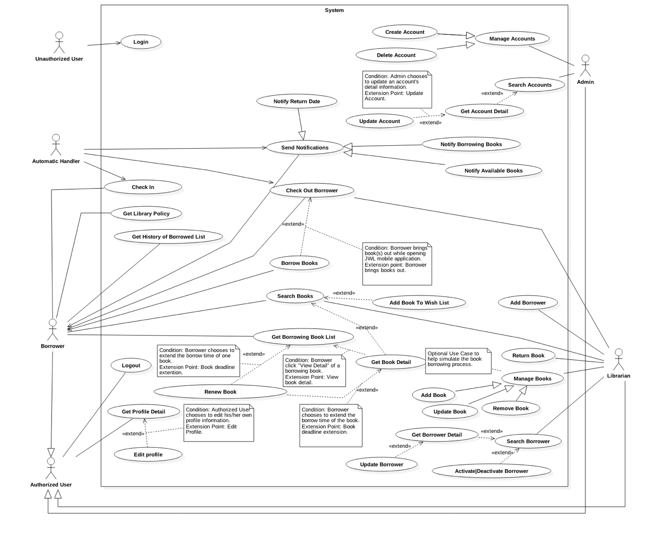

Figure 8 <Use Case> System overview

### List of Use Case

#### <Unauthorized User> Overview use case



Figure 9: <Unauthorized User> Overview Use Case

##### 2.3.1.1 <Unauthorized User> Login



Figure 10: <Unauthorized User> Login

|  |  |  |  |
| --- | --- | --- | --- |
| **USE CASE – JWL01** | | | |
| **Use Case No.** | JWL01 | **Use Case Version** | 1.0 |
| **Use Case Name** | Login | | |
| **Author** | Nguyen Tuan Anh | | |
| **Date** | February 15, 2017 | **Priority** | Normal |
| **Actor:**   * Unauthorized User.   **Summary:**   * This use case allows Unauthorized User to log into the system with a specific role.   **Goal:**   * Authenticate user, redirect user to a specific view based on the user’s role.   **Triggers:**   * Unauthorized User sends “Login” command.   **Preconditions:** N/A  **Post Conditions:**   * **Success:** Unauthorized User is logged into the system as Authorized User. * **Fail:** N/A   **Main Success Scenario:**   |  |  |  | | --- | --- | --- | | Step | Actor Action | System Response | | 1 | Unauthorized User inputs user ID and password.  [Alternative 1] |  | | 2 | Unauthorized User sends “Login” command. | Unauthorized User will be logged into System with their specific role.  The system redirects to the role’s view. |   **Alternative Scenario:**   |  |  |  | | --- | --- | --- | | No. | Actor Action | System Response | | 1 | | Unauthorized user   * Leaves the user ID and password field empty, or * Inputs wrong user ID or password | System displays the error message: “Your user ID or password is invalid.” / “Sai userID hoặc password.” |   **Exception:** N/A  **Relationships:** This use case will be extended by all other use cases, depending on the Actor’s role in the system.  **Business Rules:**   * System authenticates Actor by checking the user ID and password. * Actor enters password in a free text field which hides the password. * Actor’s password must be encrypted before sending to server. * After logged in to the system, the Actor will be redirected to a specific view:   For web view:   * If the role is “Admin”, the system will display Admin view. * If the role is “Librarian”, the system will display Librarian view.   For mobile application view:  + If the role is “Borrower”, the system will display the mobile application’s view. | | | |

Table 18: <Unauthorized User> Login

#### <Authorized User> Overview Use Case

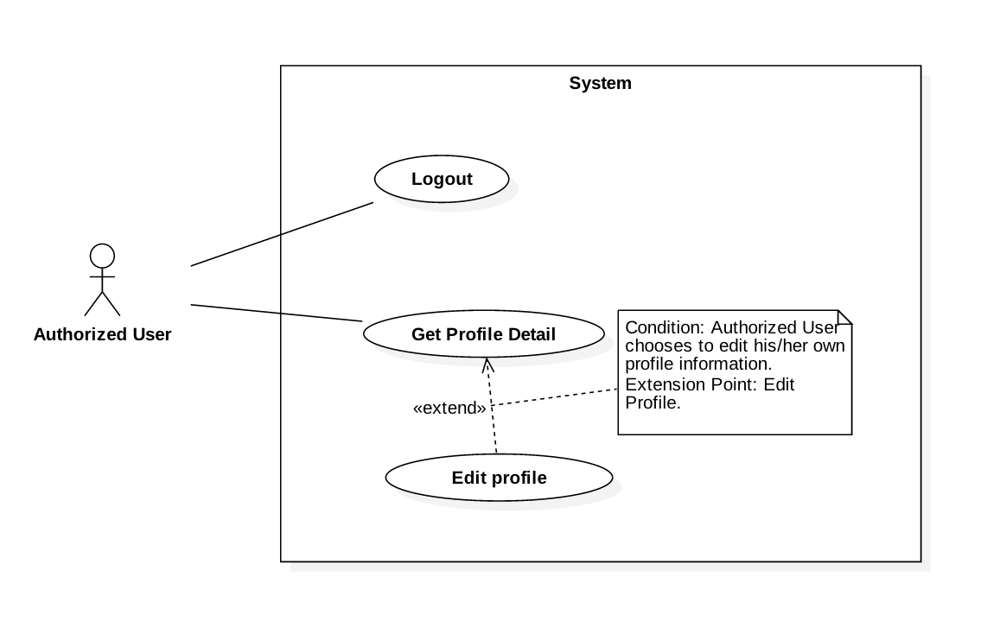

Figure 11: <Authorized User> Overview Use Case

##### <Authorized User> Get Profile Detail



Figure 12: <Authorized User> Get Profile Detail

|  |  |  |  |
| --- | --- | --- | --- |
| **USE CASE – JWL02** | | | |
| **Use Case No.** | JWL02 | **Use Case Version** | 1.0 |
| **Use Case Name** | Get Profile Detail | | |
| **Author** | Nguyen Tuan Anh | | |
| **Date** | February 20, 2017 | **Priority** | Normal |
| **Actor:**   * Authorized User.   **Summary:**  This use case allows an Actor to view his/her profile detail information, including:   * + - * User image       * User ID       * Full name       * Date of Birth       * Email       * Address       * Phone number       * Place of Work       * User Role       * Total Balance   **Goal:**   * The System shows the Actor his/her profile detail information.   **Triggers:**   * The Actor sends “Get Profile Detail” command.   **Preconditions:**   * The Actor logged into the system.   **Post Conditions:**   * **Success:** The System shows the Actor his/her profile detail information. * **Fail:** N/A.   **Main Success Scenario:**   |  |  |  | | --- | --- | --- | | Step | Actor Action | System Response | | 1 | Actor sends “Get Profile Detail”. | System shows the Actor his/her profile detail information:   * “User image”: image * “User ID”: label * “Full name”: label * “Date of Birth”: label * “Email”: label * “Address”: label * “Phone number”: label * “Place of Work”: label * “User Role”: label |   **Alternative Scenario:** N/A  **Exceptions:** N/A  **Relationships:** Extend Edit Profile: From this use case, an Actor can Edit Profile.  **Business Rules:**   * This use case only allows an Actor to get his/her own detail information. | | | |

Table 19: <Authorized User> Get Profile Detail

##### <Authorized User> Logout



Figure 13: <Authorized User> Logout

|  |  |  |  |
| --- | --- | --- | --- |
| **USE CASE – JWL03** | | | |
| **Use Case No.** | JWL03 | **Use Case Version** | 1.0 |
| **Use Case Name** | Logout | | |
| **Author** | Nguyen Tuan Anh | | |
| **Date** | February 15, 2017 | **Priority** | Normal |
| **Actor:**   * Authorized User.   **Summary:**   * This use case allows Authorized User to log out the system and become an Unauthorized User.   **Goal:**   * Invalidate the Authorized User, redirect the User to login view.   **Triggers:**   * Authorized User sends “Logout” command.   **Preconditions:**   * Actor logged in the system as an Authorized User.   **Post Conditions:**   * **Success:** Authorized User is logged out the system and becomes Unauthorized User. * **Fail:** N/A   **Main Success Scenario:**   |  |  |  | | --- | --- | --- | | Step | Actor Action | System Response | | 1 | Authorized User sends “Logout” command. | System redirects the User to login view. |   **Alternative Scenario:** N/A  **Exceptions:** N/A  **Relationships:** N/A  **Business Rules:**   * After the Actor logs out, the system destroy Actor’s session and redirect to login page. | | | |

Table 20: <Authorized User> Logout

##### <Authorized User> Edit Profile



Figure 14: <Authorized User> Edit Profile

|  |  |  |  |
| --- | --- | --- | --- |
| **USE CASE – JWL04** | | | |
| **Use Case No.** | JWL04 | **Use Case Version** | 1.0 |
| **Use Case Name** | Edit Profile | | |
| **Author** | Nguyen Tuan Anh | | |
| **Date** | February 16, 2017 | **Priority** | Normal |
| **Actor:**   * Authorized User.   **Summary:**  This use case allows an Actor to edit his/her personal information, including:   * + - * Full name       * Password       * Email       * Address       * Date of birth       * Phone number       * Place of work   **Goal:**   * Update the Actor’s personal information according to the Actor’s input.   **Triggers:**   * The Actor sends “Edit Profile” command.   **Preconditions:**   * The Actor must be logged into the System.   **Post Conditions:**   * **Success:** The Actor’s personal information is updated in the database. * **Fail:** System displays error messages according to fail reasons (see table **Exception**).   **Main Success Scenario:**   |  |  |  | | --- | --- | --- | | Step | Actor Action | System Response | | 1 | Actor sends “Edit Profile” command. | System lists out the information of the account:   * “Full name”: free text input * “Password”: free text input that hides user’s password * “Confirm Password”: free text input that hides users’ confirm password * “Date of Birth”: free text input that allows Actor to input day - month - year * “Email”: free text input * “Address”: free text input * “Phone number”: free text input * “Place of Work”: free text input | | 2 | Actor updates information. |  | | 3 | Actor sends Submit command. | * System validates the inputs then updates the account’s profile. * System redirect the Actor to the Get Profile Detail’s view. * System displays a successful message: “Update Successfully.”   [Exception 1, 2, 3, 4, 5, 6, 7] |   **Alternative Scenario:** N/A  **Exception:**   |  |  |  | | --- | --- | --- | | No | Cause | System Response | | 1 | Actor inputs Full Name field with the following wrong format:   * Blank, or all space characters * Longer than 100 characters. | System displays error messages:   * “Full name is required.” * “Full name must not be longer than 100 characters.” | | 2 | Actor inputs Password field with the following wrong format:   * Blank, or all space characters * Shorter than 6 characters * Longer than 50 characters | System displays error messages:   * “Password is required.” * “Password’s length is 6-50 characters.” | | 3 | Actor inputs Confirm Password field that does not match Password field. | System displays error message: “Confirm Password must match Password.” | | 4 | Actor inputs Email field with the following wrong format:   * Blank, or all space characters * Wrong email format (email format: [user.name]@[email.name]). | System displays error messages:   * “Email is required.” * “Wrong Email format. Please input something like your.name@mail.com” | | 5 | Actor inputs Address field with the following wrong format:   * Blank or all space characters * Longer than 250 characters | System displays error messages:   * “Address is required.” * “Address must not be longer than 250 characters.” | | 6 | Actor inputs Phone Number field with the following wrong format:   * Blank or all space characters * Wrong phone number format | System display error messages:   * “Phone Number is required.” * “Phone Number should be like +841692536224 or 01692536224.” | | 7 | Actor inputs Place of Work field with the following wrong format:   * Blank or all space characters * Longer than 100 characters | System displays error message:   * “Place of Work is required.” * “Place of Work must not be longer than 100 characters.” |   **Relationships:** Extend from Get Profile Detail: Actor can only Edit Profile from Get Profile Detail.  **Business Rules:**   * Actor’s information must not be blank. * Full name’s and place of work’s length must not be longer than 100 characters. * Password’s length is 6-50 characters. * Confirm password must match input password. * Email must be in format: [user.name]@[email.name]. * Phone number must be in format: +[phone no.] or [phone no.] * Address’s length must not be longer than 250 characters. * Password and Confirm Password must be encrypted before saving to the system. * Actor cannot update username, or user role. * This use case only allows an Actor to update his/her own profile information. | | | |

Table 21: <Authorized User> Edit Profile

#### <Admin> Overview Use Case

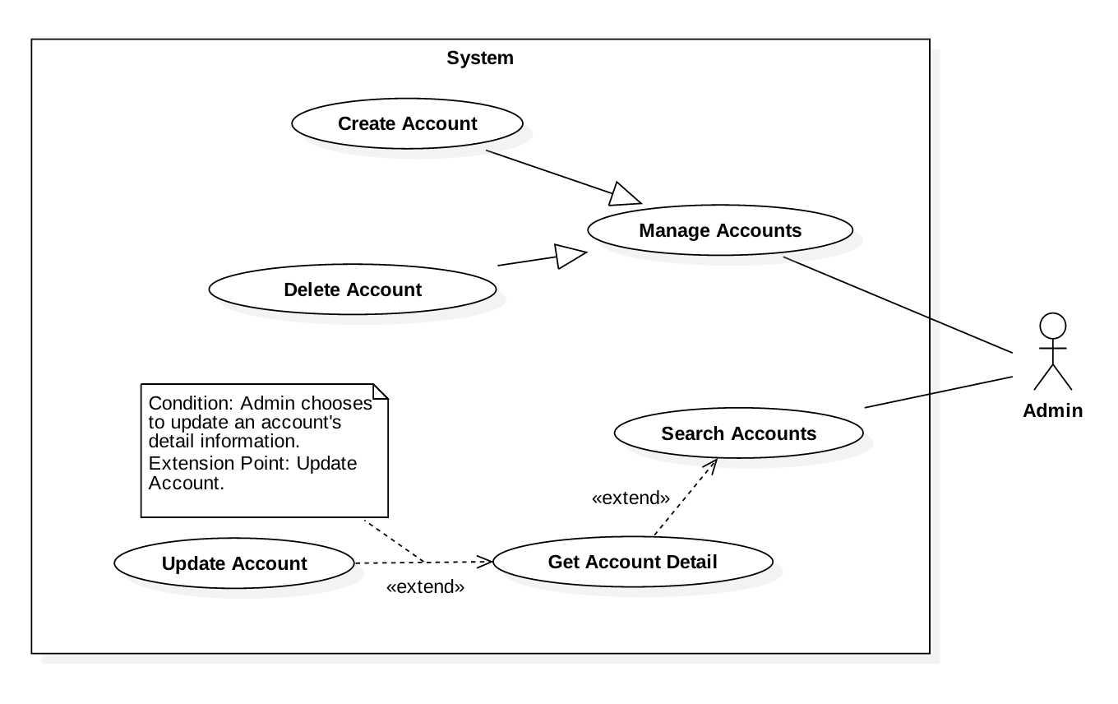

Figure 15: <Admin> Overview Use Case

##### <Admin> Create Account

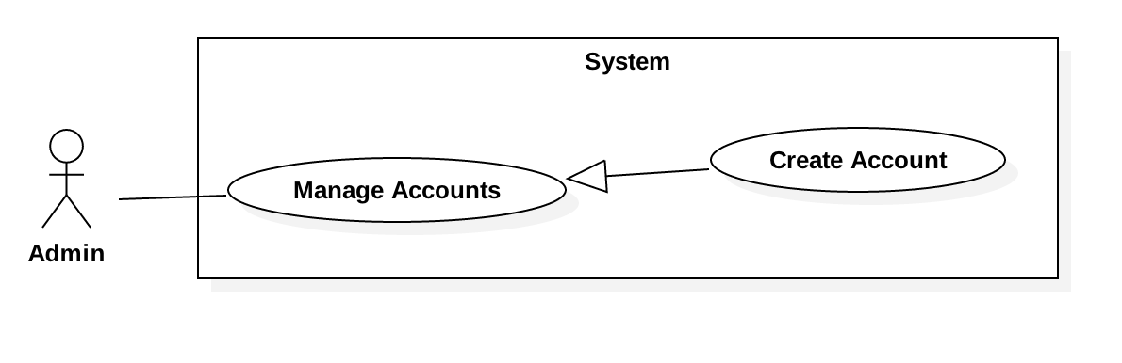

Figure 16: <Admin> Create Account

|  |  |  |  |
| --- | --- | --- | --- |
| **USE CASE – JWL05** | | | |
| **Use Case No.** | JWL05 | **Use Case Version** | 1.0 |
| **Use Case Name** | Create Account | | |
| **Author** | Nguyen Tuan Anh | | |
| **Date** | February 16, 2017 | **Priority** | Normal |
| **Actor:**   * Admin   **Summary:**   * This use case allows Admin to create an account for the System. The new account can be a Borrower, a Librarian, or an Admin.   **Goal:**   * A new account is added to the System.   **Triggers:**   * Admin sends “Create Account” command.   **Preconditions:**   * Actor logged into the system with role Admin.   **Post Conditions:**   * **Success:** A new account with input information is added to the System’s database. * **Fail:** System displays error messages showing fail reasons (see table **Exception**).   **Main Success Scenario:**   |  |  |  | | --- | --- | --- | | Step | Actor Action | System Response | | 1 | Admin sends “Create Account” command. | System lists out the information of the new account:   * “User ID”: free text input * “Full name”: free text input * “Password”: free text input that hides the input password * “Confirm Password”: free text input that hides the input password * “Date of Birth”: free text input that allows Admin to input day - month - year * “Email”: free text input * “Address”: free text input * “Phone number”: free text input * “Place of Work”: free text input * “User Role”: list that allows Admin to choose one of the system role in the list: Admin, Librarian, Borrower | | 2 | Admin inputs the information. |  | | 3 | Admin sends “Submit” command. | * System validates the input then create a new account. * System displays a successful message: “New Account for [User ID, Full name] is added.” * System clears all the free text inputs in the Create Account view.   [Exception 1, 2, 3, 4, 5, 6, 7, 8, 9] |   **Alternative Scenario:** N/A  **Exceptions:**   |  |  |  | | --- | --- | --- | | No | Cause | System Response | | 1 | Admin inputs User ID field with the following wrong format:   * Blank, or all space characters * Shorter than 6 characters. * Longer than 15 characters. | System displays error messages:   * “User ID is required.” * “User ID’s length must be 6-15 characters.” | | 2 | Admin inputs Full Name field with the following wrong format:   * Blank, or all space characters * Longer than 100 characters. | System displays error messages:   * “Full name is required.” * “Full name must not be longer than 100 characters.” | | 3 | Admin inputs Password field with the following wrong format:   * Blank, or all space characters * Shorter than 6 characters * Longer than 50 characters | System displays error messages:   * “Password is required.” * “Password’s length is 6-50 characters.” | | 4 | Admin inputs Email field with the following wrong format:   * Blank, or all space characters. * Wrong email format (email format: [user.name]@[email.name]). | System displays error messages:   * “Email Address is required.” * “Wrong email format. Please input something like your.name@mail.com”. | | 5 | Admin inputs Address field with the following wrong format:   * Blank or all space characters * Longer than 250 characters | System displays error messages:   * “Address is required.” * “Address must not be longer than 250 characters.” | | 6 | Admin inputs Phone Number field with the following wrong format:   * Blank or all space characters * Wrong phone number format. | System display error messages:   * “Phone Number is required.” * “Phone Number should be like +841692536224 or 01692536224.” | | 7 | Admin inputs Place of Work field with the following wrong format:   * Blank or all space characters * Longer than 100 characters | System displays error message:   * “Place of Work is required.” * “Place of Work must not be longer than 100 characters.” | | 8 | User ID already exists. | System displays error message: “User ID already exists.” |   **Relationships:** N/A  **Business Rules:**   * System check for the Actor’s role: only role Admin can create a new account. * System check for existing User ID before trying to create a new account. * User’s information must not be blank. * User ID length is 6-100 characters. * Full name’s and place of work’s length must not be longer than 100 characters. * Password must be encrypted before saving to the system. * Password’s length is 6-50 characters. * Email must be in format: [user.name]@[mail.name]. * Phone number must be in format: +[phone no.] or [phone no.] * Address’s length must not be longer than 250 characters. * Newly created Account has ‘activated’ status. | | | |

##### <Admin> Get Accont Detail

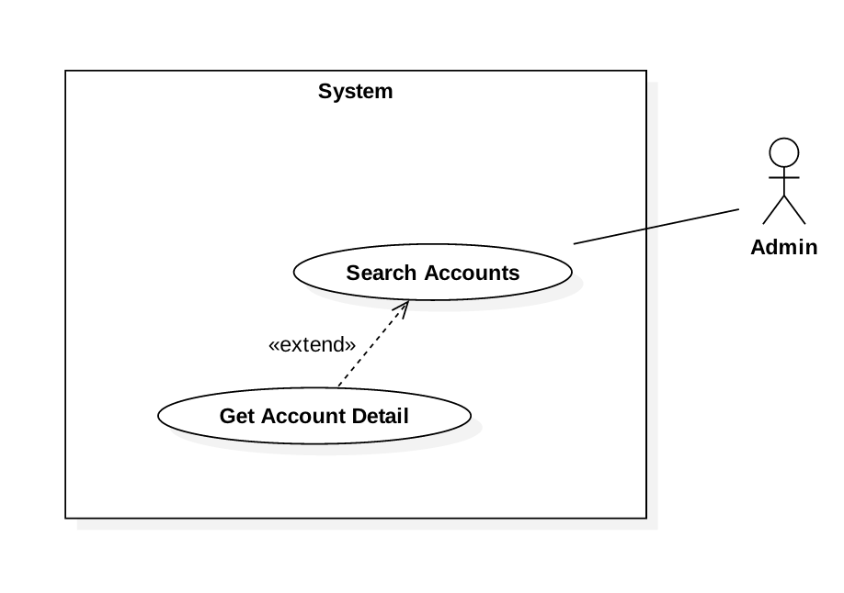

Figure 17: <Admin> Get Account Detail

|  |  |  |  |
| --- | --- | --- | --- |
| **USE CASE – JWL06** | | | |
| **Use Case No.** | JWL06 | **Use Case Version** | 1.0 |
| **Use Case Name** | Get Account Detail | | |
| **Author** | Nguyen Tuan Anh | | |
| **Date** | February 21, 2017 | **Priority** | Normal |
| **Actor:**   * Admin   **Summary:**  This use case allows Admin to get an account’s detail information, including   * + - * User ID       * Full name       * Email       * Address       * Date of birth       * Phone number       * Place of work       * User role   **Goal:**   * The System show the Admin his/her requested account’s detail information.   **Triggers:**   * Admin sends “Get Account Detail” command.   **Preconditions:**   * Actor logged in system with role Admin.   **Post Conditions:**   * **Success:** The account’s personal information is showed to the Admin. * **Fail:** N/A   **Main Success Scenario:**   |  |  |  | | --- | --- | --- | | Step | Actor Action | System Response | | 1 | Admin sends “Get Account Detail” command of a specific account. | System lists the detail information of the requested account:   * “User ID”: read only text * “Full name”: read only text * “Date of Birth”: read only text * “Email”: read only text * “Address”: read only text * “Phone number”: read only text * “Place of Work”: read only text * “User Role”: read only text |   **Alternative Scenario:** N/A  **Exception:** N/A  **Relationships:** Extend Update Account: From this use case, Admin can Update Account.  **Business Rules:**   * Admin can get any account’s detail, including Admin, Librarian, and Borrower. | | | |

*Table 22: Get Account Detail*

##### <Admin> Update Account

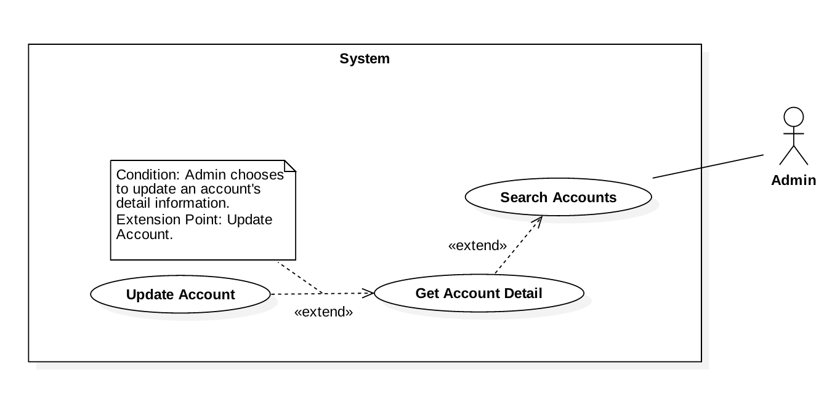

Figure 18: <Admin>Update Account

|  |  |  |  |
| --- | --- | --- | --- |
| **USE CASE – JWL07** | | | |
| **Use Case No.** | JWL07 | **Use Case Version** | 1.0 |
| **Use Case Name** | Update Account | | |
| **Author** | Nguyen Tuan Anh | | |
| **Date** | February 16, 2017 | **Priority** | Normal |
| **Actor:**   * Admin   **Summary:**  This use case allows Admin to update other accounts’ information, including   * + - * Full name       * Password       * Email       * Address       * Date of birth       * Phone number       * Place of work       * User role       * Status of user (activated/deactivated).   **Goal:**   * Update personal information of an account that Admin chooses.   **Triggers:**   * Admin sends “Update Account” command.   **Preconditions:**   * Actor logged in system with role Admin.   **Post Conditions:**   * **Success:** The account’s personal information is updated in the database. * **Fail:** System displays error messages showing fail reasons (see table **Exception**).   **Main Success Scenario:**   |  |  |  | | --- | --- | --- | | Step | Actor Action | System Response | | 1 | Admin sends “Update Account” command. | System lists out the information of the account:   * “Full name”: free text input * “Password”: free text input that hides the input password * “Confirm Password”: free text input that hides the input confirm password * “Date of Birth”: free text input that allows Admin to input day - month - year * “Email”: free text input * “Address”: free text input * “Phone number”: free text input * “Place of Work”: free text input * “User Role”: list that allows Admin to choose one of the system roles: Admin, Librarian, Borrower * User status”: checkbox, which has 2 values: checked and unchecked * Checked: activated. * Unchecked: deactivated. | | 2 | Admin input the information. |  | | 3 | Admin sends Submit command. | * System validates the input then update the account. * System redirect the Admin to Get Account Detail’s view. * System displays a successful message: “The Account of [username] is updated.”   [Exception 1, 2, 3, 4, 5, 6, 7, 8] |   **Alternative Scenario:** N/A  **Exception:**   |  |  |  | | --- | --- | --- | | No | Cause | System Response | | 1 | Admin inputs Full Name field with the following wrong format:   * Blank, or all space characters * Longer than 100 characters. | System displays error messages:   * “Full name is required.” * “Full name must not be longer than 100 characters.” | | 2 | Admin inputs Password field with the following wrong format:   * Blank, or all space characters * Shorter than 6 characters * Longer than 50 characters | System displays error messages:   * “Password is required.” * “Password’s length is 6-50 characters.” | | 3 | Admin inputs Confirm Password field that does not match Password field. | System displays error message: “Confirm Password must match Password.” | | 4 | Admin inputs Email field with the following wrong format:   * Blank, or all space characters * Wrong email format (email format: [user.name]@[email.name]). | System displays error messages:   * “Email is required.” * “Wrong Email format. Please input something like abc@somemail.com”. | | 5 | Admin inputs Address field with the following wrong format:   * Blank or all space characters * Longer than 250 characters | System displays error messages:   * “Address is required.” * “Address must not be longer than 250 characters.” | | 6 | Admin inputs Phone Number field with the following wrong format:   * Blank or all space characters * Wrong phone number format. | System displays error messages:   * “Phone Number is required.” * “Phone Number should be like +841692536224 or 01692536224.” | | 7 | Admin inputs Place of Work field with the following wrong format:   * Blank or all space characters * Longer than 100 characters | System displays error message:   * “Place of Work is required.” * “Place of Work must not be longer than 100 characters.” | | 8 | User ID does not exist. | System displays error message: “The Account [User ID, Full name] is invalid.” |   **Relationships:** Extend from Get Account Detail: Admin can Update Account from Get Account Detail.  **Business Rules:**   * System check for The Actor’s role: only Admin role can update an account. * System check for account’s existence (by User ID) before trying to update it. * User’s information must not be blank. * Full name’s and place of work’s length must not be longer than 100 characters. * Password’s length is 6-50 characters. * Confirm password must match input password. * Email must be in format: [user.name]@[email.name] * Phone number must be in format: +[phone no.] or [phone no.] * Address’s length must not be longer than 250 characters. * Password must be encrypted before saving to the system. | | | |

Table 23:<Admin> Update Account

##### <Admin> Delete Account

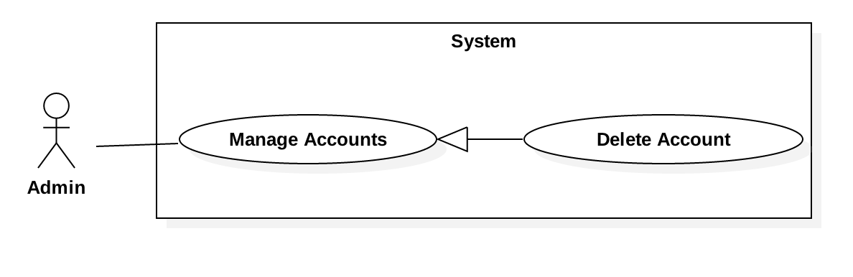

Figure 19: <Admin> Delete Account

|  |  |  |  |
| --- | --- | --- | --- |
| **USE CASE – JWL08** | | | |
| **Use Case No.** | JWL08 | **Use Case Version** | 1.0 |
| **Use Case Name** | Delete Account | | |
| **Author** | Nguyen Tuan Anh | | |
| **Date** | February 20, 2017 | **Priority** | Normal |
| **Actor:**   * Admin   **Summary:**   * This use case allows Admin to delete another account from the system.   **Goal:**   * The account’s delete date is updated in system database. No Actor can have access to that account anymore.   **Triggers:**   * Admin sends “Delete Account” command.   **Preconditions:**   * Actor logged in system with role Admin.   **Post Conditions:**   * **Success:**   + The account’s delete date is updated in the System database.  + The account can no longer be viewed or do any functions of the System.   * **Fail:** System displays error messages showing fail reasons (see table **Exception**).   **Main Success Scenario:**   |  |  |  | | --- | --- | --- | | Step | Actor Action | System Response | | 1 | Admin sends Delete Account command on a specific account. | System shows Delete Account pop up which includes:   * Confirm message: “Are you sure to delete the account [userID]?” * System asks for confirmation. | | 2 | Admin sends Confirm command.  [Alternative 1] | * System displays a successful message: “the Account [user ID, Full name] is successfully deleted.” |   **Alternative Scenario:**   |  |  |  | | --- | --- | --- | | No | Actor Action | System Response | | 1 | Admin sends “Cancel” command. | System closes the Delete Account pop up. |   **Exception:** N/A  **Relationships:** N/A  **Business Rules:**   * Before deleting an account, System checks the following conditions:   + - * The account’s user ID’s existence: if the account does not exist, or it has delete date field, System stop the delete account command.       * If the account is a Borrower and having unreturned books, System will:   + Stop the delete account command.  + Warn the Admin “This Borrower is having unreturned books!”   * + - * If the account is a Borrower and is in the library, System will:   + Stop the delete account command.  + Warn the Admin “This Borrower is in the library!”   * After the deletion, the account’s delete date is updated in the System database. * Deleted accounts can no longer be view or do any functions of the System. | | | |

Table 24: <Admin> Delete Account

#### <Librarian> Overview Use Case

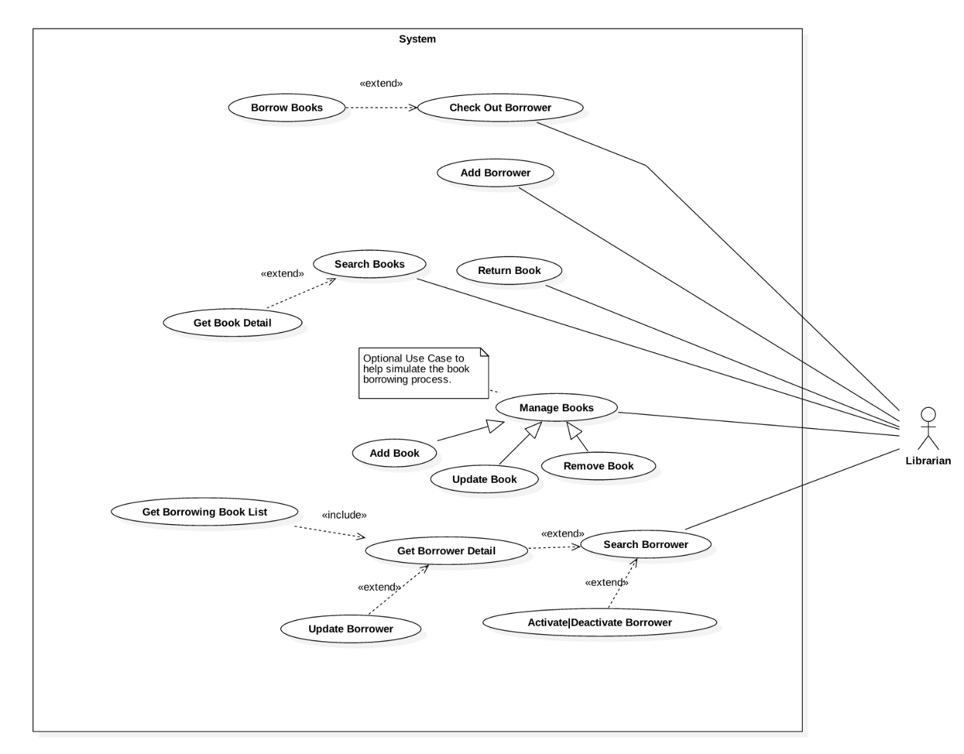

Figure 20: <Librarian> Overview Use Case

##### <Librarian> Search Book



Figure 21: <Librarian> Search Book

|  |  |  |  |
| --- | --- | --- | --- |
| **USE CASE – JWL09** | | | |
| **Use Case No.** | JWL09 | **Use Case Version** | 1.0 |
| **Use Case Name** | Search Book | | |
| **Author** | Dang Nhat Thien | | |
| **Date** | February 12, 2017 | **Priority** | Normal |
| **Actor:**   * Librarian   **Summary:**   * This use case allows Librarian to search book in library by book title.   **Goal:**   * Librarian can get a list book that match input book’s title.   **Triggers:**   * Librarian sends “Search” command.   **Preconditions:**   * Actor logged in system with role Librarian.   **Post Conditions:**   * **Success:** List of matching books based on search term is showed. * **Fail:** N/A   **Main Success Scenario:**   |  |  |  | | --- | --- | --- | | Step | Actor Action | System Response | | 1.  2. | Librarian inputs search term.  Librarian sends “Search” command. | System loads the result. Information for each book:   * No.: read only text * Title: read only text * Authors: read only text * Publisher: read only text * Publish year: read only text * Number of copies: read only text   [Alternative 1] |   **Alternative Scenario:**   |  |  |  | | --- | --- | --- | | Step | Cause | System Response | | 1 | There is no book that matches the search term. | System shows message: “No book found.” |   **Exceptions:** N/A  **Relationships:** Extend Get Book Detail: after search book successfully, librarian can Get Book Detail.  **Business Rules:**   * Name of author is taken from author table. A book can have many authors. | | | |

Table 25: <Librarian> Search Book

##### <Librarian> Add Book

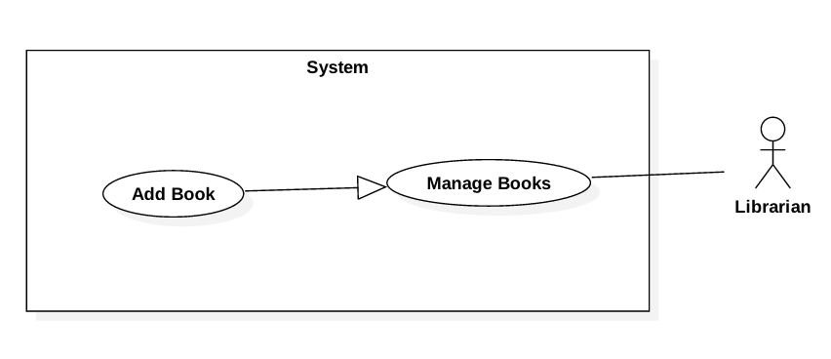

Figure 22: <Librarian> Add Book

|  |  |  |  |
| --- | --- | --- | --- |
| **USE CASE – JWL10** | | | |
| **Use Case No.** | JWL10 | **Use Case Version** | 1.1 |
| **Use Case Name** | Add Book | | |
| **Author** | Dang Nhat Thien | | |
| **Date** | March 15, 2017 | **Priority** | Normal |
| **Actor:**   * Librarian   **Summary:**   * Librarian adds new book information to the system database when the library obtains new books.   **Goal:**   * New books are available in the library system.   **Triggers:**   * Librarian sends “Add New Book” command.   **Preconditions:**   * Actor logged in system with role Librarian.   **Post Conditions:**   * **Success:** System show message: “Add successfully!” * **Fail:** N/A   **Main Success Scenario:**   |  |  |  | | --- | --- | --- | | Step | Actor Action | System Response | | 1  2  3 | Librarian sends “Add New Book”  command.  Librarian input information.  Librarian send “Save” command.  [Alternative 3] | System lists out the information of new Book:   * “Thumbnail”: the image Librarian can click to upload. Only JPG, PNG, JPEG format are accepted. Maximum file size is 3 MB, required. * “Book title”: free text input, required, length 1-50 * “Publisher”: free text input, required, length 1-100 * “Publish year”: free number input, required, max length 4 * “Page number”: free number input, required, length 1-4 * “Description”: free number input, required, length 1-500 * “Floor”: free number input, required, length 2 * “Shelf”: free text input, required, length 2. * “Author: free text input, required, length 1 – 50 * “Book type”: list of book type, required. * “Book category”: list of checkbox, required. * “Save” command. * “Cancel” command.   When text change, system verifies input information.  [Exception 1,2,3,4,5,6,7,8,9,10,11,12]  System verifies input information. New Book is saved to database. The system shows message “Book [title] has been added!”  [Exception 1, 2, 3, 4, 5, 6, 7, 8, 9, 10, 11] |   **Alternative Scenario:**   |  |  |  | | --- | --- | --- | | No | Cause | System Response | | 1 | Librarian send “Cancel” command. | System return to main view. |   **Exceptions:**   |  |  |  | | --- | --- | --- | | No | Cause | System Response | | 1 | Librarian inputs Book title field with wrong format. | System displays error message: “Book title’s length must be 1 - 50 characters.” | | 2 | Librarian inputs Publisher field with wrong format. | System displays error message: “Publisher’s length must be 1-100 characters.” | | 3 | Librarian inputs Publish year field with wrong format. | System displays error message: “Publish year must be a positive integer number and max length is 4” | | 4 | Librarian inputs Page number field with wrong format. | System displays error message: “Page must be a positive integer number and max length is 4” | | 5 | Librarian inputs Description field with wrong format. | System displays error message: “Description’s length is 1 - 500 characters” | | 6 | Librarian send Save command with no RFID is added. | System display error message: “Please input at least one RFID.” | | 7 | Librarian inputs Floor field with wrong format. | System displays error message: “Floor must be a positive integer number and max length is 2” | | 8 | Librarian inputs Shelf field with wrong format. | System display error message: “Shelf length is 2 characters” | | 9 | Librarian inputs Author field with wrong format. | System display error message: “Author length is 1 – 50 characters”. | | 10 | Librarian pick up wrong format file. | System display error message: “Image extension are JPG, JPEG, PNG only and maximum size 3MB” | | 11 | Librarian does not pick up an image. | System display error message: “Please choose a thumbnail for book.” |   **Relationships:** N/A  **Business Rules:**  - All fields are required when creating new book.   * Floor and Shelf are two attributes from Position table. A book can only be place in one position (floor, shelf). * If an author’s name does not exist in system, create new author. * A has only one book type predefined in the system. * A book can belong to many categories. | | | |

Table 26: <Librarian> Add Book

##### <Librarian> Get Book Detail

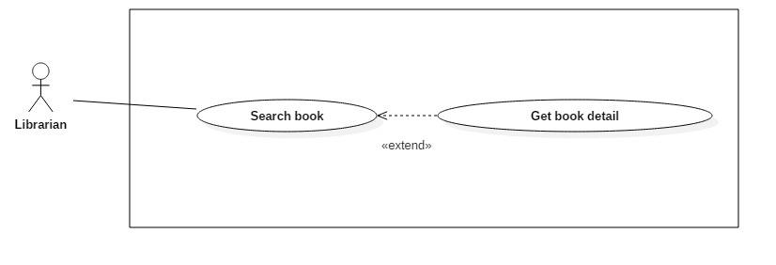

Figure 23: <Librarian> Get Book Detail

|  |  |  |  |
| --- | --- | --- | --- |
| **USE CASE – JWL11** | | | |
| **Use Case No.** | JWL11 | **Use Case Version** | 1.0 |
| **Use Case Name** | Get Book Detail | | |
| **Author** | Dang Nhat Thien | | |
| **Date** | March 16, 2017 | **Priority** | Low |
| **Actor:**   * Librarian   **Summary:**   * This use case allows Librarian to get book detail, so Librarian can Update/Delete book.   **Goal:**   * Full information of book is displayed.   **Triggers:**   * Librarian sends “Get Book Detail” command.   **Preconditions:**   * Actor logged in system with role Librarian. * Librarian find out the Book want to view detail via Search Book.   **Post Conditions:**   * **Success:** System show all information of a specific Borrower. * **Fail:** N/A.   **Main Success Scenario:**   |  |  |  | | --- | --- | --- | | Step | Actor Action | System Response | | 1 | Librarian sends “Get Book Detail” command. | System lists out the information of the book:   * Thumbnail * Title * Publisher * Publish year * Page number * Description * Position * Author * Book type * Book category * Caution money * Max number of late days * List of copies that are being borrowed |   **Alternative Scenario:** N/A  **Exception:** N/A  **Relationships:** Extend from Search Book: Librarian gets detail via Search Book  **Business Rules:**  **-** If a book has borrowing copies, system will show list of borrowing copies to the librarian. | | | |

Table 27: <Librarian> Get Book Detail

##### <Librarian> Update Book

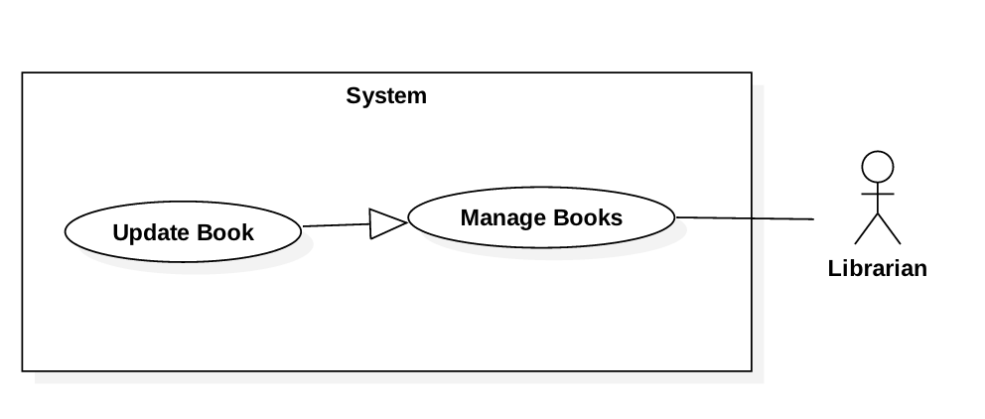

Figure 24: <Librarian> Update Book

|  |  |  |  |
| --- | --- | --- | --- |
| **USE CASE – JWL12** | | | |
| **Use Case No.** | JWL12 | **Use Case Version** | 1.1 |
| **Use Case Name** | Update Book | | |
| **Author** | Dang Nhat Thien | | |
| **Date** | March 15, 2017 | **Priority** | Normal |
| **Actor:**   * Librarian   **Summary:**   * This use case allows Librarian to update information of books.   **Goal:**   * Book’s information will be updated.   **Triggers:**   * Librarian sends “Update Book” command.   **Preconditions:**   * Actor logged in system with role Librarian. * Librarian finds out the Book want to update.   **Post Conditions:**   * **Success:** System shows message: “Update successfully!” * **Fail:** N/A   **Main Success Scenario:**   |  |  |  | | --- | --- | --- | | Step | Actor Action | System Response | | 1  2  3 | Librarian sends “Update Book”  command from a Book Detail.  Librarian input information.  [Alternative 1,2]  Librarian send “Save” command.  [Alternative 3] | System lists out the information of new Book:   * “Thumbnail”: Image Librarian can click on to upload. Only JPG, PNG, JPEG format are accepted. Maximum file size is 3 MB, required. * “Book title”: free text input, required, length 1-50 * “Publisher”: free text input, required, length 1-100 * “Publish year”: free number input, required, max length 4 * “Page number”: free number input, required, length 1-4 * “Description”: free number input, required, length 1-500 * “Floor”: free number input, required, length 2 * “Shelf”: free text input, required, length 2. * “Author: free text input, required, length 1 – 50 * “Book type”: list of book type, required. * “Book category”: list of checkbox, required. * “RFID”: free text input, max length 10, required. * “Add new copy” command. * “Delete copy” command. * “Save” command. * “Cancel” command.   When text change, system verifies input information.  [Exception 1,2,3,4,5,6,7,8,9,10,11,12]  System verifies input information. New Book with all copies of it are saved to database. The system show message “Book [title] has been added!”  [Exception 1,2,3,4,5,6,7, 8, 9, 10, 11,12] |   **Alternative Scenario:**   |  |  |  | | --- | --- | --- | | No | Cause | System Response | | 1 | Librarian send “Add New Copy” command. | This corresponding RFID is display in a list below Book information. [Exception 6]  “RFID” will be clear. | | 2 | Librarian send “Delete Copy” command. | This corresponding RFID is deleted from list. | | 3 | Librarian send “Cancel” command. | System return to main view. |   **Exceptions:**   |  |  |  | | --- | --- | --- | | No | Cause | System Response | | 1 | Librarian inputs Book title field with wrong format. | System displays error message: “Book title’s length must be 1 - 50 characters.” | | 2 | Librarian inputs Publisher field with wrong format. | System displays error message: “Publisher’s length must be 1-100 characters.” | | 3 | Librarian inputs Publish year field with wrong format. | System displays error message: “Publish year must be a positive integer number and max length is 4” | | 4 | Librarian inputs Page number field with wrong format. | System displays error message: “Page must be a positive integer number and max length is 4” | | 5 | Librarian inputs Description field with wrong format. | System displays error message: “Description’s length is 1 - 500 characters” | | 6 | Librarian inputs RFID field with wrong format. | System displays error message: “RFID’s length is 10 characters.” | | 7 | Librarian send Save command with no RFID is added. | System display error message: “Please input at least one RFID.” | | 8 | Librarian inputs Floor field with wrong format. | System displays error message: “Floor must be a positive integer number and max length is 2” | | 9 | Librarian inputs Shelf field with wrong format. | System display error message: “Shelf length is 2 characters” | | 10 | Librarian inputs Author field with wrong format. | System display error message: “Author length is 1 – 50 characters”. | | 11 | Librarian pick up wrong format file. | System display error message: “Image extension are JPG, JPEG, PNG only and maximum size 3MB” | | 12 | Librarian does not pick up an image. | System display error message: “Please choose a thumbnail for book.” |   **Relationships:** N/A  **Business Rules:**   * RFID must be added whenever Add New Book. * Floor and Shelf are two attributes of Position. | | | |

Table 28: <Librarian> Update Book

##### <Librarian> Remove Book

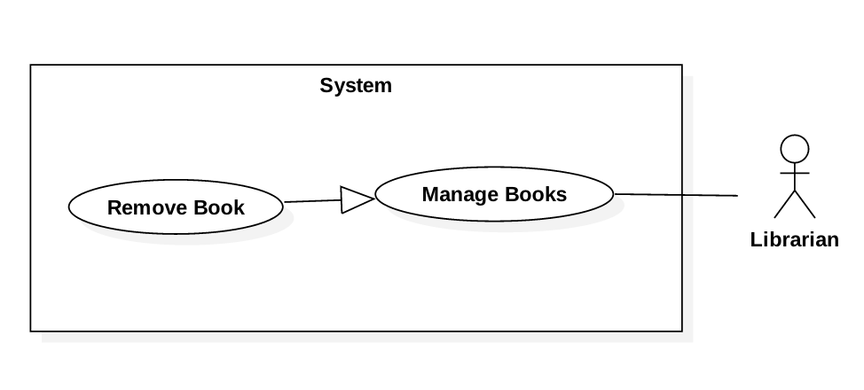

Figure 25: <Librarian> Remove Book

|  |  |  |  |
| --- | --- | --- | --- |
| **USE CASE – JWL13** | | | |
| **Use Case No.** | JWL13 | **Use Case Version** | 1.1 |
| **Use Case Name** | Remove Book | | |
| **Author** | Dang Nhat Thien | | |
| **Date** | March 15, 2017 | **Priority** | Normal |
| **Actor:**   * Librarian   **Summary:**   * This use case allows Librarian to remove a book when the library does not provide the book anymore.   **Goal:**   * Librarian removes book and all of copies. The books and copies are not available in the library system. Borrowers can’t search and borrow.   **Triggers:**   * Librarian sends “Remove Book” command.   **Preconditions:**   * Actor logged in system with role Librarian. * Librarian search the Book he/she want to remove via <Librarian> Search Book * The book must be available in the library system.   **Post Conditions:**   * **Success:**   + System show message: “Removed successfully!”  + Book’s delete date is updated.   * **Fail:** N/A   **Main Success Scenario:**   |  |  |  | | --- | --- | --- | | Step | Actor Action | System Response | | 1  2 | Librarian send “Remove” Book  Command on a specific book.  Librarian send “Yes” command.  [Alternative 1] | System displays confirmation message: “Are you sure to remove this book?”.  System removes the book and show message: “Removed successfully!”  [Exception 1] |   **Alternative Scenario:**   |  |  |  | | --- | --- | --- | | No | Cause | System Response | | 1 | Librarian send “Cancel” command. | System returns to main view. |   **Exceptions:**   |  |  |  | | --- | --- | --- | | No | Cause | System Response | | 1 | The book is being borrowed. | System displays error message: “Book is being borrowed. Can’t be removed!” |   **Relationships:** N/A  **Business Rules:**   * Book have copy is borrowing can’t be removed. * Update book’s delete date in system database. | | | |

Table 29: <Librarian> Remove Book

##### <Librarian> Add Borrower



Figure 26: <Librarian> Add Borrower

|  |  |  |  |
| --- | --- | --- | --- |
| **USE CASE – JWL14** | | | |
| **Use Case No.** | JWL14 | **Use Case Version** | 1.0 |
| **Use Case Name** | Add Borrower | | |
| **Author** | Dang Nhat Thien | | |
| **Date** | February 13, 2017 | **Priority** | Normal |
| **Actor:**   * Librarian   **Summary:**   * This use case allows Librarian to create an account for Borrower when someone asks to subscribe the library.   **Goal:**   * New account for borrower is created with status: “Activate”.   **Triggers:**   * Librarian sends “Create Borrower” command.   **Preconditions:**   * Actor logged in system with role Librarian.   **Post Conditions:**   * **Success:** Show success message: “Added successfully!”. * **Fail:** N/A   **Main Success Scenario:**   |  |  |  | | --- | --- | --- | | Step | Actor Action | System Response | | 1 | Librarian sends “Create Borrower”  command. | System lists out the information of the new account:   * “User Image”: Image Librarian can click on to upload. Only JPG, PNG, JPEG format are accepted. Maximum file size is 3 MB, required. * “User ID”: free text input, length 6-15 * “Full Name”: free text input, length 1-100 * “Email”: free text input * “Address”: free text input, length 1-250 * “Date of Birth”: view that allows Librarian to pick day – month - year * “Phone number”: free text input, length 8-12 * “Place of Work”: free text input: length 6-50 | | 2 | Librarian inputs the information. | System validates the corresponding field whenever text changed.  [Exception 1, 2, 3, 4, 5, 6, 7, 8, 9] | | 3 | Librarian sends “Save” command. | System validates the input then create a new borrower.  System displays a successful message: “New Borrower: [User Id] is added.”  [Exception 1, 2, 3, 4, 5, 6, 7, 8, 9] |   **Alternative Scenario:** N/A  **Exceptions:**   |  |  |  | | --- | --- | --- | | No | Cause | System Response | | 1 | Librarian picks up wrong format file. | System displays error message: “Image extension are JPG, JPEG, PNG only and maximum size 3MB” | | 2 | Librarian does not pick up an image. | System displays error message: “Please choose a picture for Borrower.” | | 3 | Librarian inputs User Id field with wrong format. | System displays error message: “User Id length is 6-15 characters.” | | 4 | Librarian inputs Full Name field with wrong format. | System displays error message: “Full name length is 1-100 characters.” | | 5 | Librarian inputs Email field with wrong format. | System displays error message: “Wrong Email format. Please input something like abc@somemail.com” | | 6 | Librarian inputs Address field with wrong format. | System displays error message: “Address length is 1-125 characters.” | | 7 | Librarian don’t pick up a Date of Birth. | System displays error message: “Have to pick up a Date of Birth for borrower.” | | 8 | Librarian inputs Phone Number field with wrong format. | System displays error message: “Phone Number should be all numbers at 8-12 length.” | | 9 | Librarian inputs Place of Work field with wrong format. | System displays error message: “Place of Work length is 6-50 characters.” |   **Relationships:** N/A  **Business Rules:**   * Password is a random string has min length of 6. * Email format: abc@somemail.com | | | |

Table 30: <Librarian> Add Borrower

##### <Librarian> Search Borrower



Figure 27: <Librarian> Search Borrower

|  |  |  |  |
| --- | --- | --- | --- |
| **USE CASE – JWL15** | | | |
| **Use Case No.** | JWL15 | **Use Case Version** | 1.0 |
| **Use Case Name** | Search Borrower | | |
| **Author** | Dang Nhat Thien | | |
| **Date** | February 13, 2017 | **Priority** | Normal |
| **Actor:**   * Librarian   **Summary:**   * This use case allows Librarian to search for a borrower to view his/her detail information, including his/her borrowing books.   **Goal:**   * Librarian can get a list of borrowers that match input userID.   **Triggers:**   * Librarian send Search Borrower command.   **Preconditions:**   * Actor logged in system with role Librarian.   **Post Conditions:**   * **Success:** List of matching borrowers based on search term is showed. * **Fail:** N/A   **Main Success Scenario:**   |  |  |  | | --- | --- | --- | | Step | Actor Action | System Response | | 1  2 | Librarian inputs wanted userID.  Librarian send Search command. | System loads the result. Information for each Borrower:   * No. * UserID * Full name * Email * Is in Library * Is activated   [Alternative 1] |   **Alternative Scenario:**   |  |  |  | | --- | --- | --- | | Step | Cause | System Response | | 1 | There is no borrower that matches the search term. | System shows message: “We could not find any borrowers with userID like [search term]” |   **Exceptions:** N/A  **Relationships:** Search book successfully, so librarian can Get book detail. Get book detail is extended from Search book.  **Business Rules:**   * UserId: free text input, get from account table. * Email: text, get from profile table. * Is in Library: text (True/False), get from account table. * Is activate: text (True/False), get from account table. * View detail command. | | | |

Table 31: <Librarian> Search Borrower

##### <Librarian> Get Borrower Detail

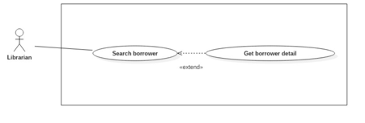

Figure 28: <Librarian> Get borrower detail.

|  |  |  |  |
| --- | --- | --- | --- |
| **USE CASE – JWL16** | | | |
| **Use Case No.** | JWL16 | **Use Case Version** | 1.0 |
| **Use Case Name** | Get Borrower Detail | | |
| **Author** | Dang Nhat Thien | | |
| **Date** | March 16, 2017 | **Priority** | Low |
| **Actor:**   * Librarian   **Summary:**   * This use case allows Librarian to view borrower’s detail. So Librarian can Update borrower’s profile.   **Goal:**   * Full information of borrower is displayed.   **Triggers:**   * Librarian sends “View Profile Detail” command.   **Preconditions:**   * Actor logged in system with role Librarian. * Librarian find out the Borrower want to view detail via Search Borrower   **Post Conditions:**   * **Success:** System shows all information of a specific Borrower. * **Fail:** N/A.   **Main Success Scenario:**   |  |  |  | | --- | --- | --- | | Step | Actor Action | System Response | | 1 | Librarian sends “View Borrower Detail” command. | System lists out the information of the account:   * User Id * Full name * Date of birth * Email * Address * Phone number * Place of work * Total Balance * Usable Balance |   **Alternative Scenario:** N/A  **Exception:** N/A  **Relationships:**   * Extend from Search Borrower: Librarian can Get Borrower Detail after Search Borrower. * Include Get Borrowing Book List: Librarian can view the borrowing book list of that borrower.   **Business Rules:**   * User Id: read only text, get from account table. * Full name: read only text, get from account table. * Date of birth: read only text, get from profile table. * Email: read only text, get from profile table. * Address: read only text, get from profile table. * Phone number: read only text, get from profile table. * Place of work: read only text, get from profile table. * Total Balance: read only text, get from account table. * Usable Balance: read only text, calculate by total balance minus current caution\_money of borrowing book copy. | | | |

Table 32: <Librarian> Get borrower detail.

##### <Librarian> Update Borrower

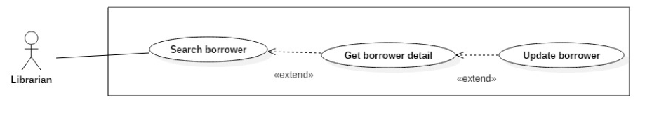

Figure 29: <Librarian> Update Borrower

|  |  |  |  |
| --- | --- | --- | --- |
| **USE CASE – JWL17** | | | |
| **Use Case No.** | JWL17 | **Use Case Version** | 1.1 |
| **Use Case Name** | Update Borrower Information | | |
| **Author** | Dang Nhat Thien | | |
| **Date** | March 16, 2017 | **Priority** | Low |
| **Actor:**   * Librarian   **Summary:**   * This use case allows Librarian to update a borrower’s information.   **Goal:**   * Borrower’s information is changed.   **Triggers:**   * Librarian sends “Update Borrower” command.   **Preconditions:**   * Actor logged in system with role Librarian.   **Post Conditions:**   * **Success:** * Update the borrower’s new information in system database. * A message is displayed: “Update successfully!”. * **Fail:** N/A.   **Main Success Scenario:**   |  |  |  | | --- | --- | --- | | Step | Actor Action | System Response | | 1 | Librarian sends “Update Borrower” command on a specific borrower. | System lists out the information of the new account:   * “User Image”: Image Librarian can click on to upload. Only JPG, PNG, JPEG format are accepted. Maximum file size is 3 MB, required. * “User ID”: free text input, length 6-15 * “Full Name”: free text input, length 1-100 * “Password”: free text input that hides the input text, length 6-50 * “Confirm Password”: free text input that hides the input text, length 6-50 * “Email”: free text input * “Address”: free text input, length 1-250 * “Date of Birth”: view that allows Librarian to pick day – month - year * “Phone number”: free text input, length 8-12   “Place of Work”: free text input: length 6-50 | | 2 | Librarian updates information. | System validate the corresponding field whenever text changed.  [Exception 1, 2, 3, 4, 5, 6, 7, 8, 9, 10, 11] | | 3 | Librarian sends Submit command. | System validates the input then update borrower.  System displays a successful message: “Update successfully!”  [Exception 1, 2, 3, 4, 5, 6, 7, 8, 9, 10, 11] |   **Alternative Scenario:** N/A  **Exception:**   |  |  |  | | --- | --- | --- | | No | Cause | System Response | | 1 | Librarian picks up wrong format file. | System display error message: “Image extension are JPG, JPEG, PNG only and maximum size 3MB” | | 2 | Librarian does not pick up an image. | System display error message: “Please choose a picture for Borrower.” | | 3 | Librarian inputs User Id field with wrong format. | System displays error message: “User Id length is 6-15 characters.” | | 4 | Librarian inputs Full Name field with wrong format. | System displays error message: “Full name length is 1-100 characters.” | | 5 | Librarian inputs Password field with wrong format. | System displays error message: “Password length is 6-50 characters.” | | 6 | Librarian inputs Confirm Password field which does not match the Password. | System displays error message: “Confirm Password must match Password.” | | 7 | Librarian inputs Email field with wrong format. | System displays error message: “Wrong Email format. Please input something like abc@somemail.com” | | 8 | Librarian inputs Address field with wrong format. | System displays error message: “Address length is 1-125 characters.” | | 9 | Librarian does not pick up a Date of Birth. | System displays error message: “Have to pick up a Date of Birth for borrower.” | | 10 | Librarian inputs Phone Number field with wrong format. | System displays error message: “Phone Number should be all numbers at 8-12 length.” | | 11 | Librarian inputs Place of Work field with wrong format. | System displays error message: “Place of Work length is 6-50 characters.” |   **Relationships:** Extend from Get Borrower Detail.  **Business Rules:**   * Password must be encrypted before saving to the system. * Email format: example abc@somemail.com. | | | |

Table 33: <Librarian> Update Borrower

#### <Borrower> Overview Use Case

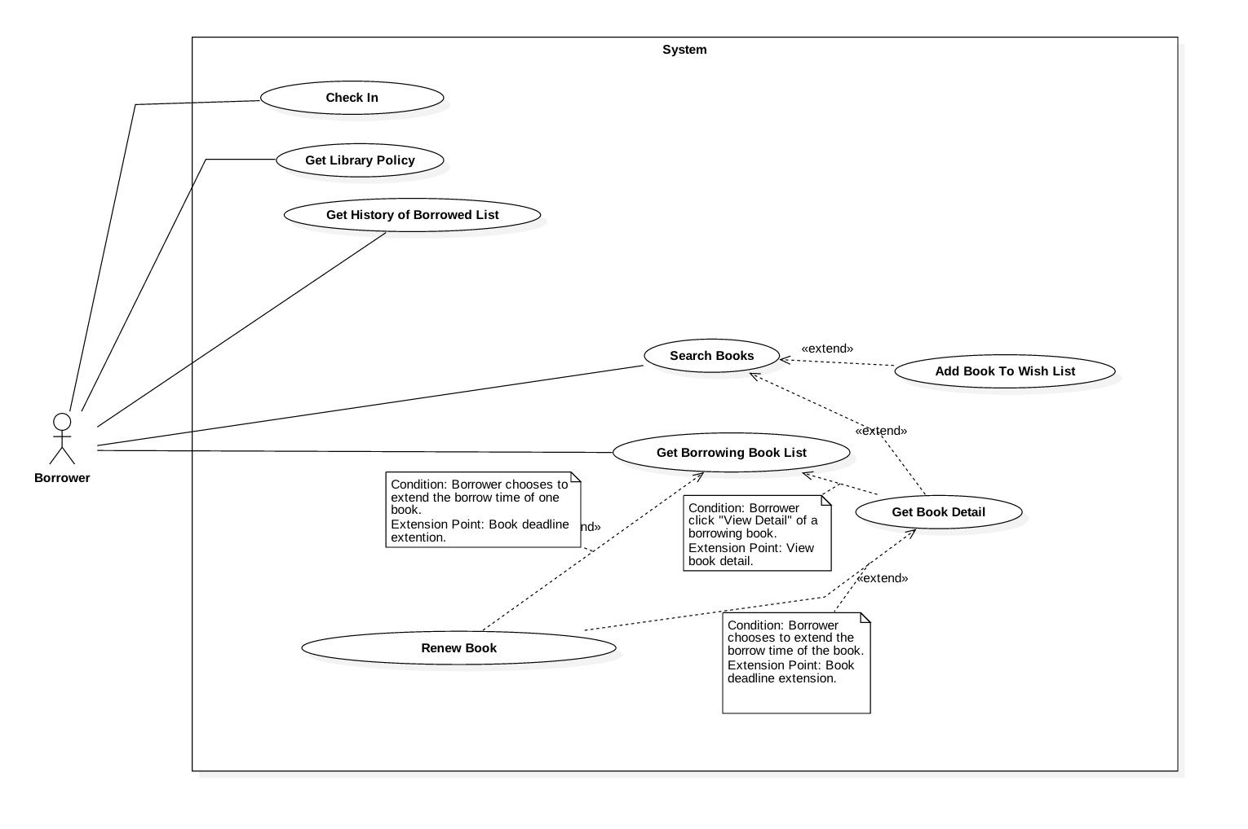

Figure 30: <Borrower> Overview Use Case

##### <Borrower> Search Book



Figure 31: <Borrower> Search Book

|  |  |  |  |
| --- | --- | --- | --- |
| **USE CASE – JWL17** | | | |
| **Use Case No.** | JWL17 | **Use Case Version** | 1.1 |
| **Use Case Name** | Search Book | | |
| **Author** | Dang Nhat Thien | | |
| **Date** | March 16, 2017 | **Priority** | Normal |
| **Actor:**   * Borrower   **Summary:**   * This use case allows Borrowers to search book. So that borrowers can view status of book, add book to wish list.   **Goal:**   * A list books that match input book’s name is displayed.   **Triggers:** Borrower send Search Command.  **Preconditions:**   * Actor logged in system with role Borrower.   **Post Conditions:**   * **Success:** List of matching books based on search term is showed. * **Fail:** A Dialog will be showed and display message: “Search fail. Please check your internet connection”.   **Main Success Scenario:**   |  |  |  | | --- | --- | --- | | Step | Actor Action | System Response | | 1 | Borrower inputs wanted book’s name.  Then send Search Command | System loads the result. Information for each account:   * Book Title * Position * Author * Is available   [Alternative 1]: There is no book that matches the search term.  [Exception 1]: Internet connection is lost. |   **Alternative Scenario:**   |  |  |  | | --- | --- | --- | | Step | Cause | System Response | | 1 | There is no book that matches the search term. | System shows message: “Không tìm thấy sách.” |   **Exceptions:**   |  |  |  | | --- | --- | --- | | No | Cause | System Response | | 1 | Internet connection is lost. | System show error message via Dialog. |   **Relationships:** Search successfully so Borrower can add book to wish list if Book is not available at that time.  **Business Rules:**   * Search return the most matched book with the search term. * Book Title: free text * Position: free text, get floor, shelf from position table. * Author: free text, get author name from author table. * Is available: Available if total book copies is more than number of borrowing books. If not, it’s not available. | | | |

Table 34: Borrower> Search Book

##### <Borrower> Add Book To Wish List

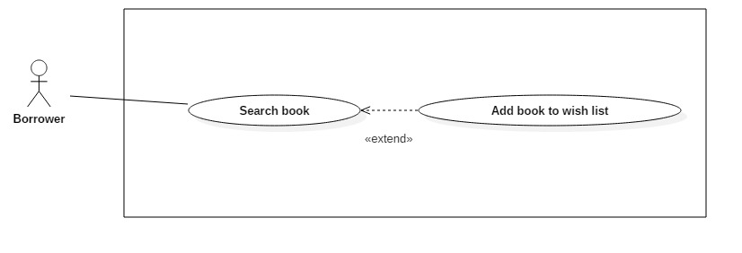

Figure 32: <Borrower> Add book to wish list

|  |  |  |  |
| --- | --- | --- | --- |
| **USE CASE – JWL18** | | | |
| **Use Case No.** | JWL18 | **Use Case Version** | 1.1 |
| **Use Case Name** | Add Book To Wish List | | |
| **Author** | Dang Nhat Thien | | |
| **Date** | March 16, 2017 | **Priority** | Normal |
| **Actor:**   * Borrower   **Summary:**   * Borrower Add Book To Wish List if a book is not available.   **Goal:**   * The book is saved as wish book in system database.   **Triggers:** Borrower send “Add Book To Wish List” command.  **Preconditions:**   * Actor logged in system with role Borrower. * Borrower searchs the book. * Book is not available.   **Post Conditions:**   * **Success:** The system shows successful icon to the actor. * **Fail:** A dialog will be showed and display message: “Có lỗi xảy ra.”.   **Main Success Scenario:**   |  |  |  | | --- | --- | --- | | Step | Actor Action | System Response | | 1 | Borrower sends “Add To Wish List” command. | * System saves to database and displays success message.   [Exception 1] Lost Internet Connection |   **Alternative Scenario:** N/A  **Exceptions:**   |  |  |  | | --- | --- | --- | | No | Cause | System Response | | 1 | Lost Internet Connection | System shows error message via Dialog. |   **Relationships:** Borrower must search book via Search book before.  **Business Rules:**   * Borrower can only add books which are currently not available to wish list. * Borrower id and book id is store in wish\_book table. * After adding book to wish list, borrower can receive notification when someone return this book. After sending notification, row has the borrower and book is deleted from wish\_book table. | | | |

Table 35: <Borrower> Add book to wish list

##### <Borrower> Get Borrowed Books



Figure 33: <Borrower> Get Borrowed Books

|  |  |  |  |
| --- | --- | --- | --- |
| **USE CASE – JWL19** | | | |
| **Use Case No.** | JWL19 | **Use Case Version** | 1.1 |
| **Use Case Name** | Get Borrowed Books | | |
| **Author** | Dang Nhat Thien | | |
| **Date** | March 16, 2017 | **Priority** | Normal |
| **Actor:**   * Borrower.   **Summary:**   * Borrower get list borrowed books to view their information, check deadline, and renew books.   **Goal:**   * List borrowed books is displayed.   **Triggers:** Borrower send “Get borrowed books” command.  **Preconditions:**   * Actor logged in system with role Borrower.   **Post Conditions:**   * **Success:** List borrowed books is displayed. * **Fail:** A dialog will be showed and display message: “Lỗi kết nối. Vui lòng kiểm tra internet”.   **Main Success Scenario:**   |  |  |  | | --- | --- | --- | | Step | Actor Action | System Response | | 1 | Borrower sends “Get borrowed books” command. | System shows list borrowed books.  [Exception 1] Lost Internet Connection. |   **Alternative Scenario:** N/A  **Exceptions:**   |  |  |  | | --- | --- | --- | | No | Cause | System Response | | 1 | Lost Internet Connection | System show error message via Dialog. |   **Relationships:** After Get Borrowed Books, Borrower can Extend Borrower Book Deadline.  **Business Rules:** N/A | | | |

Table 36: <Borrower> Get Borrowed Books

##### <Borrower> Renew Book

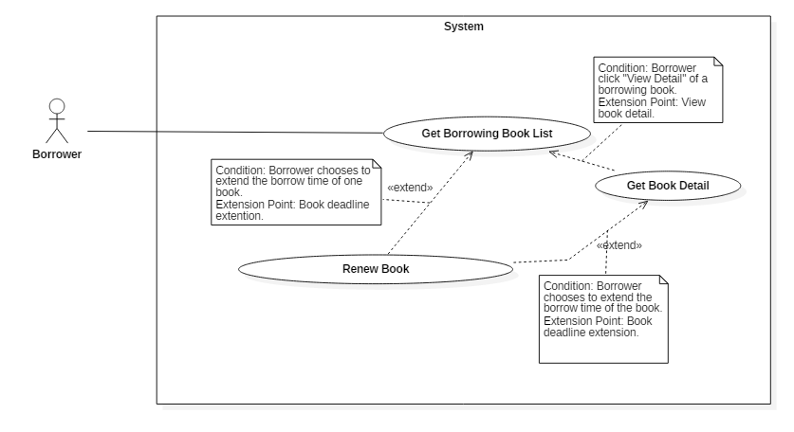

Figure 34: <Borrower> Renew Book

|  |  |  |  |
| --- | --- | --- | --- |
| **USE CASE – JWL20** | | | |
| **Use Case No.** | JWL20 | **Use Case Version** | 1.1 |
| **Use Case Name** | Extend Borrowed Book Deadline | | |
| **Author** | Dang Nhat Thien | | |
| **Date** | March 16, 2017 | **Priority** | Normal |
| **Actor:**   * Borrower   **Summary:**   * Borrower wants to have more time reading a book, so he/she renew the book’s borrow time.   **Goal:**   * Book Deadline will be extended to a fixed number of days.   **Triggers:** N/A  **Preconditions:**   * Actor logged in system with role Borrower. * Book is not overdue the max number of late days of the library’s policy.   **Post Conditions:**   * **Success:** A dialog will be showed and display message: “Sách [tựa sách] đã được gia hạn đến ngày [ngày]!” * **Fail:** A dialog will be showed and display message: “Lỗi kết nối. Vui long kiểm tra lại internet!”.   **Main Success Scenario:**   |  |  |  | | --- | --- | --- | | Step | Actor Action | System Response | | 1 | After get list borrowed books, Borrower sends “Renew” command. | System return new deadline and show success message.  [Exception 1] Lost Internet Connection. |   **Alternative Scenario:** N/A  **Exceptions:**   |  |  |  | | --- | --- | --- | | No | Cause | System Response | | 1 | Lost Internet Connection | System display error message. |   **Relationships:** Extend from Get Borrowing Book List and Get Book Detail: Borrower can renew book while viewing list of borrowing books, or view detail of a borrowing book.  **Business Rules:**  Book only can be renewed when:   * Three or less days before deadline, or * After deadline, but book is not overdue the max number of late days in the library’s policy | | | |

Table 37: <Borrower>Renew Book

#### <Automatic Handler> Overview Use Case

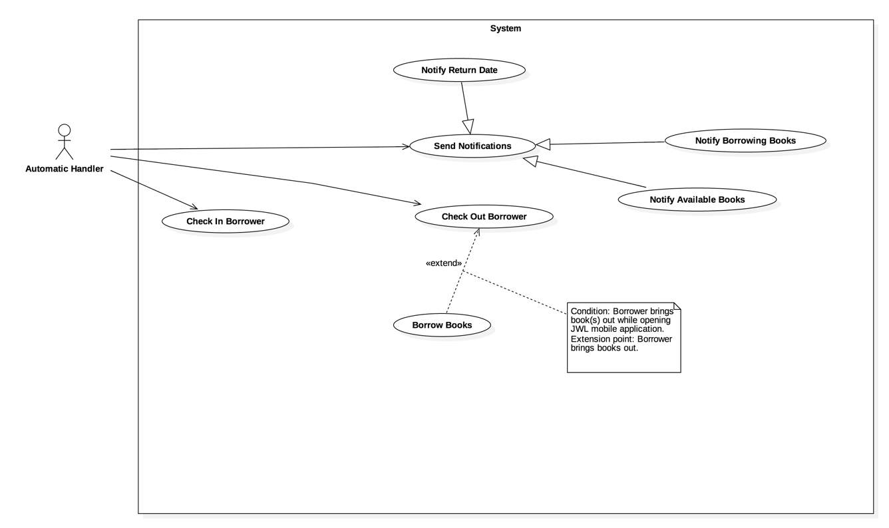

Figure 35: <Automatic Handler> Overview Use Case

##### <Automatic Handler> Check in Borrower



Figure 36: <Automatic Handler> Check in Borrower

|  |  |  |  |
| --- | --- | --- | --- |
| **USE CASE – JWL21** | | | |
| **Use Case No.** | JWL21 | **Use Case Version** | 2.0 |
| **Use Case Name** | Check in Borrower | | |
| **Author** | Vo Hong Ha | | |
| **Date** | February 13, 2017 | **Priority** | High |
| **Actor:**   * Automatic Handler   **Summary:**   * This use case allows Automatic Handler to verify a borrower’s identity.   **Goal:**   * Return message showing the borrower’s identity verification result.   **Triggers:**   * Automatic Handler checks the information of borrowers when they scan smartphone at the check in device.   **Preconditions:**   * NFC: borrower turns on NFC on mobile device. * QR Code: borrower keeps monitor bright on while showing the application. * Borrower keeps mobile phone approximately 10 – 15 cm far away from reader with QR Code check in or touch onto the reader with NFC check in.   **Post Conditions:**   * **Success:**   + The borrower’s status “in library” is updated.  + The message will show on the application.   * **Fail:** N/A   **Main Success Scenario:**   |  |  |  | | --- | --- | --- | | Step | Actor Action | System Response | | 1  2 | Automatic Handler gets the information from Check in Emulator.  Automatic Handler sends “Check in” command.  [ Exception 1] | System check the information of borrower. Then response the message of result: “Chào mừng bạn tới thư viện.”  [Alternative 1, 2] |   **Alternative Scenario:**  Alternative 1:   |  |  |  | | --- | --- | --- | | Step | Cause | System Response | | 1 | The borrower is deactivated. | System response the message of result “Tài khoản của bạn hiện đang bị khoá, vui lòng liên hệ thủ thư.” |   Alternative 2:   |  |  |  | | --- | --- | --- | | Step | Cause | System Response | | 1 | The information of borrower in mobile device is out of date. | System response the message of result “Check-in không thành công, vui lòng làm mới key và thử lại.” |   **Exceptions:** N/A  **Relationships:** N/A  **Business Rules:**   * Automatic Handler receives the response of the system, then plays sound and displays notification in comparable with that response on the Check in Emulator. * NFC and QR Code on mobile application: contains user ID and the identification key of borrower. | | | |

Table 38: <Automatic Handler> Check in Borrower

##### <Automatic Handler> Notify Return Date



Figure 37: <Automatic Handler> Notify return date

|  |  |  |  |
| --- | --- | --- | --- |
| **USE CASE – JWL22** | | | |
| **Use Case No.** | JWL22 | **Use Case Version** | 1.0 |
| **Use Case Name** | Notify return date | | |
| **Author** | Vo Hong Ha | | |
| **Date** | February 13, 2017 | **Priority** | Normal |
| **Actor:**   * Automatic Handler   **Summary:**   * This use case allows Automatic Handler to notify borrower about the return date of books   **Goal:**   * Borrowers are noticed about the return date.   **Triggers:**   * Automatic Handler sends “Return Date Notification” command.   **Preconditions:**   * Borrower has borrowing books that have 3 days remaining. * Automatic Handler hit configured time.   **Post Conditions:**   * **Success:** Borrower receive notification from system. * **Fail:** N/A   **Main Success Scenario:**   |  |  |  | | --- | --- | --- | | Step | Actor Action | System Response | | 1 | Automatic Handler check the current time. If it hits the configured time, Automatic Handler sends “Return Date Notification” command. | System sends notification to borrower:  “Bạn có sách phải trả cho thư viện”.  [Alternative 1] |   **Alternative Scenario:**  Alternative 1:   |  |  |  | | --- | --- | --- | | Step | Cause | System Response | | 1 | The book is overdue. | System sends notification to borrower:  “Sách [title] đang bị trễ hạn [number of days overdue] ngày”. |   **Exceptions:** N/A  **Relationships:** N/A  **Business Rules:**   * After the deadline of book, if the borrower still not return or renew book, Automatic Handler will minus the overdue fines on their balance and send notification of overdue everyday until the borrower return or renew it. * If the borrower does not return book before the late day’s limit, the notification will be sends to the borrower to notify that book is lost, minus the whole money of original book on the balance, deactive the borrower account. | | | |

Table 39: <Automatic Handler> Notify return date

##### <Automatic Handler> Notify Borrowing Books



Figure 38: <Automatic Handler> Notify Borrowing Books

|  |  |  |  |
| --- | --- | --- | --- |
| **USE CASE – JWL23** | | | |
| **Use Case No.** | JWL23 | **Use Case Version** | 1.0 |
| **Use Case Name** | Notify Borrowing Books | | |
| **Author** | Vo Hong Ha | | |
| **Date** | February 13, 2017 | **Priority** | Normal |
| **Actor:**   * Automatic Handler   **Summary:**   * This use case allows Automatic Handler to notify borrowers about their recent borrowed books.   **Goal:**   * Borrowers are noticed those books which they have borrowed   **Triggers:**   * Automatic Handler sends “Recent Book Notification” command.   **Preconditions:**   * Borrower has recent borrow books and check out successfully.   **Post Conditions:**   * **Success:** Borrower receives notification from system. * **Fail:** N/A   **Main Success Scenario:**   |  |  |  | | --- | --- | --- | | Step | Actor Action | System Response | | 1 | Automatic Handler sends “Recent Book Notification” command. | System sends notification to borrower:  “Mượn sách thành công. Vui lòng ấn để xem chi tiết.” |   **Alternative Scenario:** N/A  **Exceptions:** N/A  **Relationships:** N/A  **Business Rules:**   * The notification is sent only if the borrower borrows at least one book. * The borrower can view the list of recently borrowed book by click on the notification. | | | |

Table 40: <Automatic Handler> Notify Borrowing Books

##### <Automatic Handler> Notify Availabe Books



Figure 39: <Automatic Handler> Notify Available Books

|  |  |  |  |
| --- | --- | --- | --- |
| **USE CASE – JWL24** | | | |
| **Use Case No.** | JWL24 | **Use Case Version** | 1.0 |
| **Use Case Name** | Notify Available Books | | |
| **Author** | Vo Hong Ha | | |
| **Date** | February 13, 2017 | **Priority** | Normal |
| **Actor:**   * Automatic Handler   **Summary:**   * This use case allows Automatic Handler to notify borrower about the available book according to borrower’s wish list.   **Goal:**   * Borrowers are noticed those books which are available in the library.   **Triggers:**   * That book’s status become available.   **Preconditions:**   * Borrowers have added that books to their wish list.   **Post Conditions:**   * **Success:** Borrower receive the notification from system. * **Fail:** N/A   **Main Success Scenario:**   |  |  |  | | --- | --- | --- | | Step | Actor Action | System Response | | 1 | Automatic Handler sends “Available Book Notification” command. | System sends notification to borrower:  “Sách [title] bạn theo dõi đã có trong thư viện”. |   **Alternative Scenario:** N/A  **Exceptions:** N/A  **Relationships:** N/A  **Business Rules:**   * After notify borrower, the system will remove that book from borrower’s wish list. | | | |

Table 41: <Automatic Handler> Notify Available Books

##### <Automatic Handler> Check out Borrower



Figure 40: <Automatic Handler> Check out Borrower

|  |  |  |  |
| --- | --- | --- | --- |
| **USE CASE – JWL25** | | | |
| **Use Case No.** | JWL25 | **Use Case Version** | 1.0 |
| **Use Case Name** | Check out Borrower | | |
| **Author** | Vo Hong Ha | | |
| **Date** | February 13, 2017 | **Priority** | High |
| **Actor:**   * Automatic Handler   **Summary:**   * This use case allows Automatic Handler to check out the borrower.   **Goal:**   * Check out the borrowers who go out the library.   **Triggers:**   * Borrower goes into the range of init check out iBeacon.   **Preconditions:**   * Borrower not turn off the mobile application and the turn on Bluetooth, internet connection. * Borrower keeps go out the library.   **Post Conditions:**   * **Success:** Borrower receive the success message. * **Fail:** N/A   **Main Success Scenario:**   |  |  |  | | --- | --- | --- | | Step | Actor Action | System Response | | 1  2  3  4 | Borrower walks into the range of init  check out iBeacon.  Automatic Handler sends “Init  Check out” command.  Borrower walks into the range of  finish check out iBeacon.  Automatic Handler sends “Finish Check out” command. | System response message to borrower:  “Bạn có thể mượn sách”.  System response message to borrower:  “Cám ơn bạn đã sử dụng thư viện”. |   **Alternative Scenario:** N/A  **Exceptions:** N/A  **Relationships:** Extend Borrow Books: Borrower can borrow book while check out.  **Business Rules:**   * After “Finish Check out” command successful, the status of borrower “in library” must be change to “false”. * When “Init Check out” command: * The system only allows one borrower to check out at a time. * The system creates new borrow cart and calculates usable balance. | | | |

Table 42: <Automatic Handler> Check out Borrower

##### <Automatic Handler> Check out Borrow Books



Figure 41: <Automatic Handler> Check out Borrow Books

|  |  |  |  |
| --- | --- | --- | --- |
| **USE CASE – JWL26** | | | |
| **Use Case No.** | JWL26 | **Use Case Version** | 1.0 |
| **Use Case Name** | Borrow Books | | |
| **Author** | Vo Hong Ha | | |
| **Date** | February 13, 2017 | **Priority** | High |
| **Actor:**   * Automatic Handler   **Summary:**   * This use case allows Automatic Handler to scan and save borrower’s books while the borrower is walking out library.   **Goal:**   * Automatically borrow books for borrower.   **Triggers:**   * The Borrower goes through RFID Reader Gate.   **Preconditions:**   * RFID Reader Gate is installed and working correctly. * Each book has RFID tag.   **Post Conditions:**   * **Success:**   + System records all books that borrower borrows.  + Borrower receives notification from system.   * **Fail:** N/A   **Main Success Scenario:**   |  |  |  | | --- | --- | --- | | Step | Actor Action | System Response | | 1  2  3  4 | Borrower goes through RFID  Reader Gate.  Automatic Handler scans books.  Automatic Handler sends “Add New  Scanned Books” command. | System plays successful sounds.  [Exception 1] |   **Alternative Scenario:** N/A  **Exceptions:**   |  |  |  | | --- | --- | --- | | No | Cause | System Response | | 1 | Borrower does not have enough money to borrow more books. | System raises alarm. | | 2 | Borrower exceeds the number of books quota. | System raises alarm. | | 3 | Borrower fails to initiate checkout. | System raises alarm. | | 4 | Borrower has not checked in. | System raises alarm. |   **Relationships:** Extend from Check Out.  **Business Rules:**   * Borrower has initiated check out. * Borrower has enough money to borrow the books he/she is carrying. * Borrower has not exceeded number of books quota. | | | |

Table 43: <Automatic Handler> Check out Borrow Books

## Software System Attribute



### Usability

* The Android application for emulator requires 10 minutes training for librarian.
* The Android application for borrower will take 15-20 minutes to get used to the mobile system completely.
* Admin and Librarian interface are written in English include all dialogs and messages.
* Borrower interface is written in Vietnamese includes all dialogs and message.
* Emulator interface is written in English.

### Reliability

* The number of sending notification failure is 1 time per 1000 notifications.
* The scheduler tasks run at configured time with 100% execution rate.
* RFID Reader has 100% accuracy.

### Availability

* System is available 24 hours per day and 7 days per week.
* System should take at most 5 hours per month for backup or repairing.

### Security

* Privacy: Each role of user has a specific permission to interact with system.
* Only admin can grant permission to other roles.
* System always check the status of borrower before doing anything.

### Maintenanability

* The system is divided into separated modules.
* The code is easy to maintain and upgrade.

### Portability

* The web application can be used in any platform that use Chrome (v25 or above) and can connect to the Internet.
* Mobile application for borrower and emulator runs on Android API greater than 4.4.
* Providing easy installation.

### Performance

* Web appication handles the task within 5 seconds.
* Request from mobile application are responded in less than 10 second at 4Mbps.

### Conceptual Diagram

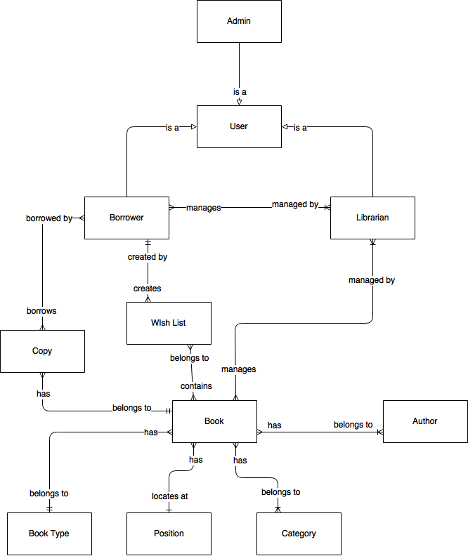

Figure 42: Conceptual Diagram

* **Data Dictionary:**

|  |  |
| --- | --- |
| **Entity Name** | **Description** |
| User | * Contains all information of users in the library. |
| Admin | * Person who manages all accounts. |
| Librarian | * Person who manages all borrowers and books. |
| Book | * Contains all information of books in the library. |
| Copy | * Contains all information of copies of books. |
| Author | * Contains all information of authors of books in the library. |
| Category | * Contains all information of book’s categories, for example, Math, Literature, Physics, Software Engineering, … |
| Book Type | * Contains all information of book’s types, for example, text book or reference book. |
| Position | * Contains all information of physical positions of books in the library. |
| Wish List | * Contains all information of books wished by borrowers. |

Table 44: Conceptual Diagram Data Dictionary

# Software Design Description

## Design Overview

* The architectural design describes the overall architecture of the system and the architecture of each main component and subsystem.
* The detailed design describes static and dynamic structure for each component and functions. It includes class diagrams, class explanations and sequence diagrams for each use cases.
* The database design describes the relationships between entities and details of each entity.
* Document overview:
* Section 1: gives an overall description of the system architecture design.
* Section 2: gives component diagrams that describe the connection and integration of the system.
* Section 3: gives the detail design description, which includes class diagram, class explanation, and sequence diagram to details the application functions.
* Section 4: gives the interface design description, which includes component interface, web application interface and mobile application design.
* Section 5: describe a fully attributed Entity Relationship Diagram.
* Section 6: describe the algorithms that apply to the system.

## System Architectural Design

### Web Application Architecture Description

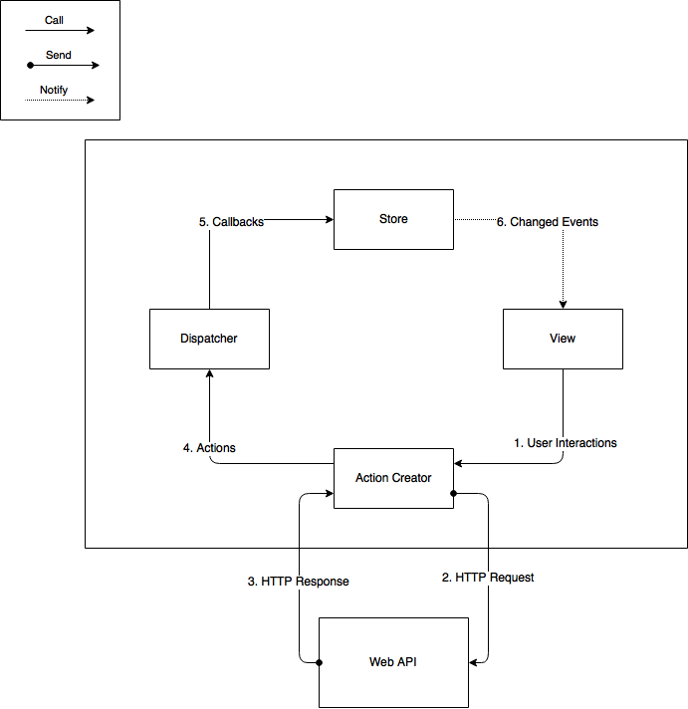

Figure 43: Web Application Architecture

The web application uses React (<https://facebook.github.io/react/)> with Flux (<https://facebook.github.io/flux/>) as its architecture. Flux creates a unidirectional data flow for web applications built with React. We choose this architecture for a couple of reasons:

* Performance: The web application’s render performance is dramatically improved thanks to React. React renders the web application with the help of its virtual DOM. Each React view component has a render method, which will update the virtual DOM. React then compares the updated virtual DOM with a virtual DOM snapshot that was taken right before the update. By doing so, React figures out exactly which virtual DOM objects have change, and only updates those different objects on the real DOM.
* Simplicity: the whole web application is simple to develop and maintain, because the data always flows in one direction. There is no need to handle event listener for each web component like in MVC application. This architecture also separates frontend from backend, so developers are able to work independently.
* Reusability and Testability: The architecture divides the application into components. This increases reusability and testability.

### Web Service Application Architecture Description

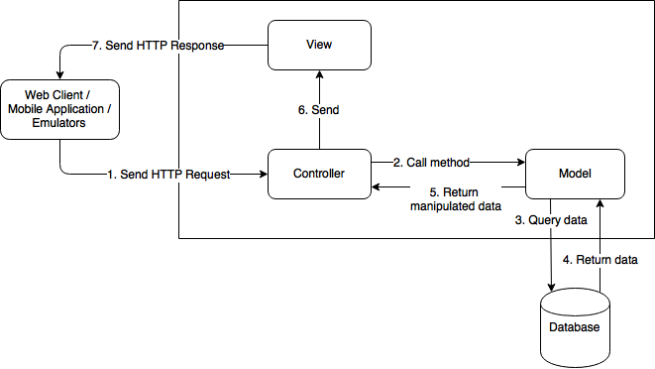

Figure 44: Web Service Architecture

The Web Service Application Architecture uses Model – View - Controller (MVC) architecture. We choose MVC for the following advantages:

* The application will be divided into three clear parts: Model – View – Controller.
* Developing: it is easier for developers to devide work and develop the system.
* Testing, Maintaining, and Extending: thanks to dividing the system into clear components, we decrease the dependence and complexity of the developing process. Therefore, testing, maintaining and extending work become much easier.

### Mobile Application Description



Figure 45: Mobile Application Architecture

Mobile application architecture will use MVC. Therefore, we can organize the code better for maintainability, extensibility, and reusability.

## Component Diagram

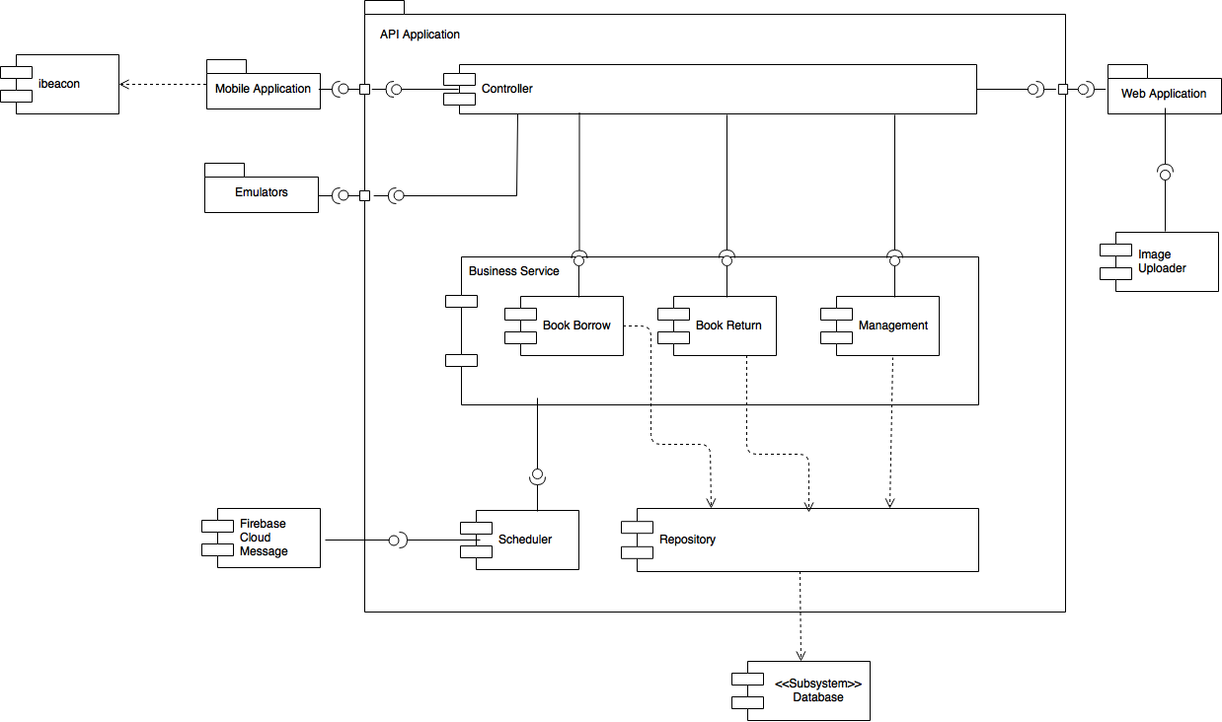

Figure 46: Web Service Architecture

|  |  |
| --- | --- |
| **Name** | **Description** |
| API Application | Provide API for Mobile application, Web application, and Emulators |
| Controller | Handles HTTP requests and calls services |
| Business Service | Handles system’s business operations |
| Management | Manages system data |
| Book Borrow | Handles borrowing books process, including: initiate borrow process, scan books, check out |
| Book Return | Handles return books process by librarian |
| Scheduler | Runs background job and call Notification |
| Repository | Abstract data layer to interact with database system |
| Database System | Stores data of the system |
| Emulators | Handles books scanning and borrower’s identification scanning. Includes Check in device, RFID Reader Gate, and Book scanner for librarian |
| Mobile Application | Provides graphical user interface for borrower |
| Web Application | Provides graphical user interface for librarian and admin |
| Firebase Cloud Message | External Component to send messages to Mobile application |
| Image Uploader | External Component to upload image and create image url |
| iBeacon | Triggers event on Mobile Application to call checkout APIs |
| Table 45: Component Dictionary | |

## Detailed Description

### Class Diagram

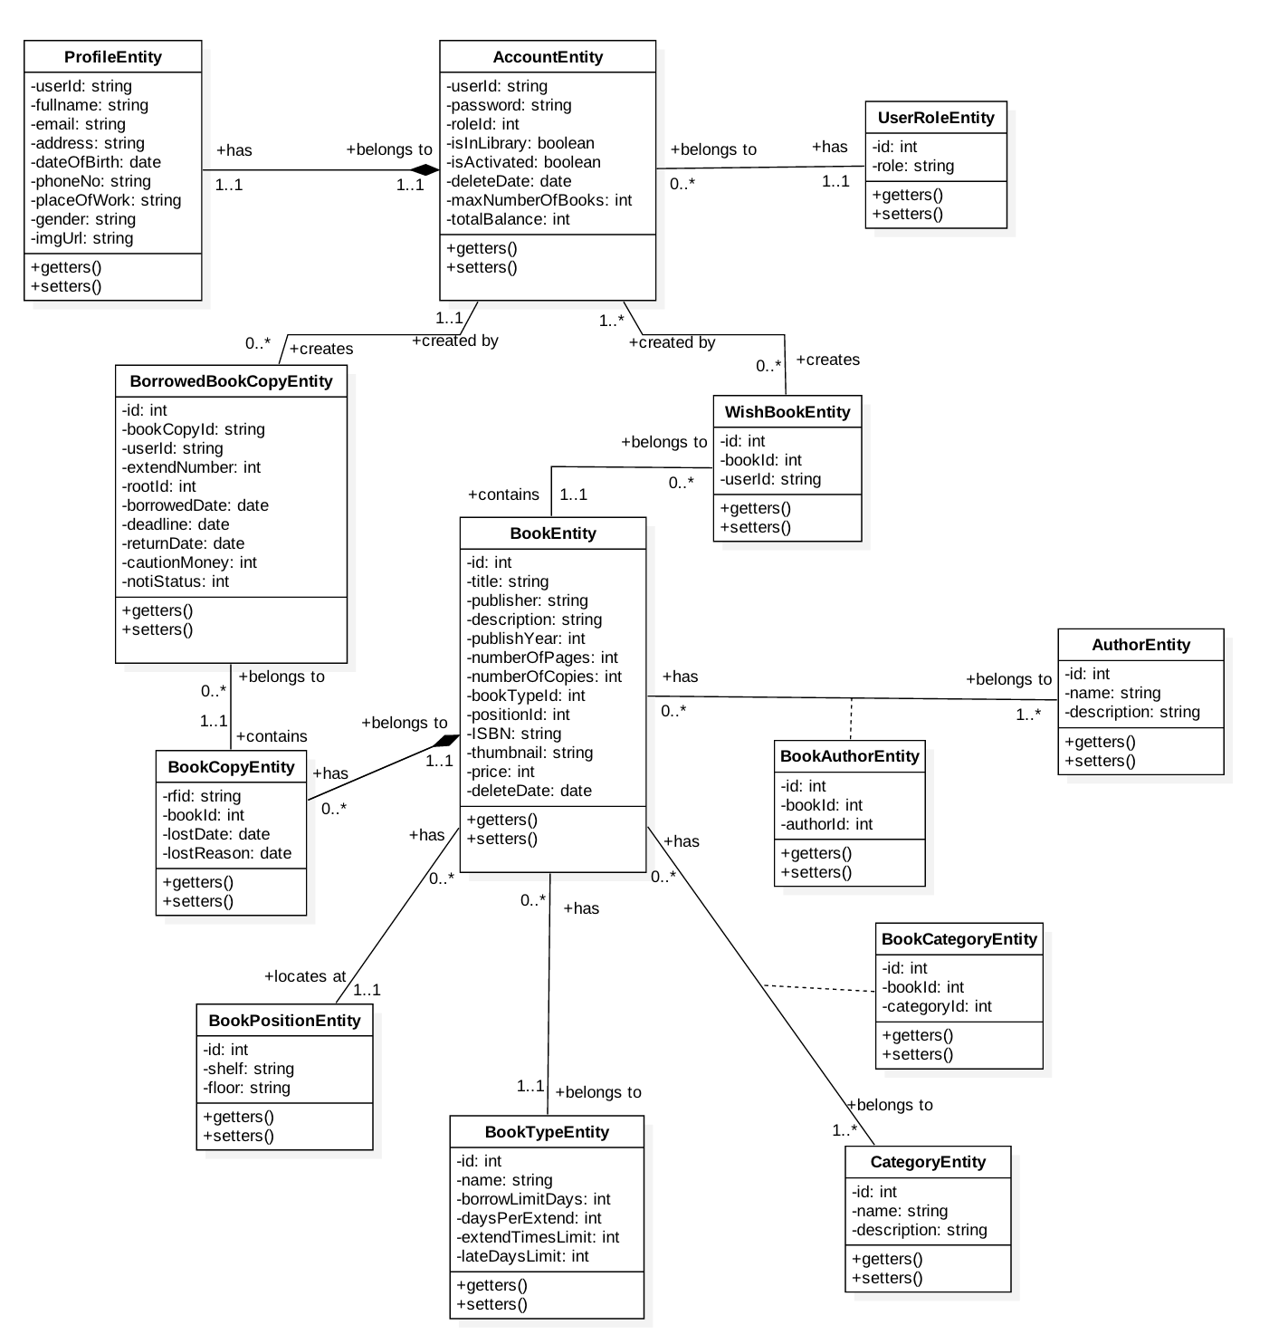

Figure 47: Class Diagram

|  |  |  |
| --- | --- | --- |
| **Class name** | **Mapping column with conceptual diagram** | **Description** |
| ProfileEntity | N/A | Contains the detail information of accounts of the system’s users. |
| AccountEntity | User | Contains the frequently accessed information of accounts of the system’s users. |
| UserRoleEntity | N/A | Contains the information of users’ roles. |
| BookEntity | Book | Contains the information of books in the system. |
| BorrowedBookCopy Entity | N/A | Contains the information of copies that are borrowed by system’s users. |
| BookCopyEntity | Book Copy | Contains the information of copies of the system’s books. |
| WishBookEntity | N/A | Contains the information of books that the system’s users put in their wishlist. |
| AuthorEntity | Author | Contains the information of author in the system. |
| BookAuthorEntity | N/A | Contains the relational information of BookEntity and AuthorEntity |
| CategoryEntity | Category | Contains the information of category of the system’s book. Example of category are math, literature, or IT. |
| BookCategoryEntity | N/A | Contains the relational information of BookEntity and CategoryEntity |
| BookTypeEntity | Book Type | Contains the information of type of the system’s book. Example of book type are reference book, or textbook. |
| BookPositionEntity | Position | Contains the information of book position in the library. Example of book position is floor 1, shelf A. |
| Table 46: Class Diagram Dictionary | | |

### Class Diagram Explanation

#### Profile

**Attributes**

|  |  |  |  |
| --- | --- | --- | --- |
| **Attribute** | **Type** | **Visibility** | **Description** |
| userId | String | Private | Unique id of an account. |
| fullname | String | Private | Full name of an account. |
| email | String | Private | Email of an account. |
| address | String | Private | Home address of an account. |
| dateOfBirth | Date | Private | Date of birth of an account. |
| phoneNo | String | Private | Contact phone number of an account. |
| placeOfWork | String | Private | Company/School name of an account. |
| gender | String | Private | Gender of an account. |
| imgUrl | String | Private | Url of an account’s profile image. |
| Table 47: Profile class attributes explanation | | | |

**Methods**

|  |  |  |  |
| --- | --- | --- | --- |
| **Method** | **Return type** | **Visibility** | **Description** |
| Getter | Attribute type | Public | Get attribute value |
| Setter | Void | Public | Set value of attribute |
| Table 48: Profile class methods explanation | | | |

#### Account

**Attributes**

|  |  |  |  |
| --- | --- | --- | --- |
| **Attribute** | **Type** | **Visibility** | **Description** |
| userId | String | Private | Unique id of an account. |
| password | String | Private | Password of an account. |
| roleId | Integer | Private | Id of user role. |
| isInLibrary | Boolean | Private | Show if an account is in library or not. |
| isActivated | Boolean | Private | Show if an account is activated or deactivated. |
| deleteDate | Date | Private | The Date that an account is deleted. |
| maxNumberOfBooks | Integer | Private | The max number of books an account can borrow. |
| totalBalance | Integer | Private | Total balance of an account. |
| Table 49: Account class attributes explanation | | | |

**Methods**

|  |  |  |  |
| --- | --- | --- | --- |
| **Method** | **Return type** | **Visibility** | **Description** |
| Getter | Attribute type | Public | Get attribute value |
| Setter | Void | Public | Set value of attribute |
| Table 50: Account method methods explanation | | | |

#### UserRole

**Attributes**

|  |  |  |  |
| --- | --- | --- | --- |
| **Attribute** | **Type** | **Visibility** | **Description** |
| id | Integer | Private | Unique id of user role. |
| role | String | Private | Name of user role. |
| Table 51: UserRole class attributes explanation | | | |

**Methods**

|  |  |  |  |
| --- | --- | --- | --- |
| **Method** | **Return type** | **Visibility** | **Description** |
| Getter | Attribute type | Public | Get attribute value |
| Setter | Void | Public | Set value of attribute |
| Table 52: UserRole class methods explanation | | | |

#### Book

**Attributes**

|  |  |  |  |
| --- | --- | --- | --- |
| **Attribute** | **Type** | **Visibility** | **Description** |
| id | Integer | Private | Unique id of a book. |
| title | String | Private | Title of a book. |
| publisher | String | Private | The publisher’s name of a book. |
| description | String | Private | Description for a book. |
| publishYear | Integer | Private | The year that the book is publish. |
| numberOfPages | Integer | Private | Total pages of a book. |
| numberOfCopies | Integer | Private | Total copies of a book in the library. |
| bookTypeId | Integer | Private | Id of book type that a book belongs to. |
| positionId | Integer | Private | Id of position that a book locates at. |
| ISBM | String | Private | ISBM of a book. |
| thumbnail | String | Private | Image url of a book. |
| price | Integer | Private | Value of a book. |
| deleteDate | Date | Private | The date that a book is deleted. |
| Table 53: Book class attributes explanation | | | |

**Methods**

|  |  |  |  |
| --- | --- | --- | --- |
| **Method** | **Return type** | **Visibility** | **Description** |
| Getter | Attribute type | Public | Get attribute value |
| Setter | Void | Public | Set value of attribute |
| Table 54: Book class methods explanation | | | |

#### WishBook

**Attributes**

|  |  |  |  |
| --- | --- | --- | --- |
| **Attribute** | **Type** | **Visibility** | **Description** |
| id | Integer | Private | Unique id of a wishbook. |
| bookId | Integer | Private | Id of the book that a wishbook contains. |
| userId | String | Private | Id of the account that creates the wishbook. |
| Table 55: Wishbook class attributes explanation | | | |

**Methods**

|  |  |  |  |
| --- | --- | --- | --- |
| **Method** | **Return type** | **Visibility** | **Description** |
| Getter | Attribute type | Public | Get attribute value |
| Setter | Void | Public | Set value of attribute |
| Table 56: Wishbook class methods description | | | |

#### BorrowedBookCopy

**Attributes**

|  |  |  |  |
| --- | --- | --- | --- |
| **Attribute** | **Type** | **Visibility** | **Description** |
| id | Integer | Private | Unique id of a borrowedBookCopy. |
| bookCopyId | String | Private | Id of the bookCopy that a borrowedBookCopy belongs to. |
| userId | String | Private | Id of the account that borrows the bookCopy. |
| cautionMoney | Integer | Private | The money that an account has to deposit to borrow a book. This attribute is calculated by *(book’s price + total fine price of that book)* |
| extendNumber | Integer | Private | The time that an account extends a bookCopy’s borrow period. |
| rootId | Integer | Private | Id of the before-extened borrowedBookCopy. |
| borrowedDate | Date | Private | The date that an account borrows a bookCopy. |
| deadline | Date | Private | The date that an account has to return the bookCopy. |
| returnDate | Date | Private | The date that an account returns the bookCopy. |
| notiStatus | Int | Private | The status for system’s scheduler to send notification to borrower. |
| Table 57: BorrowedBookCopy class attributes explanation | | | |

**Methods**

|  |  |  |  |
| --- | --- | --- | --- |
| **Method** | **Return type** | **Visibility** | **Description** |
| Getter | Attribute type | Public | Get attribute value |
| Setter | Void | Public | Set value of attribute |
| Table 58: BorrowedBookCopy class methods explanation | | | |

#### BookCopy

**Attributes**

|  |  |  |  |
| --- | --- | --- | --- |
| **Attribute** | **Type** | **Visibility** | **Description** |
| rfid | String | Private | Unique id of a bookCopy. |
| bookId | Integer | Private | Id of the book that a bookCopy belongs to. |
| lostDate | Date | Private | The date that the copy is lost. |
| lostReason | String | Private | The detail reason why the copy is lost. |
| Table 59: BookCopy class attributes explanation | | | |

**Methods**

|  |  |  |  |
| --- | --- | --- | --- |
| **Method** | **Return type** | **Visibility** | **Description** |
| Getter | Attribute type | Public | Get attribute value |
| Setter | Void | Public | Set value of attribute |
| Table 60: BookCopy class methods explanation | | | |

#### Author

**Attributes**

|  |  |  |  |
| --- | --- | --- | --- |
| **Attribute** | **Type** | **Visibility** | **Description** |
| id | Integer | Private | Unique id of an author. |
| name | String | Private | Name of an author. |
| description | String | Private | Description of an author. |
| Table 61: Author class attributes explanation | | | |

**Methods**

|  |  |  |  |
| --- | --- | --- | --- |
| **Method** | **Return type** | **Visibility** | **Description** |
| Getter | Attribute type | Public | Get attribute value |
| Setter | Void | Public | Set value of attribute |
| Table 62: Author class methods explanation | | | |

#### Category

**Attributes**

|  |  |  |  |
| --- | --- | --- | --- |
| **Attribute** | **Type** | **Visibility** | **Description** |
| id | Integer | Private | Unique id of a category. |
| name | String | Private | Name of a category. |
| description | String | Private | Description of a category. |
| Table 63: Category class attributes explanation | | | |

**Methods**

|  |  |  |  |
| --- | --- | --- | --- |
| **Method** | **Return type** | **Visibility** | **Description** |
| Getter | Attribute type | Public | Get attribute value |
| Setter | Void | Public | Set value of attribute |
| Table 64: Category class methods explanation | | | |

#### BookType

**Attributes**

|  |  |  |  |
| --- | --- | --- | --- |
| **Attribute** | **Type** | **Visibility** | **Description** |
| id | Integer | Private | Unique id of a bookType. |
| name | String | Private | Type of a bookType. |
| borrowLimitDays | Integer | Private | The number of days that a borrower can keep a book. |
| daysPerExtend | Integer | Private | The number of days a borrower can keep a book if he/she extends the book’s borrow period. |
| extendTimesLimit | Integer | Private | The number of times a borrower can extends a book’s borrow period. |
| lateDaysLimit | Integer | Private | The max days that an account can be late in returning a book. |
| Table 65: BookType class attributes explanation | | | |

**Methods**

|  |  |  |  |
| --- | --- | --- | --- |
| **Method** | **Return type** | **Visibility** | **Description** |
| Getter | Attribute type | Public | Get attribute value |
| Setter | Void | Public | Set value of attribute |
| Table 66: BookType class methods explanation | | | |

#### BookPosition

**Attributes**

|  |  |  |  |
| --- | --- | --- | --- |
| **Attribute** | **Type** | **Visibility** | **Description** |
| id | Integer | Private | Unique id of a bookPostion. |
| shelf | String | Private | Name of a shelf in the library. |
| floor | String | Private | Name of a floor in the library. |
| Table 67: BookPosition class attributes explanation | | | |

**Methods**

|  |  |  |  |
| --- | --- | --- | --- |
| **Method** | **Return type** | **Visibility** | **Description** |
| Getter | Attribute type | Public | Get attribute value |
| Setter | Void | Public | Set value of attribute |
| Table 68: BookPosition class methods explanation BookAuthorEntity **Attributes**   |  |  |  |  | | --- | --- | --- | --- | | **Attribute** | **Type** | **Visibility** | **Description** | | id | Integer | Private | Unique id of a bookAuthorEntity. | | bookId | String | Private | Id of a bookEntity. | | authorId | String | Private | .id of an authorEntity. | | Table 69: BookPosition class attributes explanation | | | |   **Methods**   |  |  |  |  | | --- | --- | --- | --- | | **Method** | **Return type** | **Visibility** | **Description** | | Getter | Attribute type | Public | Get attribute value | | Setter | Void | Public | Set value of attribute | | Table 70: BookPosition class methods explanation BookCategoryEntity **Attributes**   |  |  |  |  | | --- | --- | --- | --- | | **Attribute** | **Type** | **Visibility** | **Description** | | id | Integer | Private | Unique id of a bookCategoryEntity. | | bookId | Integer | Private | Id of a bookEntity. | | categoryId | Integer | Private | Id of a categoryEntity. | | Table 71: BookPosition class attributes explanation | | | |   **Methods**   |  |  |  |  | | --- | --- | --- | --- | | **Method** | **Return type** | **Visibility** | **Description** | | Getter | Attribute type | Public | Get attribute value | | Setter | Void | Public | Set value of attribute | | Table 72: BookPosition class methods explanation | | | | | | | | | | | |

### Interaction Diagram

#### Mobile Application

##### Unauthorized User

###### <Unauthorized User> Login

Summary: these diagrams show the process of unauthorized user login into the system using mobile application.

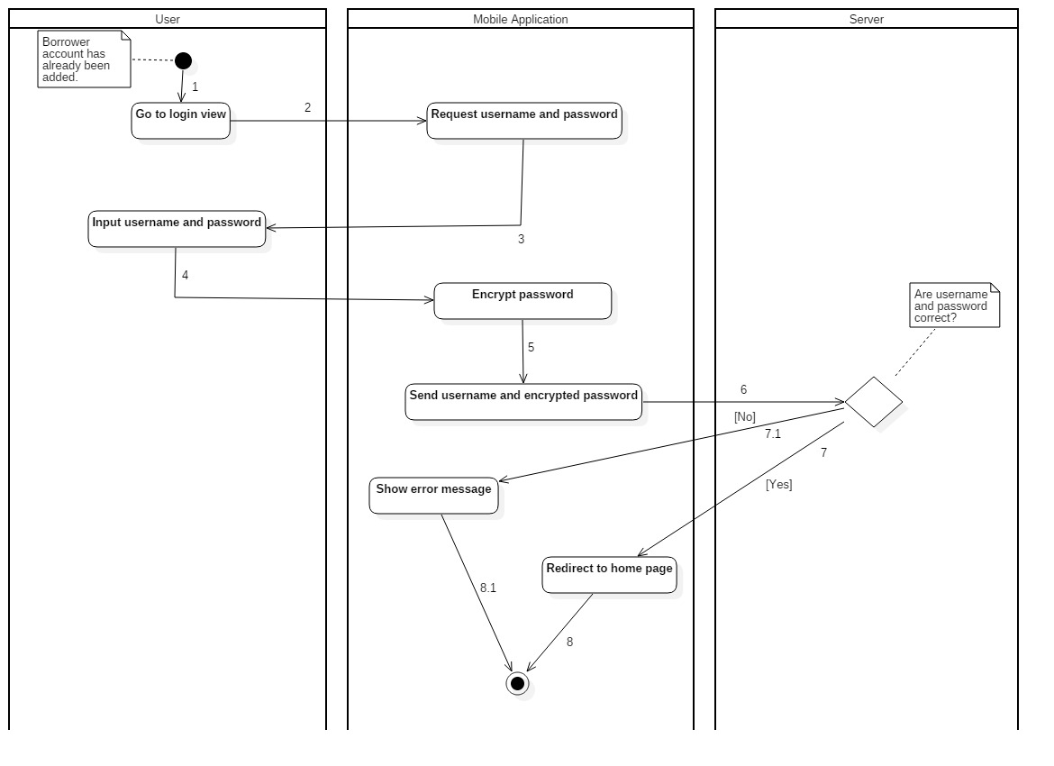

Figure 48: Activity Diagram - <Unauthorized User> Login

|  |  |  |
| --- | --- | --- |
| 1. Start. | 2. Go to login view. | 3. Request username and password. |
| 4. Input username and password. | 5. Encrypt password. | 6. Send username and encrypted password. |
| 7. Username and password are correct. | 8. Redirect to home page. | 7.1. Username and password are not correct. |
| 8.1. Show error message. |  |  |

Table 73: <Unauthorized User> Login

##### Borrower

###### <Borrower> Request new identification key

Summary: this diagram shows the process of borrower request new identification key

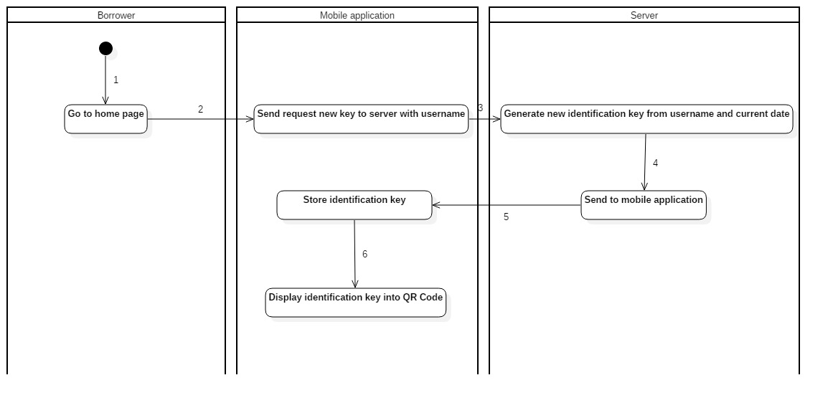

Figure 49: Activity Diagram - <Borrower> Request new identification key

|  |  |  |
| --- | --- | --- |
| 1. Start. | 2. Go to home page. | 3. Send request new key to server with username. |
| 4. Generate new identification key from username and current date. | 5. Send to mobile application. | 6. Store identification key |

Table 50: Activity Diagram - <Borrower> Request new identification key

###### <Borrower> Check in with identification key by NFC

Summary: This diagram shows the process of borrower checking in the library by their smart phone with NFC turned on.

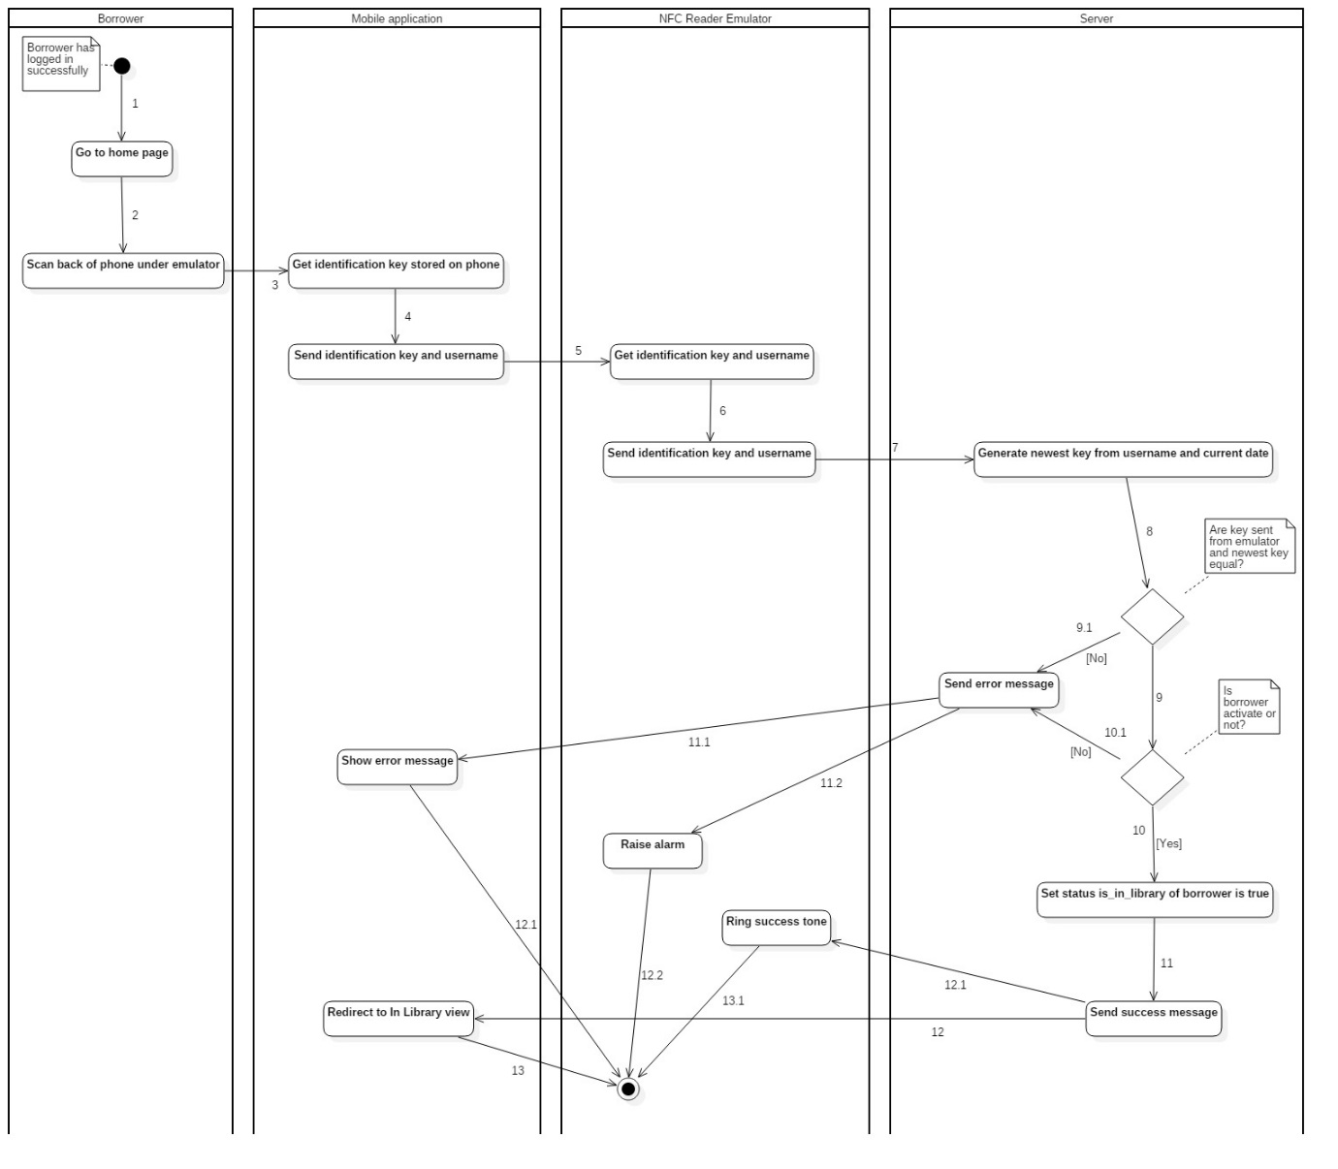

Figure 51: Activity Diagram - <Borrower> Check in with identification key by NFC

|  |  |  |
| --- | --- | --- |
| 1. Start. | 2. Go to home page. | 3. Scan back of phone under emulator. |
| 4. Get identification key stored on phone. | 5. Send identification key and username. | 6. Get identification key and username. |
| 7. Emulator send identification key and username. | 8. Generate newest key from username and current date. | 9. Key sent form emulator and newest key are equal. |
| 10. Set status is\_in\_library of borrower is true. | 11. Send success message. | 12. Redirect to In Library view. |
| 9.1. Key sent form emulator and newest key are not equal. | 11.1. Send error message to mobile app. | 12.1. Mobile app show error message. |
| 10.1. Borrower is not activated. | 11.2. Send error message. | 12.2. Raise alarm. |

Table 74: <Borrower> Check in with identification key by NFC

###### <Borrower> Check in with identification key by QR Code

Summary: This diagram shows the process of borrower checking in the library by QR Code.

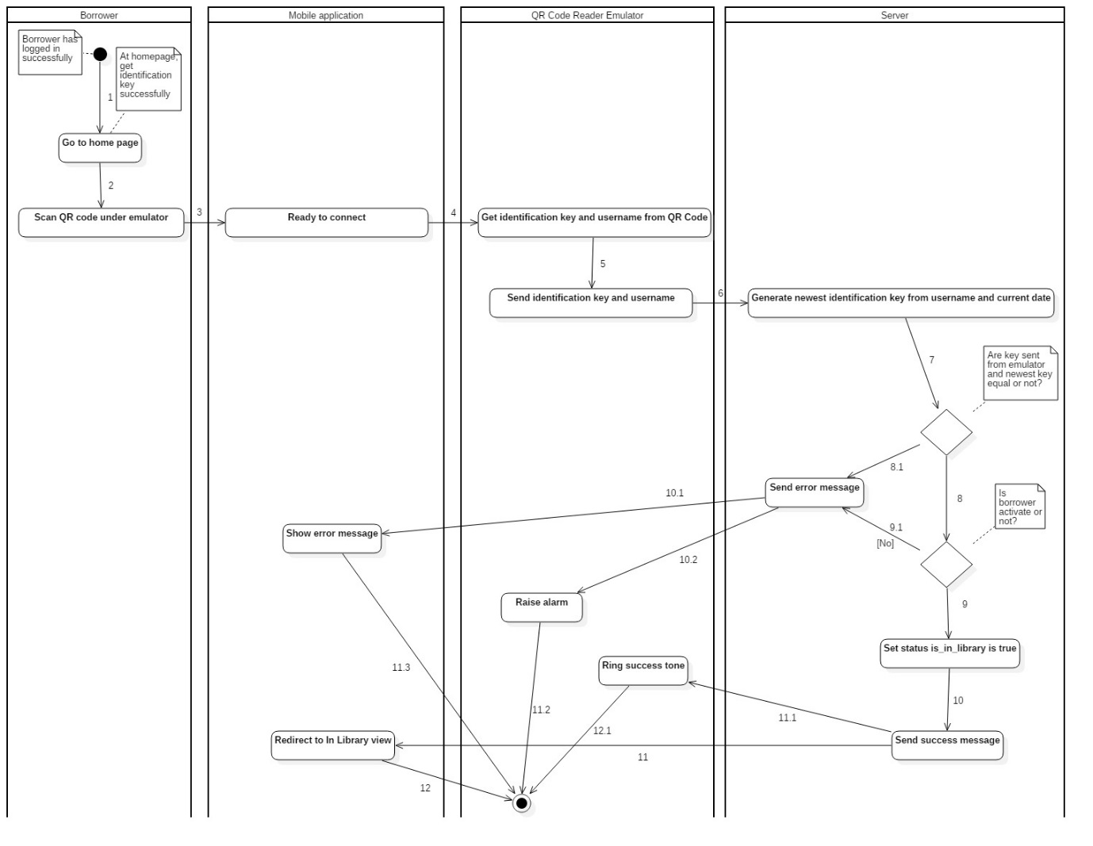

Figure 52: Activity Diagram - <Borrower> Check in with identification key by QR Code

|  |  |  |
| --- | --- | --- |
| 1. Start. | 2. Go to Check in view. | 3. Send user Id to server. |
| 4. Generate newest key from user id. | 5. Receive key from server. | 6. User scan phone under emulator. |
| 7. Borrower phone display key into QR Code. | 8. Emulator connect, get key then send to server. | 9. Generate newest key from user Id. |
| 10b. Key from user and server are not equal. | 10.1b. Notify check in fail to borrower. | 10a. Key from user and server are equal. |
| 10.1a. Borrower phone redirect to In Library view. |  |  |

Table 75: <Borrower> Check in with identification key by QR Code

###### <Borrower> Init check out

Summary: This diagram shows the process of borrowers initiating check out.

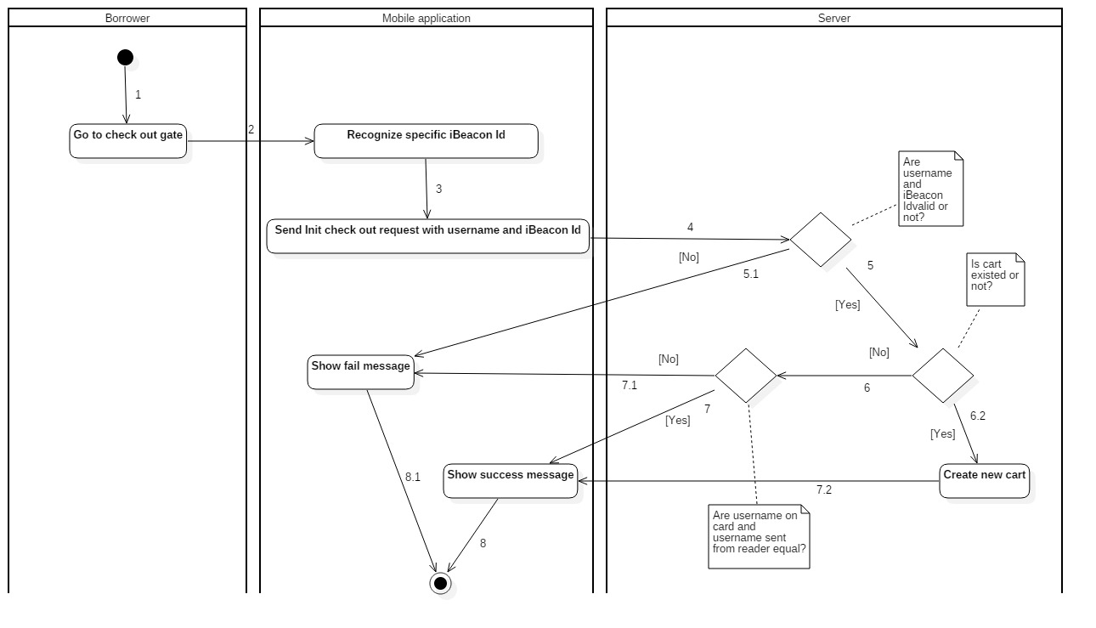

Figure 53: Activity Diagram - <Borrower> Init check out

|  |  |  |  |
| --- | --- | --- | --- |
| 1. Start. | 2. Go to check out gate. |  | 3. Recognize specific iBeacon Id. |
| 4. Send Init check out request with username and iBeacon Id. | 5. Username and iBeacon are valid. |  | 6.2. Cart is existed. |
| 7.2. Create new cart. | 8. Mobile show success message. |  | 5.1. Username or iBeacon Id is not valid. |
| 6.1. Show fail message. | 6. Cart is existed. |  | 7. Username on card is equal with username sent from reader. |
| 8. Mobile show success message. | 7.1 Username on card is not equal with username sent from reader. |  | 8.1 Mobile show fail message. |

Table 76: <Borrower> Init check out

###### <Borrower> Scan book

Summary: This diagram shows the process of borrowers scanning book.

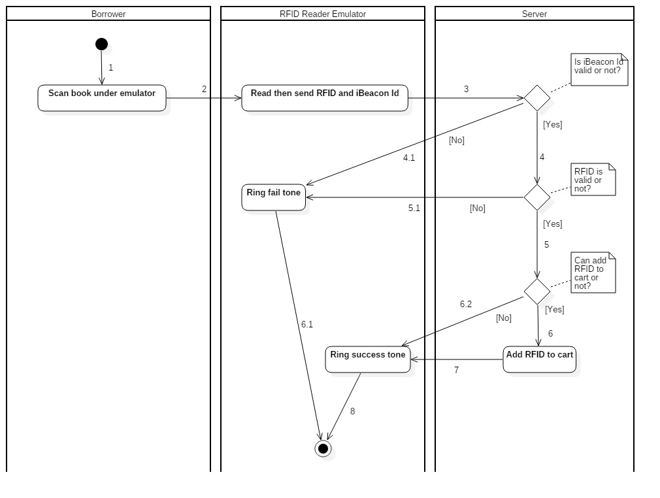

Figure 54: Activity Diagram - <Borrower> Scan book

|  |  |  |
| --- | --- | --- |
| 1. Start. | 2. Borrower scan book under emulator. | 3. Emulator read then send RFID, iBeacon Id. |
| 4. iBeacon Id is valid. | 5. RFID is valid. | 6. Can add RFID to cart. |
| 7. Add RFID to cart. | 8. Mobile application ring success tone. | 4.1. iBeacon Id is not valid. |
| 5.1. RFID is not valid. | 6.1. Ring fail tone. | 6.2. Can not add RFID to cart. |

Table 77: <Borrower> Init check out

###### <Borrower> Finish check out

Summary: This diagram shows the process of borrowers finishing check out.

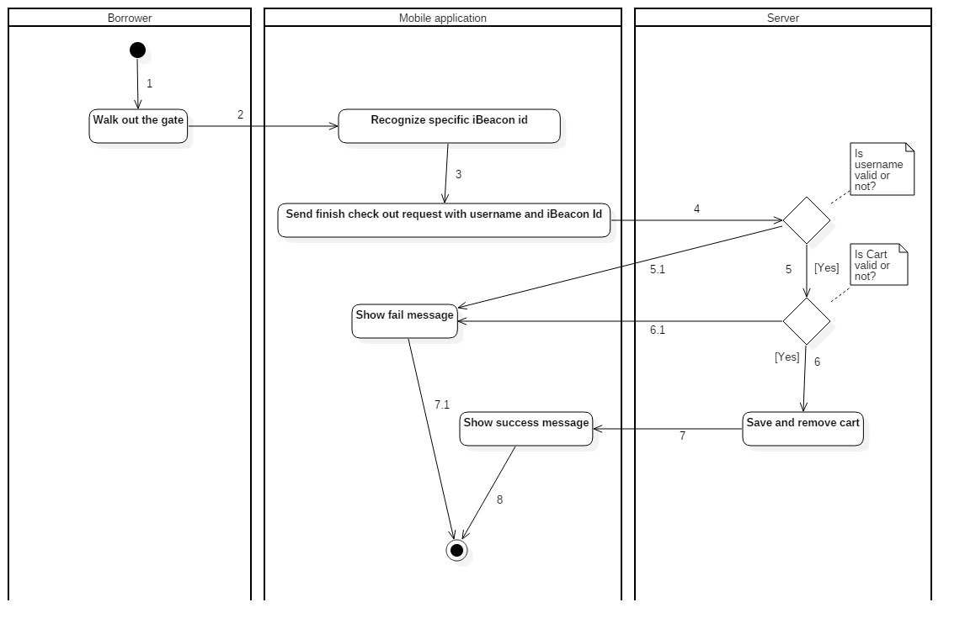

Figure 55: Activity Diagram - <Borrower> Finish check out

|  |  |  |
| --- | --- | --- |
| 1. Start. | 2. Walk out the gate. | 3. Recognize specific iBeacon Id. |
| 4. Send finish check out requeset with username and iBeacon Id. | 5. Username is valid. | 6. Cart is valid. |
| 7. Save and remove cart. | 8. Show success message. | 5.1. Username is not valid. |
| 6.1. Cart is not valid. | 7.1. Show fail message. |  |

Table 78: <Borrower> Finish check out

#### Web Application

##### Librarian Borrow Copies for Borrower

Summary: The diagrams show the process of librarian helping borrower to borrow book copies.

###### <Librarian> Init borrow book copy

Summary: This diagram shows the process of librarian initiating the borrow book copy procedure.

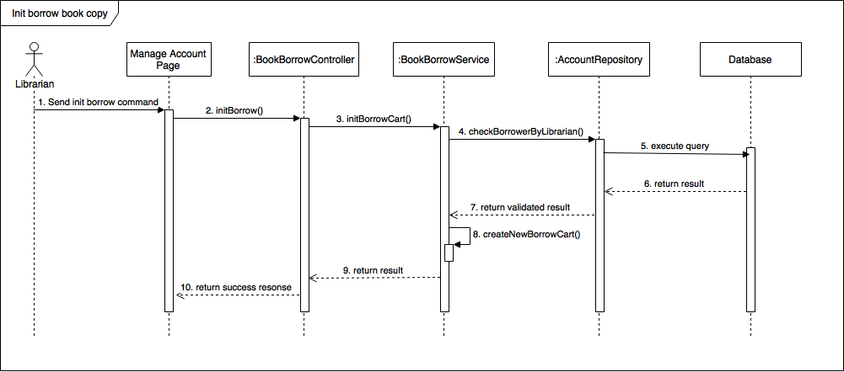

Figure 56: <Librarian> Init borrow book copy

###### <Librarian> Scan borrow copy

Summary: This diagram shows the process of librarian scanning borrow book copies for borrower.

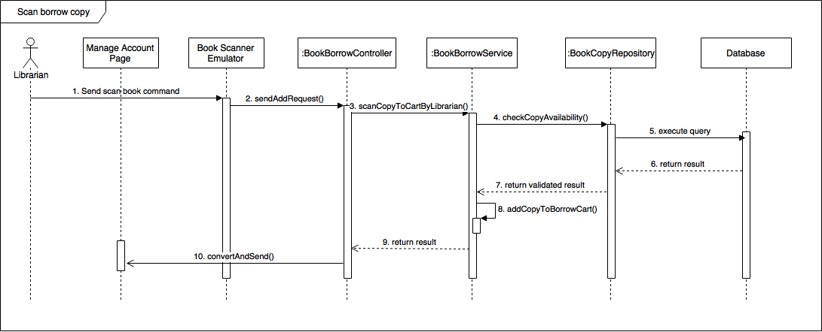 Figure 57: <Librarian> Scan borrow copy

###### <Librarian> Submit borrow copy

Summary: This diagram shows the process of librarian submitting the borrow copies for borrower.

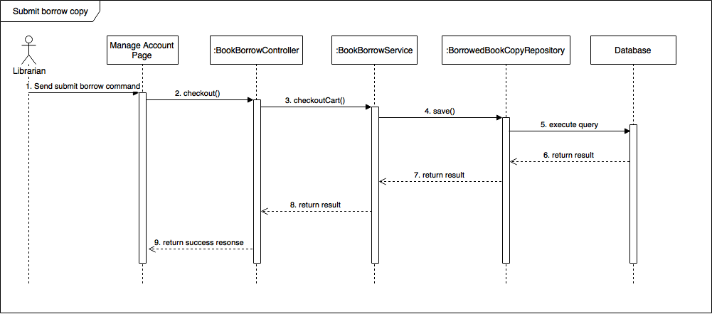 Figure 58: <Librarian> Submit borrow copy

##### Librarian Borrow Copies for Borrower

Summary: The diagrams show the process of librarian returning book copies from borrower to the library.

###### *<Librarian> Scan return copy*

Summary: This diagram shows the process of librarian scanning return book copies from borrower.

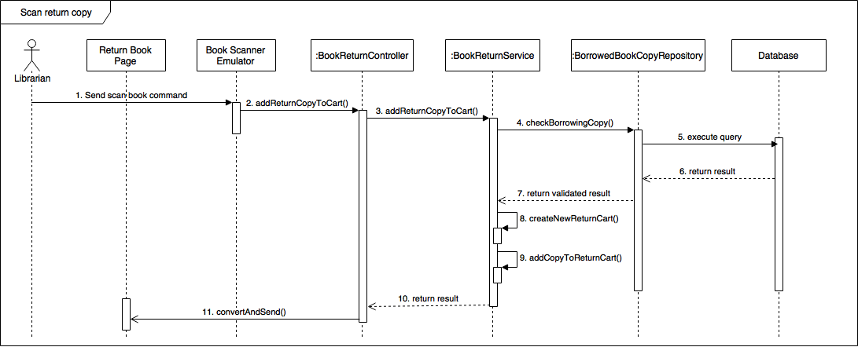 Figure 54: <Librarian> Scan return copy

###### *<Librarian> Submit return copy*

Summary: This diagram shows the process of librarian submitting the return copies from borrower.

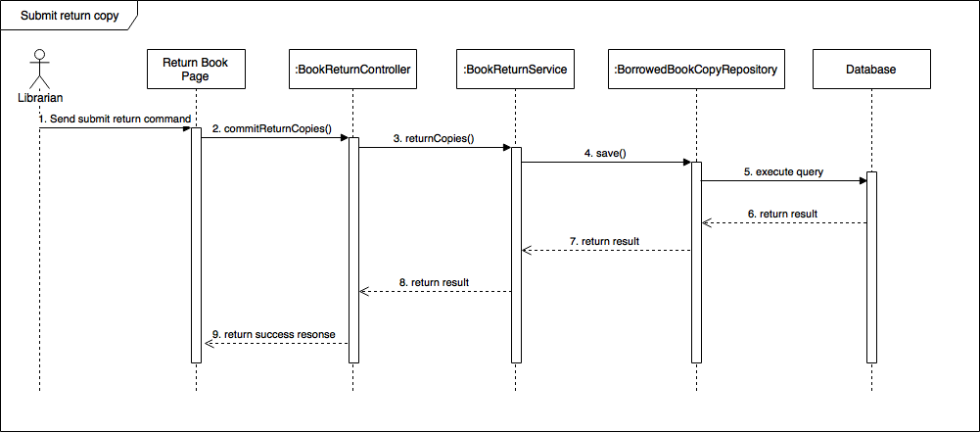 Figure 60: <Librarian> Submit return copy

## Interface

### Component interface

#### Modula of Book Borrow API

|  |  |  |  |  |  |
| --- | --- | --- | --- | --- | --- |
| **Signature** | **Description** | **Input** | **Output** | **Output Format** | **Exception** |
| initBorrowCart(BorrowerDto) | Automated handler initiates book borrowing process for a borrower by giving him/her a borrow cart | BorrowerDto object contains IBeaconId and userId | RestServiceModel contains success or fail status and message | Json | JsonProcessingException |
| initBorrowCartByLibrarian(BorrowerDto) | Librarian initiates book borrowing process for a borrower by giving him/her a borrow cart | BorrowerDto object contains librarianId and userId | RestServiceModel contains success or fail status and message | Json | JsonProcessingException |
| addCopyToCart(RfidDto) | Add a borrower’s borrow book copy to his/her borrow cart | RfidDto object contains iBeaconId and a book copy’s rfid | RestServiceModel contains rfids of successfully added book copies | Json | JsonProcessingException |
| addCopyToCartByLibrarian(RfidDto) | Add a borrower’s borrow book copy to his/her borrow cart by librarian | RfidDto object contains librarianId and a book copy’s rfid | RestServiceModel contains rfids of successfully added book copies | Json | JsonProcessingException |
| checkoutCart(BorrowerDto) | Automatic handler saves a borrower’s scanned book copies, and checkout the library for him/her | BorrowerDto object contains IBeaconId and userId | RestServiceModel contains list of detail of the borrower’s borrowed book copies | Json | JsonProcessingException |
| checkoutCartByLibrarian(BorrowerDto) | Librarian saves a borrower’s scanned book copies, and checkout the library for him/her | BorrowerDto object contains librarianId and userId | RestServiceModel contains list of detail of the borrower’s borrowed book copies | Json | JsonProcessingException |
| cancelAddingBooks(BorrowerDto) | Librarian cancels the book borrowing process of a borrower | BorrowerDto object contains librarianId and userId | RestServiceModel contains list of rfids of canceled book copies | Json | JsonProcessingException |
| getBorrowingBookByUserid(AccountDto) | Get all borrowed book copies of a borrower | AccountDto object contains userId | RestServiceModel contains list of detail of the borrower’s borrowed book copies | Json | JsonProcessingException |
| deleteBorrowingCopy(BorrowedBookCopyDto) | Delete a borrowing book copy of a borrower | BorrowedBookCopyDto object contains userId and the book copy’s rfid | RestServiceModel contains list of detail of the borrower’s remaining borrowed book copies | Json | JsonProcessingException |
| renewBookCopy(String) | Renew the borrow time of a book copy | Rfid of the book copy | RestServiceModel contains detail of the renewed book copy | Json | JsonProcessingException |
| Table 79: Book Borrow API | | | | | |

#### Modula of Book Return API

|  |  |  |  |  |  |
| --- | --- | --- | --- | --- | --- |
| **Signature** | **Description** | **Input** | **Output** | **Output Format** | **Exception** |
| addReturnCopyToCart(RfidDto) | Add a return book copy from borrower to return cart | RfidDto object contains librarianId and the book copy’s rfid | RestServiceModel object contains detail of the return book copy | Json | JsonProcessingException |
| commitReturnCopies(String) | Save return book copies in return cart to database | librarianId | RestServiceModel object contains list of detail of the returned book copies | Json | JsonProcessingException |
| cancelReturnCopies(String) | Cancel the current book return process | librarianId | RestServiceModel object contains cancel success/fail status and message | Json | JsonProcessingException |
| Table 80: Book Return API | | | | | |

#### Modula of Book API

|  |  |  |  |  |  |
| --- | --- | --- | --- | --- | --- |
| **Signature** | **Description** | **Input** | **Output** | **Output Format** | **Exception** |
| getAllBooks() | Get all books in the library |  | RestServiceModel object contains list of books | Json | JsonProcessingException |
| getBookDetail(int) | Get detail of a book | bookId | RestServiceModel object contains detail of a book | Json | JsonProcessingException |
| getBorrowingCopies(int) | Get all borrowing copies of a book | bookId | RestServiceModel object contains list of borrowing copies of a book | Json | JsonProcessingException |
| searchBooks(String, String) | Search book | Params search\_term and user\_id | RestServiceModel object contains list of search result | Json | JsonProcessingException |
| Table 81: Book API | | | | | |

#### Modula of History API

|  |  |  |  |  |  |
| --- | --- | --- | --- | --- | --- |
| **Signature** | **Description** | **Input** | **Output** | **Output Format** | **Exception** |
| getHistory(String) | Get list of all book copies that a borrower borrowed | userId | RestServiceModel object contains list of detail of borrowed book copies | Json | JsonProcessingException |
| Table 82: History API | | | | | |

#### Modula of User API

|  |  |  |  |  |  |
| --- | --- | --- | --- | --- | --- |
| **Signature** | **Description** | **Input** | **Output** | **Output Format** | **Exception** |
| getAllUser() | Get all accounts of the library |  | RestServiceModel object contains list of accounts | Json | JsonProcessingException |
| getAllBorrower() | Get all borrower accounts of the library |  | RestServiceModel object contains list of borrower accounts | Json | JsonProcessingException |
| createUser(UserDto) | Create a new account | UserDto object contain detail information of the new account | RestServiceModel object contains information of the newly created account | Json | JsonProcessingException |
| login(AccountDto) | Login an account. | AccountDto object contain userId and password | RestServiceModel object contains some information of the logged in account (not including password) | Json | JsonProcessingException |
| loginByStaff(AccountDto) | Login a librarian/admin account. | AccountDto object contain userId and password | RestServiceModel object contains some information of the logged in account (not including password) | Json | JsonProcessingException |
| search(String) | Search account in the library | Param term | RestServiceModel object contains list of search result | Json | JsonProcessingException |
| searchBorrowers(String) | Search borrowers in the library | Param term | RestServiceModel object contains list of search result | Json | JsonProcessingException |
| getDetail(String) | Get detail information of an account | userId | RestServiceModel object contains detail of an account | Json | JsonProcessingException |
| getStatus(String) | Get status of an account: in library or not | userId | RestServiceModel object contains the account’s wanted status | Json | JsonProcessingException |
| updateToken(String, String) | Update an account’s Google token | Params userId and googleToken | void | Json | JsonProcessingException |
| requestKey(String) | Generate a unique key of an account to use in checking in the library | userId | RestServiceModel object contains the wanted requestKey string | Json | JsonProcessingException |
| checkin(String, String) | Checkin an account | userId,  and param key (the account’s unique key) | RestServiceModel object contains checkin successful result (true/false) | Json | JsonProcessingException |
| getSystemDate() | Get the current date of the system |  | RestServiceModel object contains the string date | Json | JsonProcessingException |
| updateTotalBalance(AccountDto) | Update the total balance of a borrower | AccountDto Object contain userId | RestServiceModel object contains the new value of borrower’s balance | Json | JsonProcessingException |
| setIsActivate(Boolean, String) | Activate/Deactivate an account | isActivate, userId | RestServiceModel object contains the status of account | Json | JsonProcessingException |
| Table 83: User API | | | | | |

#### Modula of WishBook API

|  |  |  |  |  |  |
| --- | --- | --- | --- | --- | --- |
| **Signature** | **Description** | **Input** | **Output** | **Output Format** | **Exception** |
| addToWishList(String, String) | Add a book to an account’s wishlist | Params user\_id and book\_id | RestServiceModel object contains the added book | Json | JsonProcessingException |
| removeFromWishList(String, String) | Remove a book from an account’s wishlist | Params user\_id and book\_id | RestServiceModel object contains the removed book | Json | JsonProcessingException |
| Table 84: WishBook API | | | | | |

### User Interface Design

#### Mobile Application Design

##### Unauthorized User

###### <Unauthorized User> Login

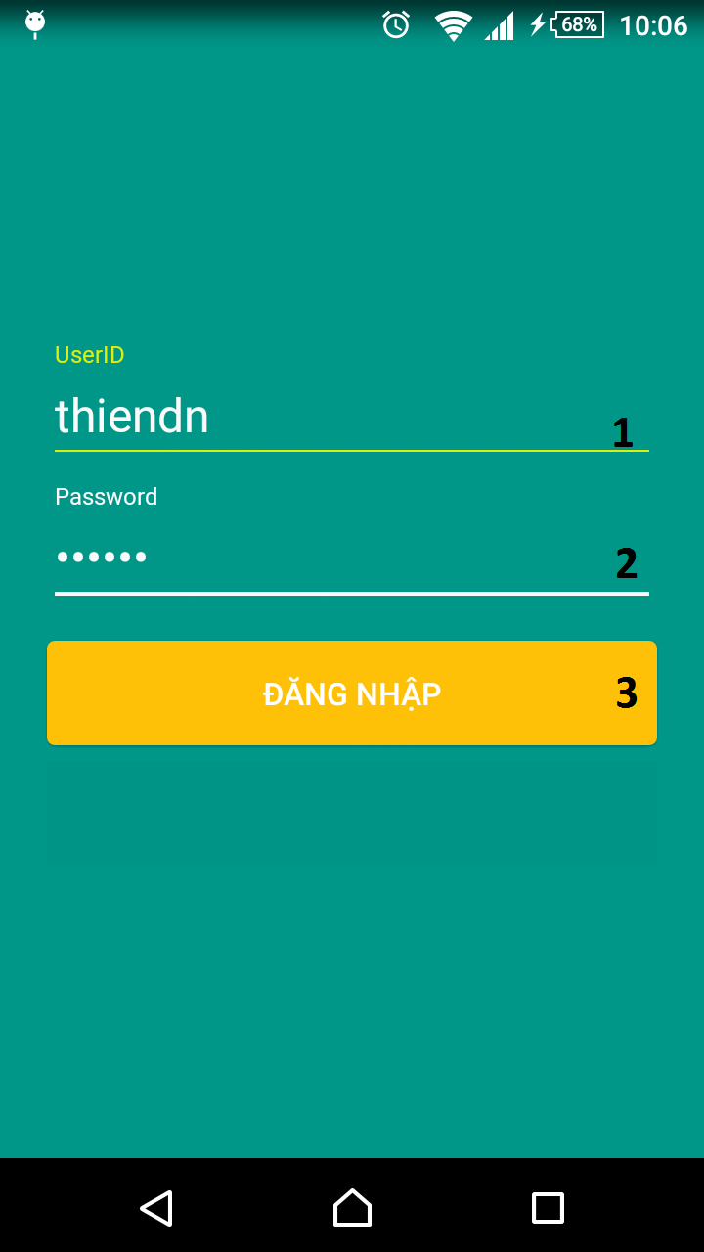

Figure 56: Mobile application UI - <Unauthorized User> Login

**Fields**

|  |  |  |  |  |  |  |  |
| --- | --- | --- | --- | --- | --- | --- | --- |
| **No** | **Field name** | **Description** | **Read only** | **Mandatory** | **Control type** | **Data type** | **Length** |
| 1 | UserID | Fill in text | No | Yes | Textbox | String | N/A |
| 2 | Password | Fill in password | No | Yes | Password | String | N/A |
| Table 85: Mobile application UI - <Unauthorized User> Login Fields. | | | | | |  |  |

**Buttons/Hyperlinks**

|  |  |  |  |  |
| --- | --- | --- | --- | --- |
| **No** | **Function** | **Description** | **Validation** | **Outcome** |
| 3 | Login | Login to the system | UserID and Password can not blank. | Transfer to specific page with specific account. |

Table 86: Mobile application UI - <Unauthorized User> Login Buttons/Hyperlinks

##### Authorized User

###### <Borrower> Home Page

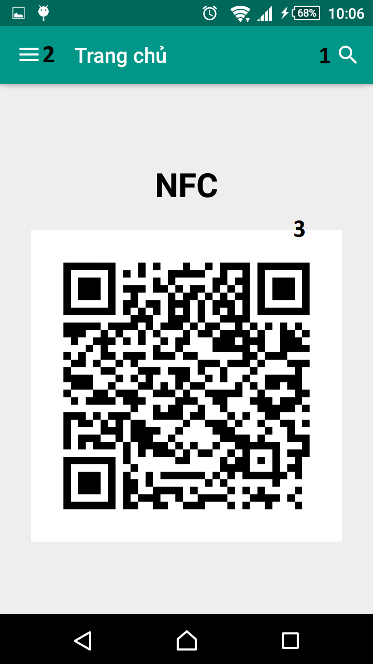

Figure 57: Mobile application UI - <Borrower> Home Page

**Buttons/Hyperlink**

|  |  |  |  |  |
| --- | --- | --- | --- | --- |
| **No** | **Function** | **Description** | **Validation** | **Outcome** |
| **1** | Search | Search for book | N/A | Display search bar |
| **2** | Show menu | Open drawer menu | N/A | Display drawer menu at the left |

Table 87: Mobile application UI - <Borrower> Home Page Buttons/Hyperlink

**Fields**

|  |  |  |  |  |  |  |  |
| --- | --- | --- | --- | --- | --- | --- | --- |
| **No** | **Field name** | **Description** | **Read only** | **Mandatory** | **Control type** | **Data type** | **Length** |
| **3** | QRCode | QRCode Image content private key and user Id | Yes | Yes | ImageView | Bitmap | N/A |

Table 88: Mobile application UI - <Borrower> Home Page Fields

###### <Borrower> View borrowing books

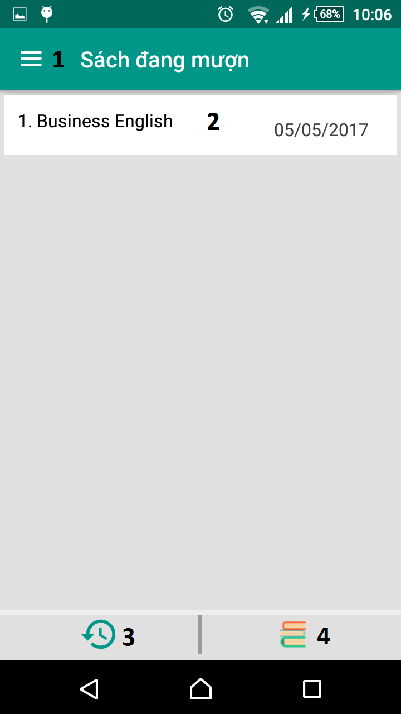

Figure 58: Mobile application UI - <Borrower> View borrowing books.

**Buttons/Hyperlinks**

|  |  |  |  |  |
| --- | --- | --- | --- | --- |
| **No** | **Function** | **Description** | **Validation** | **Outcome** |
| **1** | Menu | Open left | N/A | Display drawer menu at the left |
| **2** | Book | View book detail | N/A | Book detail page is displayed |
| **3** | Borrowing books | Open borrowing books tab | N/A | Borrowing books tab is displayed |
| **4** | Recent books | Open recent books tab | Available only if recently borrow books. | Recent books tab is displayed |

Table 89: Mobile application UI - <Borrower> Borrowing Books Buttons/Hyperlink

###### <Borrower> History

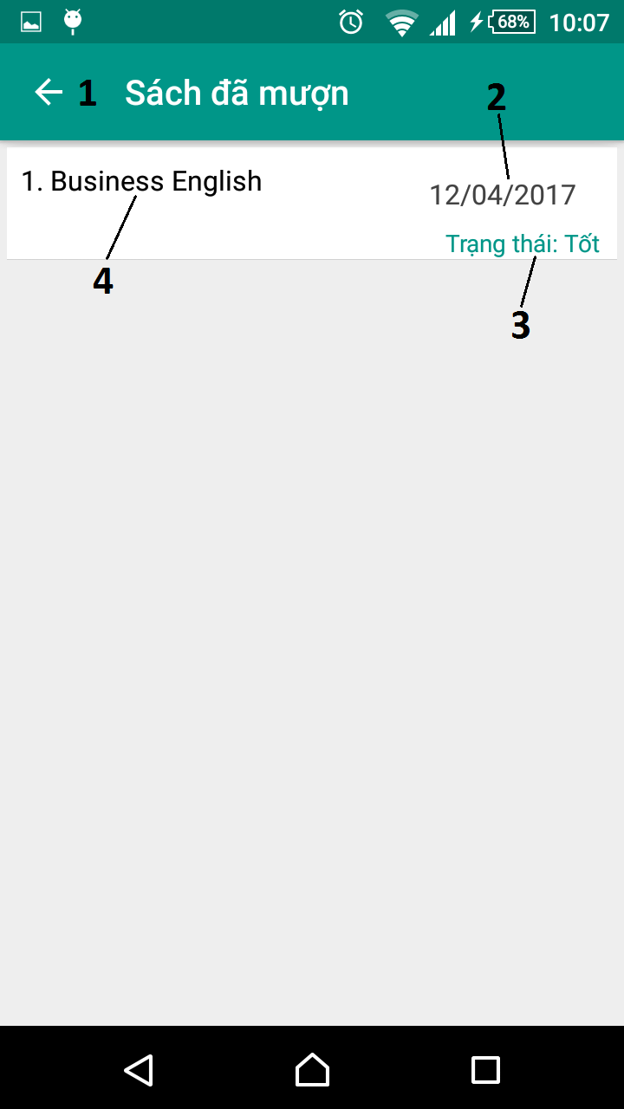

Figure 59: Mobile application UI - <Borrower> View history

**Buttons/Hyperlinks**

|  |  |  |  |  |
| --- | --- | --- | --- | --- |
| **No** | **Function** | **Description** | **Validation** | **Outcome** |
| **1** | Back | Return to previous step | N/A | Return to Home Page or Borrowing Books. |

Table 90: Mobile application UI - <Borrower> History Buttons/Hyperlink

**Fields**

|  |  |  |  |  |  |  |  |
| --- | --- | --- | --- | --- | --- | --- | --- |
| **No** | **Field name** | **Description** | **Read only** | **Mandatory** | **Control type** | **Data type** | **Length** |
| **2** | Deadline | Deadline of a borrowed book. | Yes | Yes | Text view | String | N/A |
| **3** | Status | Returning’s status. | Yes | Yes | Text view | String | N/A |
| **4** | Book name | Name of book | Yes | Yes | Text view | String | N/A |

Table 91: Mobile application UI - <Borrower> History Fields

###### <Borrower> View search result

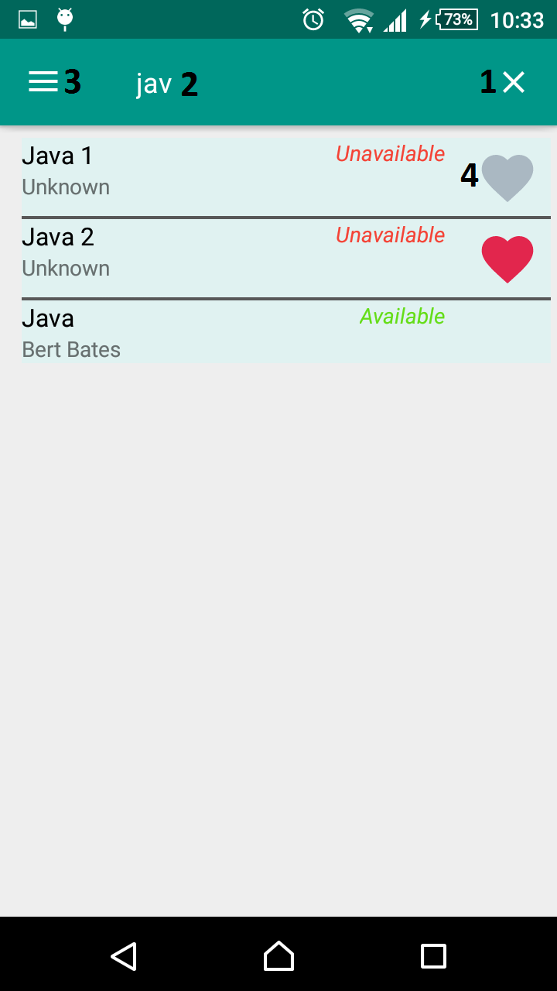

Figure 60: Mobile application UI - <Borrower> View search result

**Buttons/Hyperlinks**

|  |  |  |  |  |
| --- | --- | --- | --- | --- |
| **No** | **Function** | **Description** | **Validation** | **Outcome** |
| **1** | Clear search key | Clear search query | N/A | Search box will be cleared |
| **3** | Menu | Open left | N/A | Display drawer menu at the left |
| **4** | Add to wishlist | Add not available book to wishlist of borrower | Enable only if book is not available | Button change color if success |

Table 92: Mobile application UI - <Borrower> View Search Result Buttons/Hyperlink

**Fields**

|  |  |  |  |  |  |  |  |
| --- | --- | --- | --- | --- | --- | --- | --- |
| **No** | **Field name** | **Description** | **Read only** | **Mandatory** | **Control type** | **Data type** | **Length** |
| **2** | Search box | Name of book to want to search | No | Yes | Edit Text | String | N/A |

Table 93: Mobile application UI - <Borrower> View Search Result Fields

###### <Borrower> View book detail

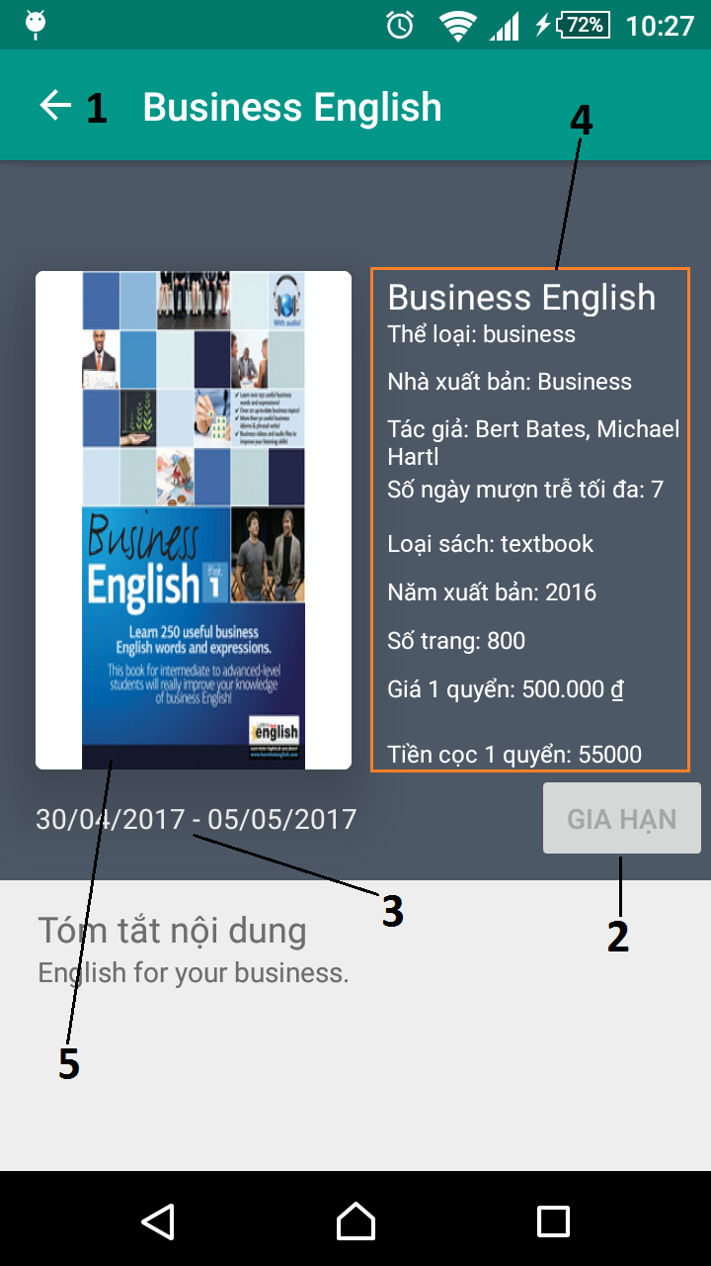

Figure 61: Mobile application UI - <Borrower> View book detail

**Buttons/Hyperlinks**

|  |  |  |  |  |
| --- | --- | --- | --- | --- |
| **No** | **Function** | **Description** | **Validation** | **Outcome** |
| **1** | Back | Return to previous step | N/A | Return to Borrowing Books. |
| **2** | Renew | Renew a book | Only if book is near or miss deadline. | Book is renewed then redirect to borrowing books list. |

**Fields**

|  |  |  |  |  |  |  |  |
| --- | --- | --- | --- | --- | --- | --- | --- |
| **No** | **Field name** | **Description** | **Read only** | **Mandatory** | **Control type** | **Data type** | **Length** |
| **3** | Search box | Borrowed date and deadline | Yes | Yes | Text view | String | N/A |
| **4** | Book’s information | Detail information of book | Yes | Yes | Text view | String | N/A |
| **5** | Book’s thumbnail | Thumbnail of book | Yes | Yes | ImageView | Bitmap | N/A |

#### Web Application Design

##### Admin

###### <Admin> Manage Accounts

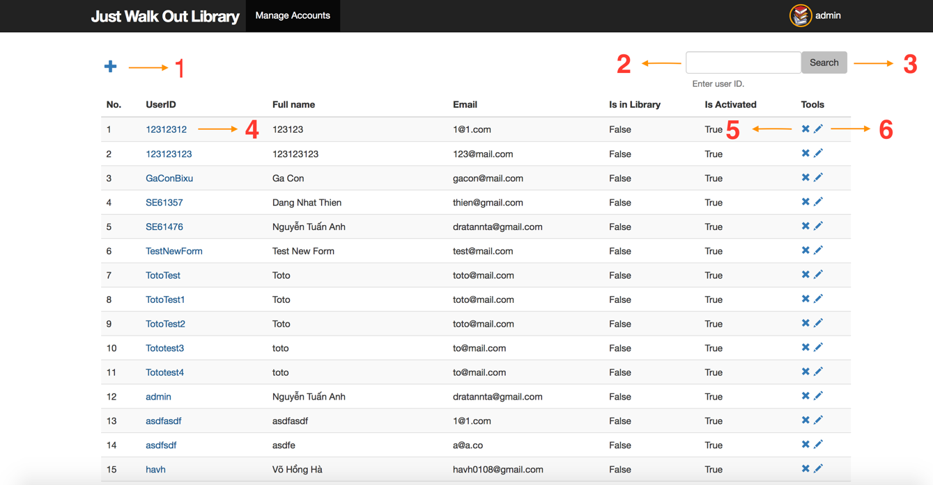

Figure 66: Web application UI - <Admin> Manage Accounts

**Fields**

|  |  |  |  |  |  |  |  |
| --- | --- | --- | --- | --- | --- | --- | --- |
| **No** | **Field Name** | **Description** | **Read Only** | **Mandatory** | **Control Type** | **Data Type** | **Length** |
| **2** | Search Input | Take search term as user ID | No | Yes | Textbox | String | N/A |

Table 78: Web application UI - <Admin> Manage Accounts Fields

**Buttons/Hyperlinks**

|  |  |  |  |  |
| --- | --- | --- | --- | --- |
| **No** | **Function** | **Description** | **Validation** | **Outcome** |
| **1** | showNewAccountView | Go to create new account view | N/A | Redirect to create new account view |
| **3** | searchAccounts | Search accounts by search term | N/A | Call search accounts api |
| **4** | showAccountDetailView | Go to account detail view | N/A | Redirect to account detail view |
| **5** | deleteAccount | Delete chosen account | N/A | Call delete account api |
| **6** | showEditAccountView | Go to edit account view | N/A | Redirect to edit account view |

Table 79: Web application UI - <Admin> Manage Accounts Buttons/links

###### <Admin> Create New Account

**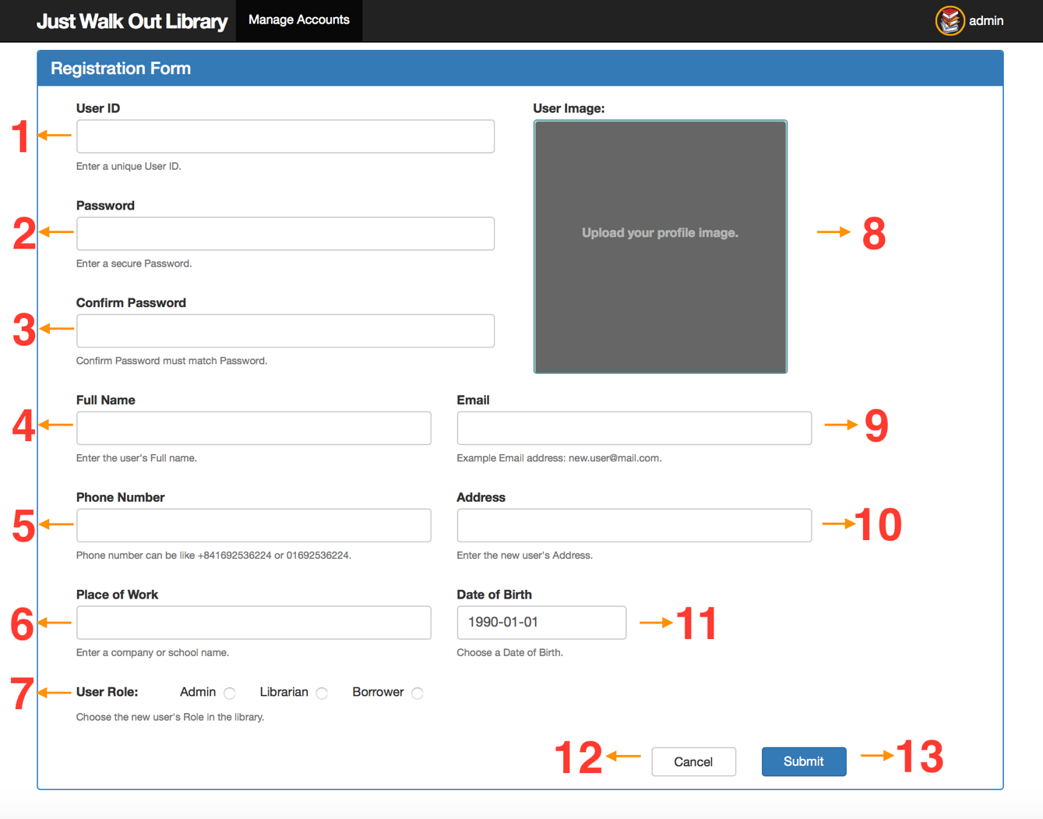**

Figure 67: Web application UI - <Admin> Create New Account

**Fields**

|  |  |  |  |  |  |  |  |
| --- | --- | --- | --- | --- | --- | --- | --- |
| **No** | **Field Name** | **Description** | **Read Only** | **Mandatory** | **Control Type** | **Data Type** | **Length** |
| **1** | User ID input | Fill in the unique user ID of the new account | No | Yes | Textbox | String | N/A |
| **2** | Password input | Fill in the password of the new account | No | Yes | Textbox | String | N/A |
| **3** | Confirm password input | Fill in the confirm password | No | Yes | Textbox | String | N/A |
| **4** | Full name input | Fill in the full name of the new account | No | Yes | Textbox | String | N/A |
| **5** | Phone number input | Fill in the phone number of the new account | No | Yes | Textbox | String | N/A |
| **6** | Place of work input | Fill in the work place of the new account | No | Yes | Textbox | String | N/A |
| **7** | Role input | Choose one of the available user roles for the new account | No | Yes | Radio button | String | N/A |
| **8** | User image input | Choose the profile image of the new account | No | Yes | Image input | String | N/A |
| **9** | Email input | Fill in the email of the new account | No | Yes | Textbox | String | N/A |
| **10** | Address input | Fill in the address of the new account | No | Yes | Textbox | String | N/A |
| **11** | Date of birth input | Fill in the date of birth of the new account | No | Yes | Date picker | String | N/A |

Table 80: Web application UI - <Admin> Create New Account Fields

**Buttons/Hyperlinks**

|  |  |  |  |  |
| --- | --- | --- | --- | --- |
| **No** | **Function** | **Description** | **Validation** | **Outcome** |
| **12** | cancelCreate | Discard changes and go back to the manage accounts page | N/A | Redirect to the manage accounts page |
| **13** | submitNewAccount | Save new account’s information to the system | Check for each input’s validation before saving information to the system | Create a new account and redirect to the manage accounts view |

Table 81: Web application UI - <Admin> Create New Account Buttons/links

###### <Admin> Get Account Detail

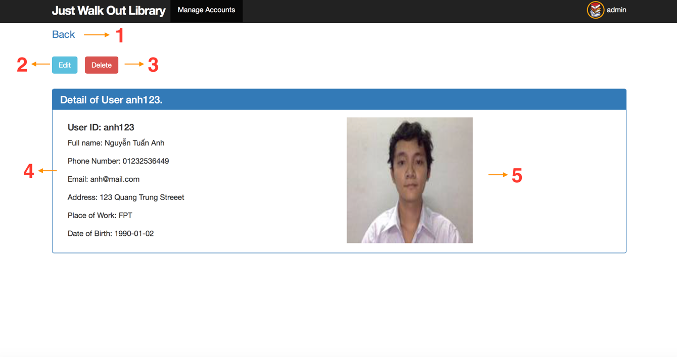

Figure 68: Web application UI - <Admin> Get Account Detail

**Fields**

|  |  |  |  |  |  |  |  |
| --- | --- | --- | --- | --- | --- | --- | --- |
| **No** | **Field Name** | **Description** | **Read Only** | **Mandatory** | **Control Type** | **Data Type** | **Length** |
| **4** | Account’s detail information | Show all the detail information of the account | Yes | Yes | Textbox | String | N/A |
| **4** | Account’s profile image | Show the account’s profile image | Yes | Yes | Image | String | N/A |

Table 82: Web application UI - <Admin> Get Account Detail Fields

**Buttons/Hyperlinks**

|  |  |  |  |  |
| --- | --- | --- | --- | --- |
| **No** | **Function** | **Description** | **Validation** | **Outcome** |
| **1** | back | Go back to the last visited link | N/A | Redirect to the last visited link |
| **2** | showEditAccountPage | Go to the edit account view | N/A | Redirect to the edit account view |
| **3** | deleteAccount | Delete current account | N/A | Delete the account and redirect to manage accounts view |

Table 83: Web application UI - <Admin> Get Account Detail Buttons/links

##### Librarian

###### <Librarian> Get Account Detail

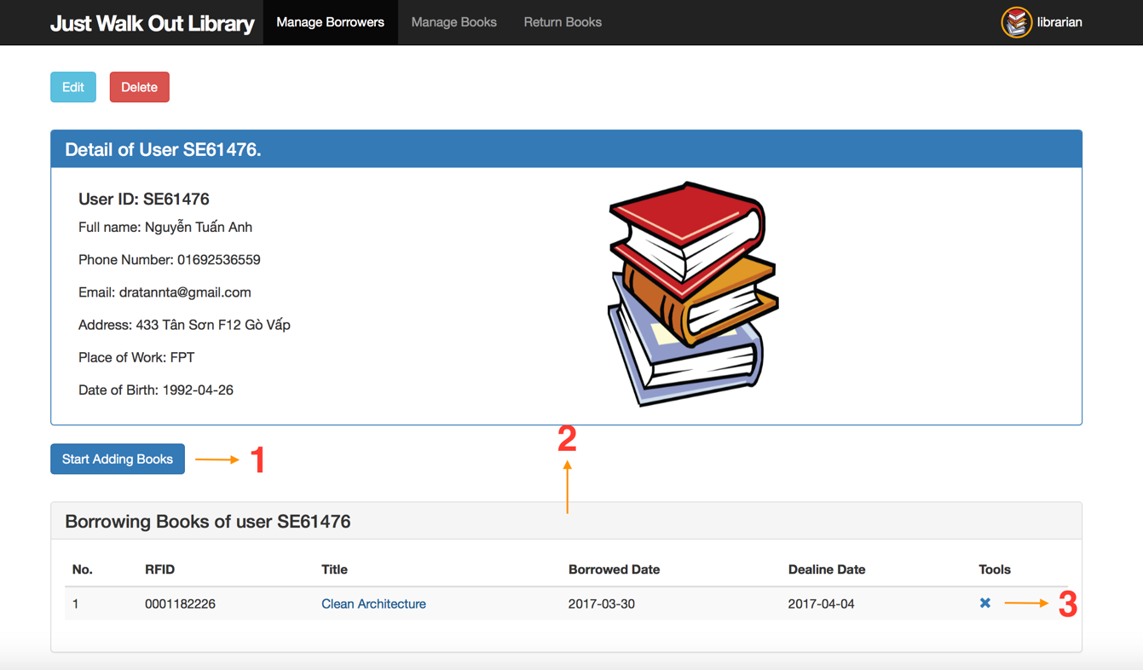

Figure 69: Web application UI - <Librarian> Get Account Detail

**Buttons/Hyperlinks**

|  |  |  |  |  |
| --- | --- | --- | --- | --- |
| **No** | **Function** | **Description** | **Validation** | **Outcome** |
| **1** | startBookBorrowProcess | Start book borrow process for the viewed account | N/A | Librarian can scan books for the viewed account. The book scanned will be updated in the borrowing books table Show the “Cancel” and “Stop Adding Books” button, and hide the current button |
| **3** | deleteBorrowingBook | Delete the borrowing book copy of the viewed account | N/A | Delete the borrowing book copy in the system, and update the table |

Table 84: Web application UI - <Librarian> Get Account Detail Fields

**Table**

|  |  |  |  |  |  |  |  |
| --- | --- | --- | --- | --- | --- | --- | --- |
| **No** | **Table Name** | **Description** | **Read Only** | **Mandatory** | **Control Type** | **Data Type** | **Length** |
| **2** | Borrowing books table | Show borrowing book copies for the viewed account | N/A | Yes | Table | N/A | N/A |

Table 85: Web application UI - <Librarian> Get Account Detail table

###### <Librarian> Borrow Book Copies

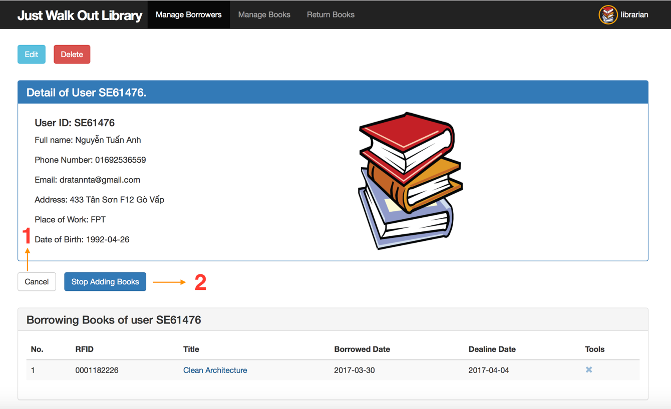

Figure 70: Web application UI - <Librarian> Borrow Book Copies

**Buttons/Hyperlinks**

|  |  |  |  |  |
| --- | --- | --- | --- | --- |
| **No** | **Function** | **Description** | **Validation** | **Outcome** |
| **1** | Cancel | Discard all changes | N/A | Refresh the borrowing books table to the before-scanned state Hide the “Cancel” and “Stop Adding Books” buttons, and show the “Start Adding Books” button |
| **3** | submitBorrowBookCopies | Submit all scanned book copies to the system | N/A | Save the scanned book copies to the system for the viewed account Hide the “Cancel” and “Stop Adding Books” buttons, and show the “Start Adding Books” button |

Table 86: Web application UI - <Librarian> Borrow Book Copies Buttons/links

###### <Librarian> Return Book Copies

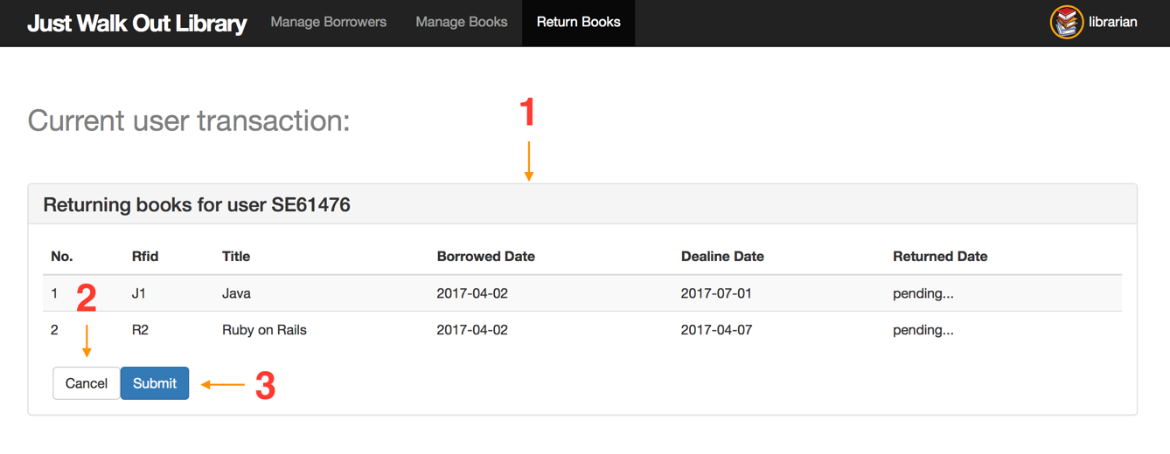

Figure 71: Web application UI - <Librarian> Return Book Copies

**Table**

|  |  |  |  |  |  |  |  |
| --- | --- | --- | --- | --- | --- | --- | --- |
| **No** | **Table Name** | **Description** | **Read Only** | **Mandatory** | **Control Type** | **Data Type** | **Length** |
| **1** | Returning books table | Show returning book copies information | N/A | Yes | Table | N/A | N/A |

Table 87: Web application UI - <Librarian> Return Book Copies table

**Buttons/Hyperlinks**

|  |  |  |  |  |
| --- | --- | --- | --- | --- |
| **No** | **Function** | **Description** | **Validation** | **Outcome** |
| **2** | Cancel | Discard all changes | N/A | Discard pending change to returning books table Hide the “Cancel” and “Submit” buttons |
| **3** | submitReturnBookCopies | Submit all scanned return book copies to the system | N/A | Save the scanned return book copies to the system Hide the “Cancel” and “Submit” buttons |

Table 88: Web application UI - <Librarian> Return Book Copies Buttons/links

#### RFID Reader GUI

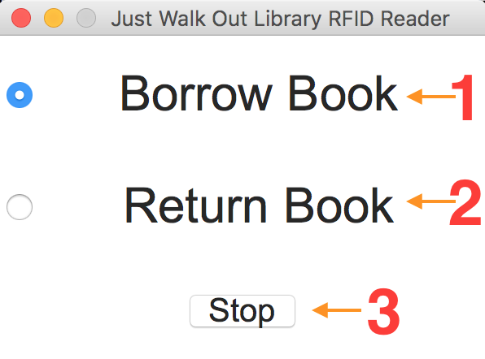

Figure 72: RFID Reader GUI

**Buttons/Hyperlinks**

|  |  |  |  |  |
| --- | --- | --- | --- | --- |
| **No** | **Function** | **Description** | **Validation** | **Outcome** |
| **1** | switchBorrowBookMode | Switch the RFID Reader to borrow books mode | N/A | Librarian can scan book copies for book borrowing process |
| **2** | switchReturnBookMode | Switch the RFID Reader to return books mode | N/A | Librarian can scan book copies for book returning process |
| **2** | stop | Stop the application | N/A | The application is closed |

Table 89: RFID Reader GUI Buttons/links

## Database Design

### Entity Relationship Diagram (ERD)

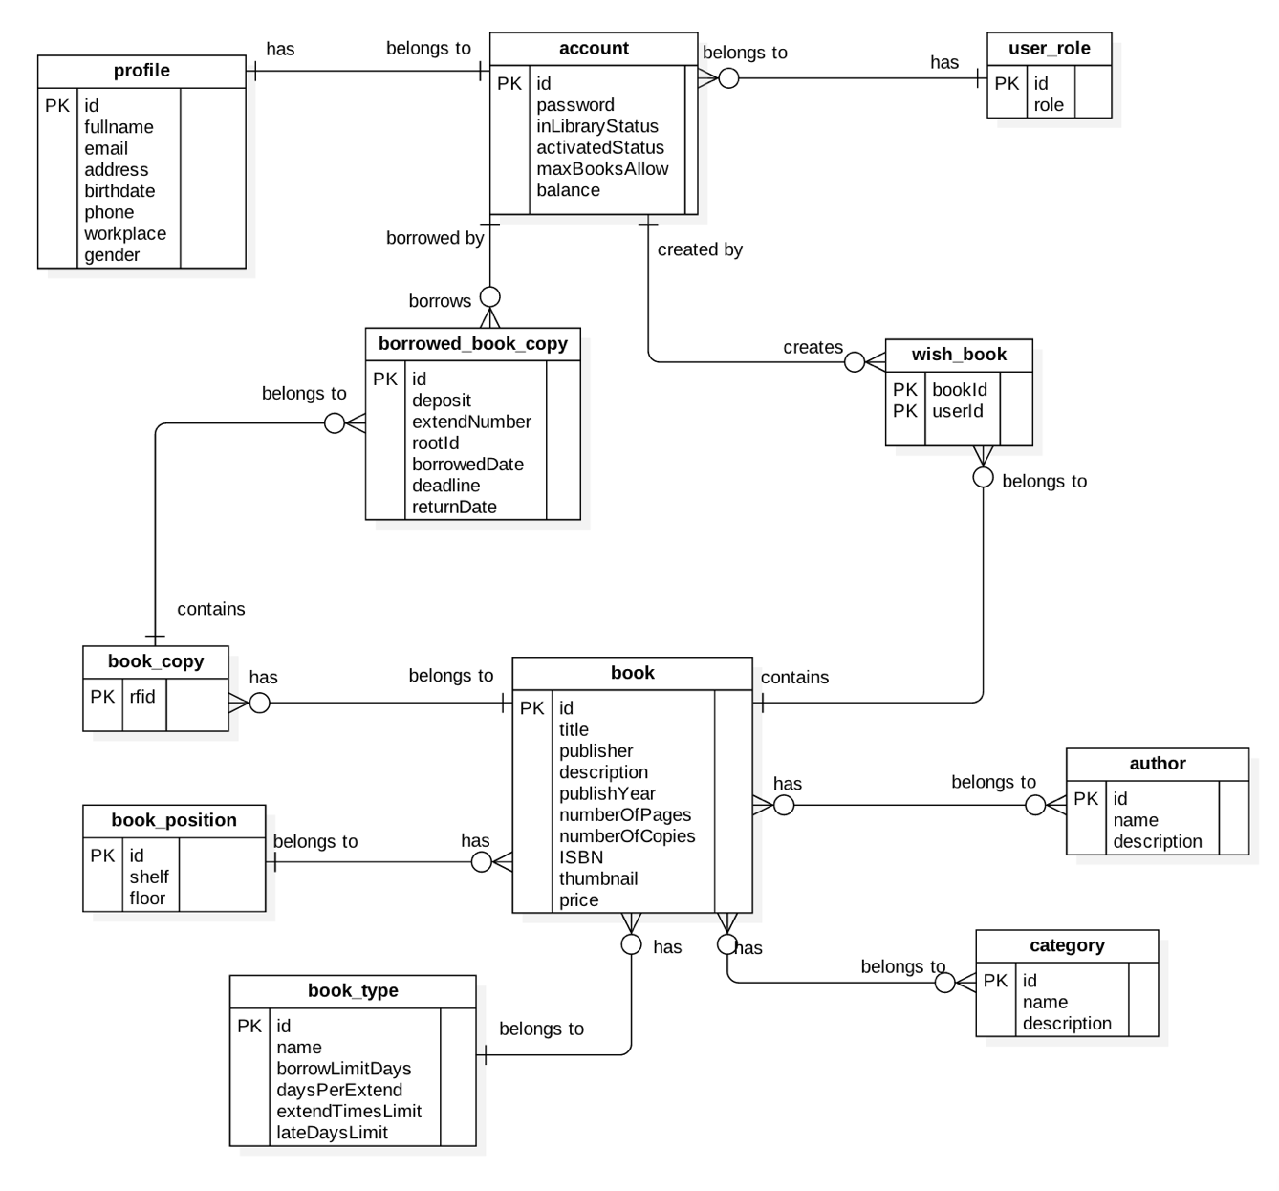

Figure 73: Entity Relationship Diagram (ERD)

### Data Dictionary

|  |  |
| --- | --- |
| **Entity Data Dictionary: describe contents of all entities** | |
| **Entity Name** | **Description** |
| Account | Contains frequently accessed information of all accounts in the system. |
| Profile | Contains information of detail profile of accounts in the system. |
| UserRole | Contains information of all role in the system. |
| WishBook | Contains a list of books that the accounts in the system put in their wishlist. |
| BorrowedBookCopies | Contains a list of borrowed book copies that the accounts in the system borrowed. |
| BookCopy | Contains information of all book copies of books in the system. |
| Book | Contains information of all books in the system. |
| BookPosition | Contains information of all book positions in the system. |
| BookType | Contains information of all book types in the system. |
| Category | Contains information of all book categories in the system. |
| Author | Contains information of all book authors in the system. |

Table 90: Data Dictionary

## Algorithms

### Check in Algorithms

#### Definition

Token authentication is a technique to prove that the borrower is who he/she claims to be. Requests which have the right token will be processed.

#### Define the problem

When the borrower use mobile application to check in. Mobile application sends some information to emulator for verification, we have to make sure that the information only valid in a specific time for checking in.

#### Solution

To solve this problem, we should follow these steps:

* Mobile application send a request for private key before checking – in.
* Server generate key base on user id and time then send to mobile application.
* When borrower check-in, emulator get user and key from mobile application.

Server generate key base on user id then compare with key sent from emulator, if it matchs current server token, request will be processed.

#### Image Recognizer Concepts

* **Concept:** is a definition that be attached to an image. It could be understood as tags of an image. A concept belongs to a model.
* **Non-Concept:** is a definition that be attached to an image. It tells that the image does not have this tag. This is useful to increase accuracy of Image Recognizer.
* **Model:** is a set of concepts (or tags), it could be customized to predict a given image. An output of a model is percent of each concept in that model. For example: a food model contains: pizza, noodle and hamburger can have an output like: 20% pizza, 10% noodle and 1% of hamburger.
* **Input:** is an image used to feed a model. It could be an url or a raw file

#### Solution

To make Image Recognizer to be useful we decided to create two custom models.

* **Category:** used to detect a category of an image. For example: detect if a cloth is t-shirt, skirt or dress
* **Concept:** used to detect the definition of design of a cloth. For example: detect if a cloth is stripe, plain, modern, classic or having superman

When creating a new product, staff will add images, concepts and non-concepts to make the system aware of the product. The training process includes:

* Step 1: Staff creates a new product with basic information includes: an image, name, price, description and category
* Step 2: Staff inputs multiple images that best describes the new product
* Step 3: Staff then inputs concepts that best describes the product. He or she also input non-concepts to tell that those concepts do not belong to this product
* Step 4: Staff then adds options to the product. For example, a cloth can have many color and variety of sizes
* Step 5: Staff publishes the product. The system then wraps all necessary data (images, concepts and non-concepts) and submits them to Image Recognizer System in a separate background thread. The system will start training process
* Step 6: After successful training the system then notify users about new product

#### Complexity

In total, the complexity of this algorithm based on the image recognizer. They do not publish summary algorithms or any descriptions. As the result, we spend time testing the algorithm complexity.

|  |  |
| --- | --- |
| **Network** | **Time (s)** |
| Wi-Fi (Download: 35.91M, Upload: 22.08M, Ping: 2ms) | 17.066 |
| 3G (Download: 24.44M, Upload: 2.55M, Ping: 20ms) | 18.882 |

#### Accuracy

* From testing result image recognition rate is more than 80%. The testing process:
* Step 1: train a product with multiple images
* Step 2: send those images one by one to the predict API
* Step 3: collect data and analyze
* From the result to optimize the training we process we should input at least 5 images. From the document adding more images we increase the accuracy of training process. We recommend input 10 images for each product

#### Flow chart



### Timsort Algorithms

#### Definition

- The algorithms used to sort a given array

#### Define the problem

- The system can sort the search result base on color difference. As the result, we need an algorithm to solve it

#### Complexity

- The complexity of the algorithm is 

#### References

- References: <https://en.wikipedia.org/wiki/Timsort>

### Color Distance Algorithms

#### Definition

- The algorithms used to determine the similarity of two colors

#### Define the problem

- The system can find the best color match the image. It can also sort the clothes based on color. This lead to the need of calculate a score between a detected color and a color of a cloth

#### Solution

- We will use CIEDE2000 algorithm for calculating the distance between two given colors

#### Complexity

- The algorithm has complexity 

#### References

- References: <https://en.wikipedia.org/wiki/Color_difference>

### Detect Best Color Algorithms

#### Definition

- The algorithms used to find the best color available in the system the match the color results from Image Recognizer

#### Define the problem

- Users would like to have search results sorted by color. As the result, we need an algorithm to find the best color in the system that match the input image

#### Solution

- Step 1: User input an image

- Step 2: System send image to Image Recognizer to detect colors

- Step 3: Sort the result from Image Recognizer and take only the first half of them. The formula is:

 

(n is the number of colors return by Image Recognizer, a is hex color of a color return from Image Recognizer, b is the percent of a from the input image, D is the max color difference, and c is a color in the system

- Step 4: System iterates through all colors available and calculates the score between them and finds the best result

#### Complexity

- Given N is number of colors return from Image Recognizer

- The sort algorithm takes 

- Calculate the score takes 

- Given M is number of colors in the system (M is less then 20)

🡪 The complexity of the algorithm is 

#### Comparing to other methods

<https://drive.google.com/open?id=0B67tFOgiGX6YUzNBaE01dXBsU2s>

#### Flow chart



### Search with Picture Algorithms

#### Definition

- The algorithms used to get products from the system that match the picture taken by users

#### Define the problem

- Users can search for products via pictures, so we need an algorithm that can make our system able to detect the pictures and return the best possible result. It can also detect pictures based on users’ choice of categories.

#### Solution

When searching for products, users can either select pictures from device or take a new one. The process includes:

* Step 1: Users input picture
* Step 2: System will scale and save picture
* Step 3: Users continue to select category from the list provided by the system (ex: Shirts, T-Shirt, Jeans or Shorts) or chooses to skip
* Step 4: System send image url to Image Recognizer
* Step 5: If Image Recognizer unable to detect the image (result concept and category must be >= 50%), system will write a log file to record it
* Step 6: Otherwise return data for user

#### Complexity

The complexity of this algorithm is depended on the image recognition service for which they do not provide any summary or description; therefore, we spend time testing the algorithm complexity.

|  |  |
| --- | --- |
| **Network** | **Time (s)** |
| Wi-Fi (Download: 35.91M, Upload: 22.08M, Ping: 2ms) | 4.039 |
| 3G (Download: 24.44M, Upload: 2.55M, Ping: 20ms) | 5.633 |

#### Accuracy

* From testing, result rate returned from Image Recognition service is more than 80%.
* Test result:
* Category: <https://drive.google.com/open?id=0B0EgBSrhB9kfUFA3RVVoSnoyRlU>
* Concept:

<https://drive.google.com/open?id=0B0EgBSrhB9kfSzNqMzBNMldILXM>

* The testing process:
* Step 1: Search for new products that do not already exist in the system
* Step 2: Start training for the new products
* Step 3: Search for those products again and collect data

#### Flow chart



### Suggest T-Shirt Size Algorithms

#### Definition

* The algorithms propose method to determine the T-shirt size suitable for a person.

#### Define the problem

* Some users do not know their correct T-shirt sizes so we need an algorithm to help users by suggesting the suitable sizes based on their gender, height and weight.

#### Solution

|  |  |  |  |
| --- | --- | --- | --- |
| **Female** | **Body figures** | **Male** | **Body figures** |
| **Size S** | 1m48 – 1m53  37kg – 41kg | **Size S** | 1m60 – 1m67  48kg – 53kg |
| **Size M** | 1m54 – 1m58  42kg – 46kg | **Size M** | 1m68 – 1m74  54kg – 60kg |
| **Size L** | 1m59 – 1m56  47kg – 52kg | **Size L** | > 1m75  61kg – 66kg |
| **Size XL** | 52kg – 56kg | **Size XL** | 67kg – 72kg |
| **Size XXL** | > 56kg | **Size XXL** | > 72kg |

References:

<http://shopbonny.mov.mn/bvct/s/4/cach-chon-size-ao-dua-vao-chieu-cao-can-nang-.html>

### Suggest Shirt Size Algorithms

#### Definition

* The algorithms propose method to determine the shirt size suitable for a person.

#### Define the problem

* Some users do not know their correct shirt sizes so we need an algorithm to help users by suggesting the suitable sizes based on the sizes of their neck and chest.

#### Solution

|  |  |  |
| --- | --- | --- |
| Neck size | Chest size | Clothe size (US) |
| 37 | 78 – 81 | S |
| 38 | 82 – 85 | S |
| 39 | 86 – 89 | M |
| 40 | 90 – 93 | M |
| 41 | 94 – 97 | L |
| 42 | 98 – 101 | L |
| 43 | 102 – 105 | XL |
| 44 | 105 – 108 | XL |

References:

<http://infonet.vn/cach-chon-size-ao-so-mi-nam-nu-phu-hop-chieu-cao-can-nang-post162780.info>

# Report No. 5 System Implementation & Test

## Introduction

### Overview

This section describes the approach and methodologies used by group to plan, organize and manage the testing of JWL system. It provides in the detail all necessary information about the implementation and testing procedure of the system included test plans, test cases, test result, test environments, pass/fail criteria and risks estimations as well as a checklist to cover all possible cases.

### Test Approach

* Goal: Test all features in the whole JWL system based on the core flow.
* Method: black-box testing
* Technique: check list

The testing for this project will consists of Integration System test level. Testing the program which was integrated and as a complete system to ensure that the software requirements have been met.

* Integration testing would be performed by all member of team and approved by team leader.

System testing is focused on assessing the system’s reliability. This process is concerned with finding errors that result from unanticipated interactions between components and component interface problems.

## Database Relationship Diagram

### Physical Diagram



### Data Dictionary

|  |  |
| --- | --- |
| Data dictionary: describe content of all tables | |
| Table Name | **Description** |
| account | Contain the information of all user. |
| profile | Contain the detail information of each user. |
| user\_role | Contain the information of role. |
| book | Contain the information of all book. |
| book\_copy | Contain the information of all book copy. |
| borrowed\_book\_copy | Contain the information of each borrowed book copy. |
| wish\_book | Contain the information of borrower’s wish list. |
| book\_author | Contain all author belong to a book. |
| author | Contain the information of all author. |
| book\_position | Contain the information of book’s position. |
| book\_category | Contain all category belong to a book. |
| category | Contain the information of all category. |
| book\_type | Contain the information of book’s type. |

|  |  |  |  |  |
| --- | --- | --- | --- | --- |
| Table Name | Attributes | Description | Domain | Null |
| account | user\_id{PK} | Unique identifier of an account | String | No |
| password | Password of an account | String | No |
| role\_id{FK} | Unique identifier of an account’s role | Integer | No |
| is\_in\_library | Show if an account is in library or not | Boolean | No |
| is\_activated | Show if an account is activated or deactivated | Boolean | No |
| delete\_date | Date that an account is deleted | Date | Yes |
| max\_number\_of\_books | The maximum number of books an account can borrow | Integer | No |
| total\_balance | Total balance of account | Integer | No |
| usable\_balance | Balance of an account after that account borrows book(s). | Integer | No |
| profile | user\_id{PK} | Unique identifier of a profile | Integer | No |
| fullname | Full name of an account | String | No |
| email | Email of an account | String | No |
| address | Home address of an account | String | No |
| date\_of\_birth | Date of birth of an account | Date | No |
| phone\_no | Contact phone number of an account | String | No |
| place\_of\_work | Company/School name of an account | String | No |
| gender | Gender of an account | Bit | No |
| user\_role | id{PK} | Unique identifier of a role | Integer | No |
| role | Name of a user role | String | No |
| book | id{PK} | Unique identifier of a book | Integer | No |
| title | Title of a book | String | No |
| publisher | Publisher name of a book | String | No |
| description | Description of a book | String | No |
| publish\_year | The year that book is published | Integer | No |
| number\_of\_pages | Total pages of a book | Integer | No |
| number\_of\_copies | Total copy of a book in the library | Integer | No |
| book\_type\_id{FK} | Id of book type that a book belongs to | Integer | No |
| position\_id{FK} | Id of position that a book locates at | Integer | No |
| ISBN | ISBN of a book | String | No |
| thumbnail | Image url of a book | String | No |
| price | Value of a book | Integer | No |
| delete\_date | Date that a book is deleted | Date | Yes |
| book\_copy | rfid{PK} | Unique identifier of a book copy | Integer | No |
| book\_id{FK} | Id of the book that a book copy belongs to | Integer | No |
| borrowed\_book\_copy | id{PK} | Unique identifier of a borrowed book copy | Integer | No |
| book\_copy\_id{FK} | Id of the book copy that a borrowed book copy belongs to | Integer | No |
| user\_id{FK} | Id of the account that borrows the book copy | String | No |
| deposit | Total balance that an account has to deposit to borrow a book | Integer | No |
| extend\_number | Time that an account extends a book copy’s borrow period | Integer | No |
| root\_id{FK} | Id of the before-extended borrowed book copy | Integer | Yes |
| borrowed\_date | Date that an account borrows a book copy | Date | No |
| deadline | Date that an account has to return the book copy | Date | No |
| return\_date | Date that an account returns the book copy | Date | Yes |
| wish\_book | id{PK} | Unique identifier of a wish book | Integer | No |
| book\_id{FK} | Id of the book that a wish book contains | Integer | No |
| user\_id{FK} | Id of the account that creates the wish book | String | No |
| book\_author | id{PK} | Unique identifier of a book author | Integer | No |
| book\_id{FK} | Id of the book that a book author belongs to | Integer | No |
| author\_id{FK} | Id of the author that a book author belongs to | Integer | No |
| author | id{PK} | Unique identifier of an author | Integer | No |
| name | Name of an author | String | No |
| description | Description of an author | String | Yes |
| book\_position | id{PK} | Unique identifier of a book position | Integer | No |
| shelf | Name of a shelf in the library | String | No |
| floor | Name of a floor in the library | String | Yes |
| book\_category | id{PK} | Unique identifier of a book category | Integer | No |
| book\_id{FK} | Id of the book that a book category belongs to | Integer | No |
| category\_id{FK} | Id of the category that a book category belongs to | Integer | No |
| category | id{PK} | Unique identifier of a category | Integer | No |
| name | Name of a category | String | No |
| description | Description of a category | String | Yes |
| book\_type | id | Unique identifier of a book type | Integer | No |
| name | Name of a type | String | No |
| borrow\_limit\_days | Number of days that a borrower can keep a book | Integer | No |
| days\_per\_extends | Number of days that a borrower can keep a book if borrower extends the book’s borrow period | Integer | No |
| extend\_times\_limit | Number of time a borrower can extends a book’s borrow period | Integer | No |
| late\_days\_limit | The maximum days that an account can be late in returning a book | Integer | No |

1. Table 73: Data dictionary: Describe content of all tables

## Implementation

### 3.1 Backend Architecture Implementation

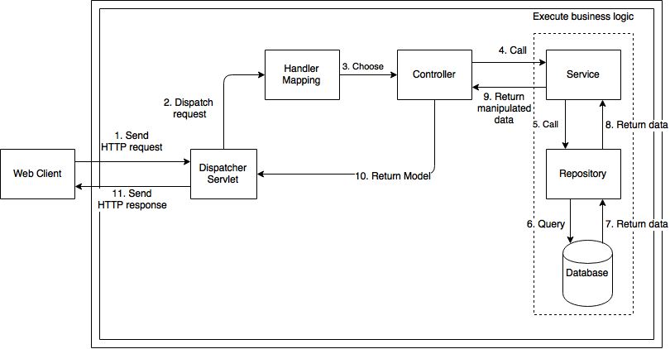

Figure 74: Backend Architecture Implementation

|  |  |
| --- | --- |
| **Name** | **Description** |
| Web Client | Web application users |
| Dispatcher Servlet | Receive request and map correct resource |
| Handler Mapping | Mapping incoming request |
| Controller | Send and receive HTTP request |
| Service | Hold business logic |
| Repository | DAOs, access database directly |
| Database | Contains a collection of schemas, table, queries |

### Mobile Application Architecture Implementation



|  |  |
| --- | --- |
| **Name** | **Description** |
| Controller | Represents a portion of UI in an Activity |
| Model | Business logic layer |
| Web Services | Interface to communicate with web application |
| View | Outputs the display of information |

### 3.3 Web Architecture Implementation

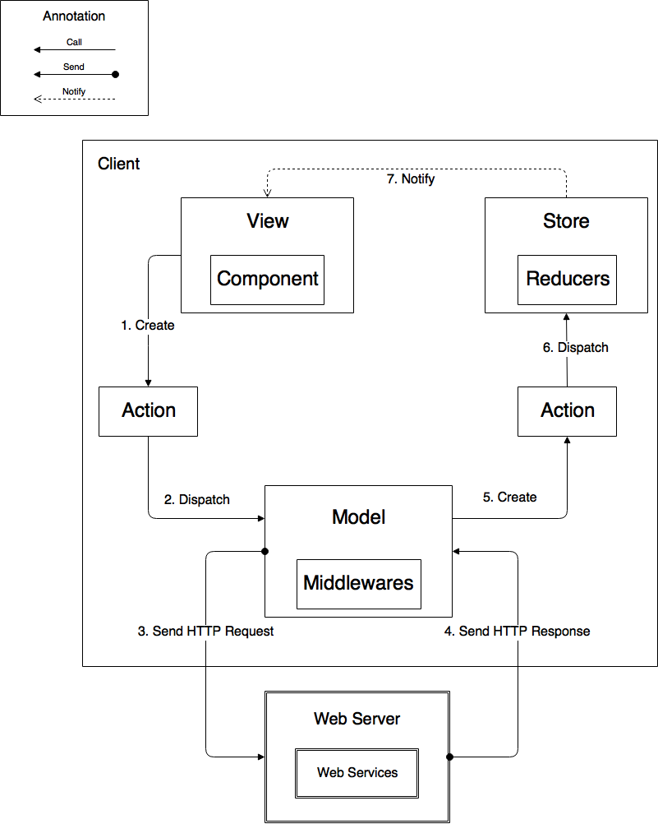

|  |  |
| --- | --- |
| **Name** | **Description** |
| View | Output display of information |
| Components | Encapsulates and reuses part of View |
| Store | Contains application states |
| Reducers | Are functions to manipulate states |
| Action | Are commands to communicate with Model and Store |
| Model | Data Access Layer |
| Middleware | Contains business logic |
| Web Server | Contains Web services |
| Web Services | Interface to communicate with web application |

## Test Plans

### Features to be tested

* 1. **Web application**:
     + Admin: Create/Delete account.
     + Librarian: Add/Update book. Activate/Deactivate borrower. Borrow book for borrower. Return book.
  2. **Mobile application**:
     + Borrower: Check in/out.Scan book.
  3. **Emulator application**:
     + Verify borrower
     + Top up card
     + Publish card
  4. **Automatic Handler**:
     + Notification return date
     + Auto checkout borrower
     + Notification available books
     + Notification recent borrow books

### Features not to be tested

1. **Web application**:

* View income report

1. **Passenger**:

* View cards’ information
* Search bus routes by bus code
* Find buses by lacations

1. **Mobile** **application**

* View cards’ information
* View outcome report

## System Testing Test Case

### Communication Diagram



Figure 63: <Testcase> System Test



### System Test Cases

#### Web Application Test Cases

* + - 1. <Unauthorized User> Login

|  |  |  |  |  |  |  |
| --- | --- | --- | --- | --- | --- | --- |
| ID | Test Case Description | Test case procedure | Expected output | Inter-test case dependence | Result | Test Date |
| LG01 | Login with valid phone number and password | 1. Go to login page 2. Input valid phone and password 3. Press “Đăng nhập” button | Show target main page. |  | Pass | From 20/9/16  To 12/12/16 |
| LG02 | Login with invalid phone number or password | 1. Go to login page 2. Input invalid phone and password 3. Press “Đăng nhập” button | Show message “Sai số điện thoại hoặc mật khẩu” |  | Pass | From 20/9/16  To 12/12/16 |
| LG03 | Login with blocked account | 1. Go to login page 2. Input blocked account phone number and password 3. Press “Đăng nhập” button | Show message “Tài khoản đã bị khóa” |  | Pass | From 20/9/16  To 12/12/16 |

Table 75: <Unauthorized> Login

* + - 1. <Manager> Add card

|  |  |  |  |  |  |  |
| --- | --- | --- | --- | --- | --- | --- |
| ID | Test Case Description | Test case procedure | Expected output | Inter-test case dependence | Result | Test Date |
| AC01 | Add card successful | 1. Go to card page 2. Press “Thêm thẻ mới” button 3. Tap new card on the emulator 4. Input initial card balance 5. Press “Lưu” button | Updated card page with new promotion added |  | Pass | From 1/10/16  To 12/12/16 |

Table 76: <Manager> Add Card

* + - 1. <Staff> Activate/Deactivate card

|  |  |  |  |  |  |  |
| --- | --- | --- | --- | --- | --- | --- |
| ID | Test Case Description | Test case procedure | Expected output | Inter-test case dependence | Result | Test Date |
| AD01 | Activate card successful | 1. Go to card page 2. Press “Mở khóa thẻ” button | “Mở khóa thẻ” button change to “Khóa thẻ” button |  | Pass | From 1/10/16  To 12/12/16 |
| AC02 | Deactivate card successful | 1. Go to card page 2. Press “Mở khóa thẻ” button | “Khóa thẻ” button change to “Mở khóa thẻ” button |  | Pass | From 1/10/16  To 12/12/16 |

Table 77: <Staff> Add Card

* + - 1. <Passenger> Add credit

|  |  |  |  |  |  |  |
| --- | --- | --- | --- | --- | --- | --- |
| ID | Test Case Description | Test case procedure | Expected output | Inter-test case dependence | Result | Test Date |
| CR01 | Add credit successfully | 1. Go to card page 2. Press “Nạp tiền” button 3. Select a credit plan 4. Input valid PayPal account 5. Press “Continue” button | Updated “Thẻ của bạn” panel with updated balance |  | Pass | From 25/9/16  To 12/12/16 |
| CR02 | Add credit using invalid PayPal account | 1. Go to card page 2. Press “Nạp tiền” button 3. Select a credit plan 4. Input invalid PayPal account 5. Press “Continue” button | Show error message “Check your email address and password and try again.” |  | Pass | From 25/9/16  To 12/12/16 |

Table 78: <Passenger> Add Credit

#### Mobile Application Test Cases

* + - 1. <Passenger> Login

|  |  |  |  |  |  |  |
| --- | --- | --- | --- | --- | --- | --- |
| ID | Test Case Description | Test case procedure | Expected output | Inter-test case dependence | Result | Test Date |
| LI01 | Login successfully | 1. Open “GBTS” application 2. Input valid phone number and password 3. Press “Login” button | Show main screen |  | Pass | From 1/10/16  To 12/12/16 |
| LI02 | Login with invalid phone number or password | 1. Open “GBTS” application 2. Input invalid phone number and password 3. Press “Login” button | Show message “Sai điện thoại hoặc mật khẩu” |  | Pass | From 1/10/16  To 12/12/16 |
| LI03 | Login with blocked account | 1. Open “GBTS” application 2. Input with blocked account 3. Press “Login” button | Show message “Tài khoản đã bị khóa” |  | Pass | From 1/10/16  To 12/12/16 |

Table 79: <Passenger> Login

* + - 1. <Passenger> Add credit

|  |  |  |  |  |  |  |
| --- | --- | --- | --- | --- | --- | --- |
| ID | Test Case Description | Test case procedure | Expected output | Inter-test case dependence | Result | Test Date |
| CR01 | Add credit successful | 1. Open “GBTS” application 2. Input valid phone number and password 3. Press “Login” button 4. Select card panel 5. Choose a card 6. Press “Nạp tiền” button 7. Select credit package 8. Press “Thanh toán” button 9. Press “Pay with” PayPal” button 10. Input valid email and password 11. Press “Login” button 12. Press “Pay with PayPal” button 13. Press “Pay” button | Updated “Thẻ của bạn” panel with updated balance |  | Pass | From 5/10/16  To 12/12/16 |
|  | Add credit using wrong PayPal account | 1. Open “GBTS” application 2. Input valid phone number and password 3. Press “Login” button 4. Select card panel 5. Choose a card 6. Press “Nạp tiền” button 7. Select credit package 8. Press “Thanh toán” button 9. Press “Pay with” PayPal” button 10. Input invalid account 11. Press “Login” button 12. Press “Pay with PayPal” button 13. Press “Pay” button | Show error message “Check your email address and password and try again.” |  | Pass | From 5/10/16  To 12/12/16 |

Table 80: <Passenger> Add Credit

* + - 1. <Passenger> Buy ticket by phone

|  |  |  |  |  |  |  |
| --- | --- | --- | --- | --- | --- | --- |
| ID | Test Case Description | Test case procedure | Expected output | Inter-test case dependence | Result | Test Date |
| PT01 | Buy ticket by phone successfully | 1. Open “GBTS” application 2. Input valid phone number and password 3. Press “Login” button 4. Tap phone on the emulator | Show successful message |  | Pass | From 7/11/16  To 12/12/16 |

Table 81: <Passenger> Buy ticket by phone

* + - 1. <Passenger> Top up card

|  |  |  |  |  |  |  |
| --- | --- | --- | --- | --- | --- | --- |
| ID | Test Case Description | Test case procedure | Expected output | Inter-test case dependence | Result | Test Date |
| TU01 | Top up card successfully | 1. Open “GBTS” application 2. Input valid phone number and password 3. Press “Login” button 4. Select card panel 5. Choose a card 6. Press “Nạp tiền” button 7. Press “Nạp tiền bằng thẻ cào” button 8. Input valid scratch card’s code 9. Press “Nạp” button | Show main screen |  | Pass | From 10/10/16  To 12/12/16 |
| TU02 | Top up card using wrong code | 1. Open “GBTS” application 2. Input valid phone number and password 3. Press “Login” button 4. Select card panel 5. Choose a card 6. Press “Nạp tiền” button 7. Press “Nạp tiền bằng thẻ cào” button 8. Input valid scratch card’s code 9. Press “Nạp” button | Show message “Mã nạp tiền không hợp lệ hoặc hết hạn” |  | Pass | From 10/10/16  To 12/12/16 |
| TU03 | Top up card without a code | 1. Open “GBTS” application 2. Input valid phone number and password 3. Press “Login” button 4. Select card panel 5. Choose a card 6. Press “Nạp tiền” button 7. Press “Nạp tiền bằng thẻ cào” button 8. Leave scratch card’s code space blank 9. Press “Nạp” button | Show message “Mã nạp tiền không hợp lệ hoặc hết hạn” |  | Pass | From 10/10/16  To 12/12/16 |

Table 82: <Passenger> Top up card

* + - 1. <Emulator> Verify ticket

|  |  |  |  |  |  |  |
| --- | --- | --- | --- | --- | --- | --- |
| ID | Test Case Description | Test case procedure | Expected output | Inter-test case dependence | Result | Test Date |
| TU01 | Verify ticket successfully | 1. Tap GBTS card on the emulator | Show success screen |  | Pass | From 20/9/16  To 12/12/16 |

Table 82: <Emulator> Verify ticket

* + - 1. <Emulator> Verify mobile ticket

|  |  |  |  |  |  |  |
| --- | --- | --- | --- | --- | --- | --- |
| ID | Test Case Description | Test case procedure | Expected output | Inter-test case dependence | Result | Test Date |
| TU01 | Verify ticket with token successfully | 1. Open GBTS application on passenger’s phone 2. Tap passenger’s phone on the emulator to confirm | Show success screen |  | Pass | From 1/10/16  To 12/12/16 |

Table 83: <Emulator> Verify mobile ticket

# Software User’s Manual

## Installation Guide

### Setting up environment at server side

#### Hardware Requirement

|  |  |
| --- | --- |
| Hardware Specification | |
| Internet Connection | 100 Mbps |
| Server type | Shared Windows Hosting on Window Server |

#### Software Requirement

|  |  |
| --- | --- |
| Software | Application name/version |
| Operating System | Windows Server 2012 R2 |
| Visual Studio | 2013 or 2015 |
| Web Server | IIS 8.1 |
| Database | Microsoft SQL Server 2012 R2 |
| Control Panel | Plesk 11 |

### Deployment at server side

#### Prepare deployment package

* + Publish web application.
  + Step by step:

1. Click right into web package. Click to “Publish”



1. Publish web with steps bellows:









#### Deploy web application on server

* Step 1 : Go to Plesk Control Panel and login
* Step 2 : Click “File Manager” feature



* Step 3: Upload all published files from Visual Studio to httpdocs folder



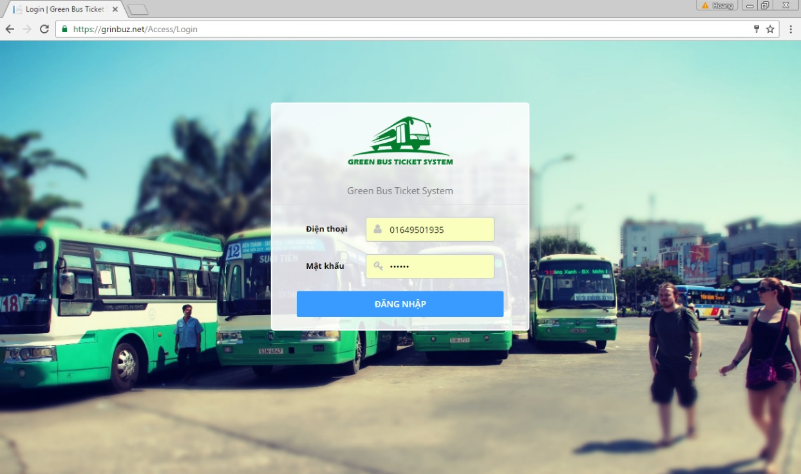

### Deployment at Client Side

* On mobile device, install one of the application from the GBTS package application apk from our attachment on the CD.

*For Bus Emulator:*

* + Install “GBTS Emulator”

*For Customer:*

* + Install “GBTS”

*For Staff:*

* + Install “Máy nạp tiền”
  + Install “CardPublisherStaff” for staff use
  + Install “GBTS Card Publisher” for web use

## User Guide

### Web application

* + 1. <Unauthorized user>Login



|  |  |
| --- | --- |
| Step | Description |
| 1 | Click “ĐĂNG NHẬP” button |

* + 1. <Passenger> Get NFC cards

|  |  |
| --- | --- |
| Step | Description |
| 1 | Click “Thẻ của bạn” button |

* + 1. <Passenger> Edit card name

|  |  |
| --- | --- |
| Step | Description |
| 1 | Click “Thẻ của bạn” button |
| 2 | Input new card name |
| 3 | Click save button |

<Passenger> Add credit



|  |  |
| --- | --- |
| Step | Description |
| 1 | Click “Thẻ của bạn” button |
| 2 | Click “Nạp tiền” button |
| 3 | Select a credit plan |
| 4 | Click “Thanh toán” button |
| 5 | Confirm the payment by clicking “Continue” |

* + 1. <Passenger> Get outcome report

|  |  |
| --- | --- |
| Step | Description |
| 1 | Click “Báo cáo chi tiêu” button |

* + 1. <Passenger> Look up bus route



|  |  |
| --- | --- |
| Step | Description |
| 1 | Click “Tìm xe buýt” button |
| 2 | Input “Nơi khởi hành” and “Nơi đến” |
| 3 | Click search button |

* + 1. <Passenger> Find bus

|  |  |
| --- | --- |
| Step | Description |
| 1 | Click “Tra cứu tuyến” button |
| 2 | Choose a bus route in a list or input bus route name or code into “Mã số tuyến hoặc tên tuyến” |

* + 1. <Administrator> Search account



|  |  |
| --- | --- |
| Step | Description |
| 1 | Click “Quản lý tài khoản” button |
| 2 | Input a phone number |
| 3 | Click search button |

* + 1. <Administrator> Add account





|  |  |
| --- | --- |
| Step | Description |
| 1 | Click “Quản lý tài khoản” button |
| 2 | Click Thêm tài khoản” button |
| 3 | Input phone number and select one of the roles |
| 4 | Click “Lưu” button |

* + 1. <Administrator> Activate/Deactivate account





|  |  |
| --- | --- |
| Step | Description |
| 1 | Click “Quản lý tài khoản” button |
| 2 | Input a phone number |
| 3 | Click “Khóa tài khoản” or “Mở khóa tài khoản” button |

* + 1. <Staff> Publish scratch cards



|  |  |
| --- | --- |
| Step | Description |
| 1 | Click “Phát hành thẻ cào” button |
| 2 | Click “Phát hành mới” button |
| 3 | Input all information |
| 4 | Click “Phát hành” button |

* + 1. <Staff> Search card



|  |  |
| --- | --- |
| Step | Description |
| 1 | Click “Quản lý thẻ” button |
| 2 | Input card ID |
| 4 | Click search button |

* + 1. <Staff> Add card





|  |  |
| --- | --- |
| Step | Description |
| 1 | Click “Quản lý thẻ” button |
| 2 | Click “Thêm thẻ mới” button |
| 3 | Tap new NFC card on the NFC reader or enter card ID by hand |
| 4 | Input initial balance |
| 5 | Click “Lưu” button |

* + 1. <Staff> Activate/Deactivate card





|  |  |
| --- | --- |
| Step | Description |
| 1 | Click “Quản lý thẻ” button |
| 2 | Input card ID or a phone number |
| 3 | Click “Khóa thẻ” button or “Mở khóa thẻ” button |

* + 1. <Staff> Search passenger



|  |  |
| --- | --- |
| Step | Description |
| 1 | Click “Quản lý hành khác” button |
| 2 | Input phone number or name |
| 3 | Click search button |

* + 1. <Manager> Add ticket type





|  |  |
| --- | --- |
| Step | Description |
| 1 | Click “Quản lý giá vé” button |
| 2 | Input phone number or name |
| 3 | Click “Lưu” button |

* + 1. <Manager> Edit ticket type





|  |  |
| --- | --- |
| Step | Description |
| 1 | Click “Quản lý giá vé” button |
| 2 | Click edit button on a ticket type |
| 3 | Click “Lưu” button |

* + 1. <Manager> Delete ticket type





|  |  |
| --- | --- |
| Step | Description |
| 1 | Click “Quản lý giá vé” button |
| 2 | Click delete button on a ticket type |
| 3 | Confirm by clicking “Xóa” button |

* + 1. <Manager> Add credit plan





|  |  |
| --- | --- |
| Step | Description |
| 1 | Click “Quản lý gói nạp tiền” button |
| 2 | Click “Thêm gói” button |
| 3 | Input new credit plan information |
| 4 | Click “Lưu” button |

* + 1. <Manager> Edit credit plan





|  |  |
| --- | --- |
| Step | Description |
| 1 | Click “Quản lý gói nạp tiền” button |
| 2 | Click edit button on a credit plan |
| 3 | Edit credit plan information |
| 4 | Click “Lưu” button |

* + 1. <Manager> Delete credit plan





|  |  |
| --- | --- |
| Step | Description |
| 1 | Click “Quản lý gói nạp tiền” button |
| 2 | Click delete button on a credit plan |
| 3 | Confirm by clicking “Xóa” button |

* + 1. <Manager> Add subscription





|  |  |
| --- | --- |
| Step | Description |
| 1 | Click “Quản lý gói ưu đãi” button |
| 2 | Click “Thêm ưu đãi mới” button |
| 3 | Enter new promotion package information |
| 4 | Click save button |

* + 1. <Manager> Edit subscription



|  |  |
| --- | --- |
| Step | Description |
| 1 | Click “Quản lý gói ưu đãi” button |
| 3 | Edit promotion package information |
| 4 | Click save button |

* + 1. <Manager> Delete subscription





|  |  |
| --- | --- |
| Step | Description |
| 1 | Click “Quản lý gói ưu đãi” button |
| 3 | Click delete button on a promotion package |
| 4 | Confirm by click “Xóa” button |

* + 1. <Manager> Get income report



|  |  |
| --- | --- |
| Step | Description |
| 1 | Click “Báo cáo thu nhập” button |
| 3 | Input query information |
| 4 | Click search button |

* + 1. <Manager> Create promotion



|  |  |
| --- | --- |
| Step | Description |
| 1 | Click “Tạo quảng cáo” button |
| 3 | Input new advertisement information |
| 4 | Click “Gửi” button |

### Mobile application

* + 1. <Passenger> View Login



|  |  |
| --- | --- |
| Step | Description |
| 1 | Tab “ĐĂNG NHẬP” |
| 2 | Tap “KÍCH HOẠT “ |

* + 1. <Passenger> View Active Card

|  |  |
| --- | --- |
| Step | Description |
| 1 | Input your phone number, tap and hold to Active Card |

#### <Passenger> Function Overview



|  |  |
| --- | --- |
| Step | Description |
| 1 | Tap “THẺ CỦA TÔI”. |
| 2 | Tap “BÁO CÁO CHI TIÊU” |
| 3 | Tap “TRA CỨU TUYẾN” |
| 4 | Tap “TÌM XE BUÝT” |
| 5 | Tap “TÀI KHOẢN” |
| 6 | Tap “LIÊN HỆ “ |

#### <Passenger> THẺ CỦA TÔI





|  |  |
| --- | --- |
| Step | Description |
| 1 | Click one item of list card on fragment to view details and purchase. |
| 2 | Tap “ICON” to edit Name card. |
| 3 | Tap “NẠP THẺ TRỰC TUYẾN” purchase to recharge. |
| 4 | Tap “NẠP BẰNG THẺ CÀO”. |
| 5 | Click one item of list credit plan on fragment to recharge. |
| 6 | Tap “NẠP” to recharge. |

#### <Passenger> BÁO CÁO CHI TIÊU





|  |  |
| --- | --- |
| Step | Description |
| 1 | Click “TỪ NGÀY” to choose date. |
| 2 | Click “ĐẾN NGÀY” to choose date. |
| 3 | Click “ICON SEARCH” to get report. |

#### <Passenger> TRA CỨU TUYẾN



|  |  |
| --- | --- |
| Step | Description |
| 1 | Filler to fine bus routes |
| 2 | Click one item of list bus routes to find direction and bus routes. |

#### <Passenger> TÌM XE BUÝT



|  |  |
| --- | --- |
| Step | Description |
| 1 | Choose origin direction |
| 2 | Choose destination direction |
| 3 | Tap “TÌM KIẾM” to find bus routes |

#### <Passenger > TÀI KHOẢN



|  |  |
| --- | --- |
| Step | Description |
| 1 | Click “LƯU” to change profile. |

### Emulator application

#### Verify ticket



|  |  |
| --- | --- |
| Step | Description |
| 1 | Open Bus Emulator application |
| 2 | Tap and hold NFC card or NFC-enabled phone on the NFC reader |

#### Configure emulator



|  |  |
| --- | --- |
| Step | Description |
| 1 | Open Bus Emulator application |
| 2 | Tap driver’s NFC card on the NFC reader |
| 3 | Press on Bus floating button |
| 4 | Input a bus code and select a ticket type |
| 5 | Press “Lưu cài đặt” button |

#### C:\Users\Duc\AppData\Local\Microsoft\Windows\Temporary Internet Files\Content.Word\Screenshot_20161120-212352.pngSell cash ticket

|  |  |
| --- | --- |
| Step | Description |
| 1 | Open Bus Emulator application |
| 2 | Tap driver’s NFC card on the NFC reader |
| 3 | Press on Cash floating button |

#### Publish card

|  |  |
| --- | --- |
| Step | Description |
| 1 | Open Card Publisher application |
| 2 | Open publish card panel on the web application |
| 3 | Tap and hold new NFC card on the NFC reader |



#### C:\Users\Duc\AppData\Local\Microsoft\Windows\Temporary Internet Files\Content.Word\Screenshot_20161120-212801.pngPublish card (Immediately publish a card without using the web application)

|  |  |
| --- | --- |
| Step | Description |
| 1 | Open Card Publisher application |
| 2 | Tap and hold new NFC card on the NFC reader |

# Appendix

1. UML Documentation of IBM <http://www.ibm.com/developerworks/rational/library/769.html?ca=drs->
2. AES encryption

[http://](http://www.ibm.com/developerworks/rational/library/769.html?ca=drs-)www.java2s.com/Code/Java/Security/EncryptionanddecryptionwithAESECBPKCS7Padding.htm

1. Android Developer Guide – Application Fundamentals

<https://developer.android.com/guide/components/fundamentals.html>

1. FPT Vietnamese Accentizer

[http://doc.openfpt.vn/services/vnaccent/documentation.html#/README](http://doc.openfpt.vn/services/vnaccent/documentation.html%23/README)

1. Google Firebase Api

<https://firebase.google.com/docs/reference/>